XWM Webserver

UPTO

Dummies - Formatting numbers as dollar amounts

Contents

XWM Webserver 5

Install Ubuntu 5

Create the virtual machine ‘xwm-web’ 5

Name and operating system 5

Memory size 5

Hard disk 6

Hard disk file type 6

Storage on physical hard disk 6

File location and size 7

Install Ubuntu 8

Configure ‘xwm-mysql’ to boot from the installation image 8

Create a Virtual Box snapshot 10

Bridge the network connection 11

Install deja-dup and do a backup 12

Remote desktop using xRDP 14

Configure the firewall for RDP 14

Remote onto xwm-mysql 15

Install Apache 16

Overview 16

Install Apache 16

Setting Up Virtual Hosts 17

Test the site 20

Install Visual Studio code 22

Install MySQL 23

Install MySQL on xwm-web 23

Connect to a remote MySQL server 24

Create the folder ‘examples’ 25

HTML 26

First HTML page 26

Table 28

Link 29

Image 30

CSS 31

CSS Comments 31

Inline CSS 31

Internal CSS 32

External CSS 33

Element selectors 34

Individual element selector 34

Class (multiple element selector) 35

Font-Family Selection 36

Font Size 37

Font Color 38

Borders 39

Border Styles 39

List (list styles) 40

Add a Background 41

Background image 42

Page Layouts 43

Liquid layout 44

Two-Column Fixed-Width 45

Display 46

Two-Column Liquid 47

Adding Headers and Footers 48

JavaScript 50

Use JavaScript 50

Alert 51

Variables 52

Arrays 53

String 54

If/Else *(conditionals)* 55

For Loop 56

For loop an array 57

While loop 58

Functions 59

Creating functions 59

Adding function arguments (p204) 59

Testing numbers 60

Returning a result from function 61

Objects 62

Add a property to an object 63

Working with Documents 64

Using ‘GetElementById’ to access an element 64

Page Redirection 67

jQuery 68

Installing jQuery) 68

Using CDN-hosted jQuery 68

Adding jQuery to a Page 68

Incorporating the jQuery ready() function 69

Selecting Elements with jQuery 70

Changing elements 72

Changing Attributes and Styles 74

Reading attributes 74

Writing attributes 75

setTimeout() 77

Changing CSS 78

Removing a class 79

Reacting to Events with JavaScript and jQuery 80

Working with Forms 80

return false; 84

preventDefault() 84

Checking for blank fields (p246) 85

Mouse Events 88

Capturing mouse clicks 88

Mouse movement 91

Keyboard button events 93

Preventing character input 94

Troubleshooting JavaScript 97

Comments 97

alert() 97

Developer tools 97

PHP 98

PHP description 98

PHP Tags 98

PHP Process 98

Install PHP 99

PHP Variables 102

Naming a variable 102

Creating and assigning values to variables 102

Using variables in ‘echo’ statements 102

Displaying variables with var_dump() 103

PHP Constants 104

Variable datatypes 105

Determining a data type 105

Formatting dollar amounts 105

Escape characters 107

Using single and double quotes with strings 108

Storing really long strings 109

Arrays 110

Create ‘home’ 115

# XWM Webserver

Create a webserver xwm-web that:

* allows users to update settings
* responds to REST commands sent from the mobile app TUFCv3
* sends SQL queries to the database xwm-mysql

# Install Ubuntu

## Create the virtual machine ‘xwm-web’

To create a new Virtual Machine in Virtual Box

select: Machine > New

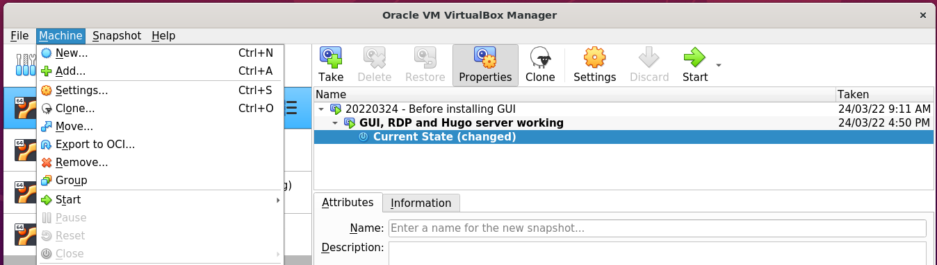

### Name and operating system

Name: xwm-web

Folder: /media/nath/4TB/XWM

Type: Linux

Version: Ubuntu (64-bit)

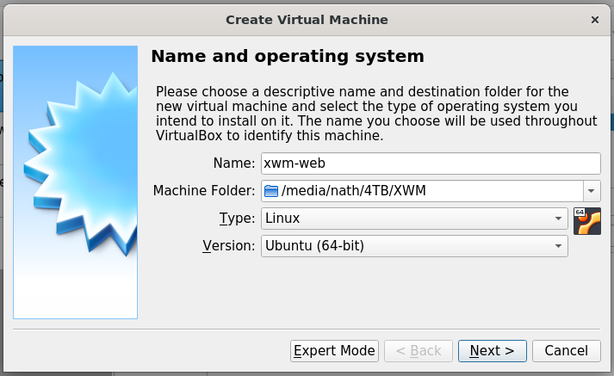

### Memory size

Select: 4096 MB

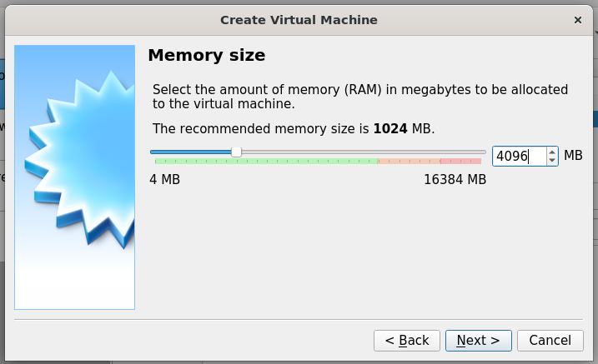

*Next, Hard disk …*

### Hard disk

Select: Create a hard disk now

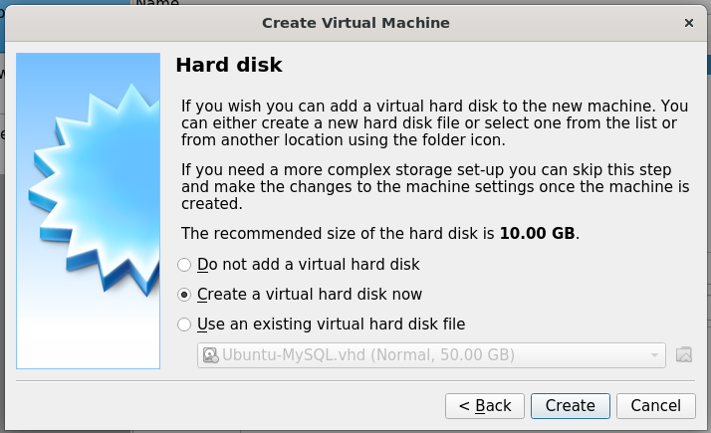

### Hard disk file type

Select: VHD (Virtual Hard Disk)

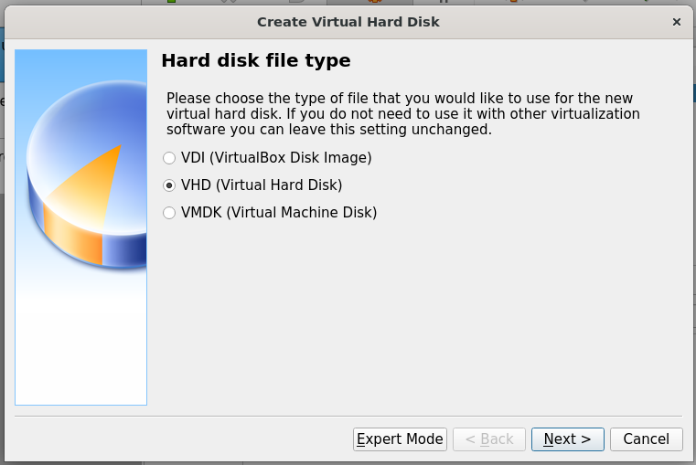

### Storage on physical hard disk

Select: Dynamically allocated

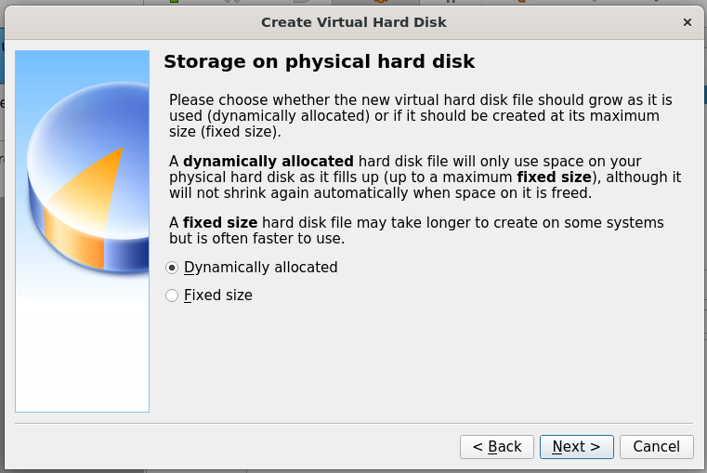

*Next, File location and size …*

### File location and size

Location: /media/nath/4TB/XWM/xwm-mysql/xwm-mysql.vhd

Size: 50 GB

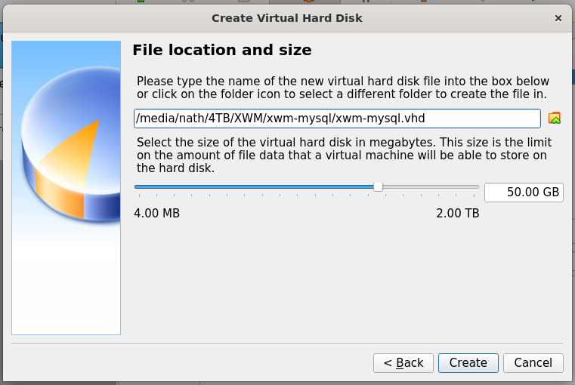

Click: Create *(above)*

The virtual machine xwm-web

is displayed in the left column Virtual Box.

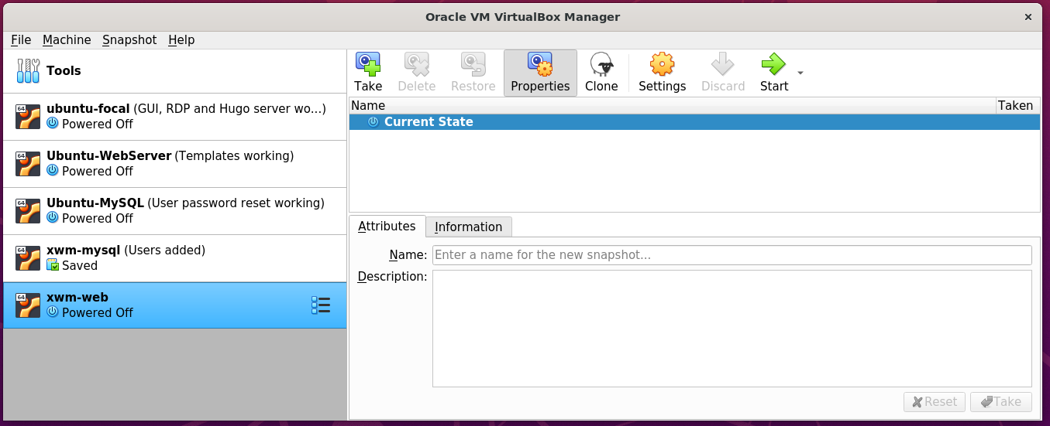

*Next, Install Ubuntu …*

# Install Ubuntu

Download the latest version of Ubuntu from: https://ubuntu.com/download/desktop

### Configure ‘xwm-mysql’ to boot from the installation image

Open Virtual Box on the host server Ubuntu-LAMP

In the left column, right click the virtual machine xwm-web

and select Settings

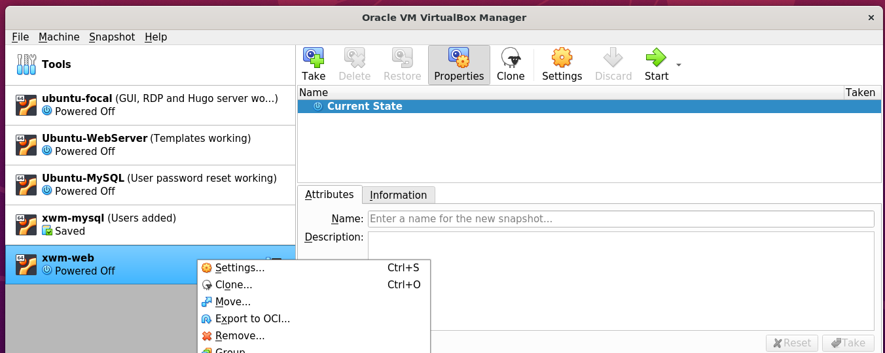

In the left column of Settings, select Storage

then in the middle panel, select Controller: IDE

on the right, select Choose a disk file

and select the downloaded Ubuntu installation image.

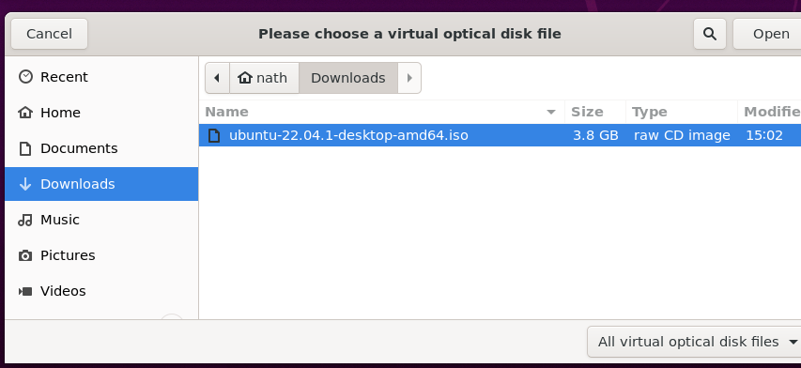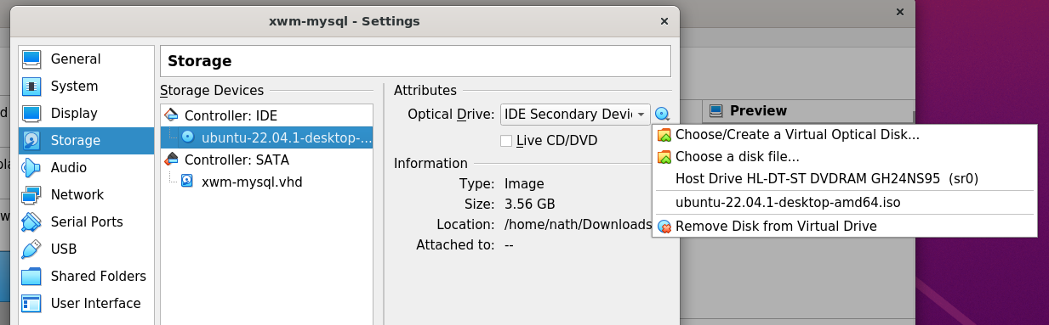

The installation iso has been selected

as the virtual machine’s CD

This means that when xwm-web boots

it will run the installation iso image.

Start the virtual machine xwm-web

by clicking Start > Normal Start

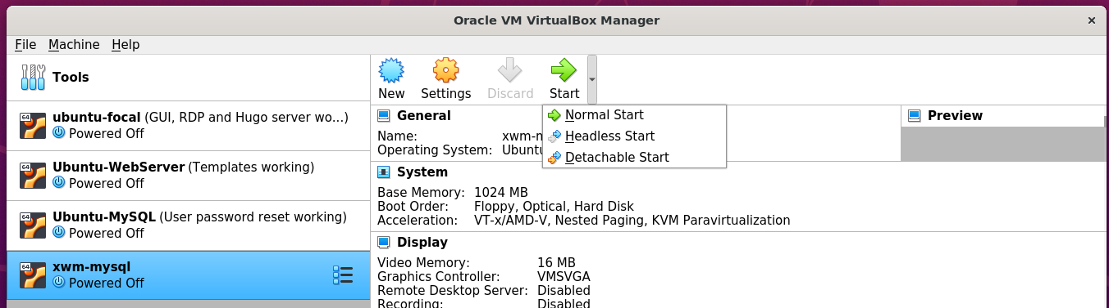

The boot options are displayed.

Select: Try or install Ubuntu

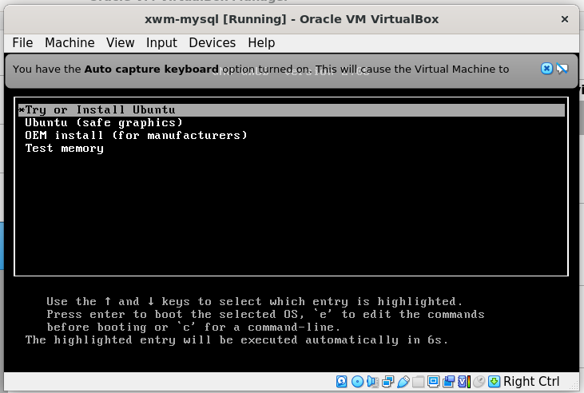

Follow the installation prompts to install Ubuntu

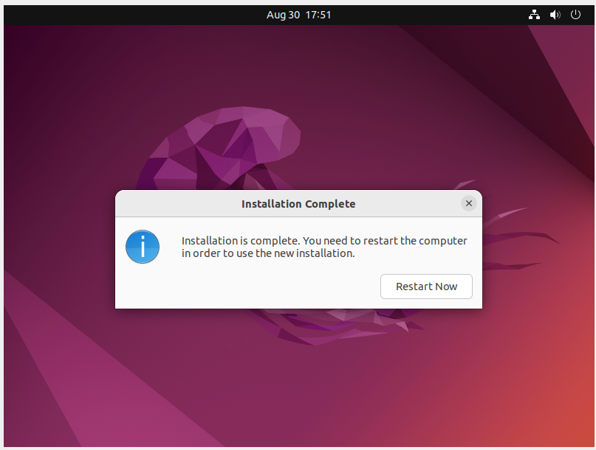

Shut down xwm-web

remove the installation iso

then restart the virtual machine

to complete the installation.

*Next, create a snapshot …*

## Create a Virtual Box snapshot

Once the installation completes

restart the virtual machine

run Ubuntu updates

then create a snapshot of xwm-web

Create a snapshot

of the newly installed virtual machine xwm-web

In the left menu of Virtual Box

click xwm-web’s settings icon *(the waffle)*

and click Snapshots

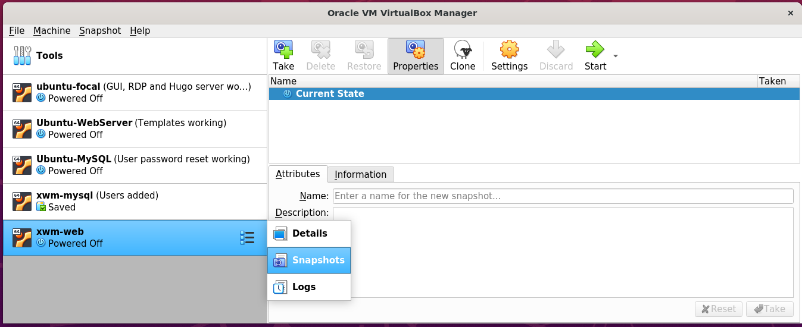

Then on the right, click the Take icon.

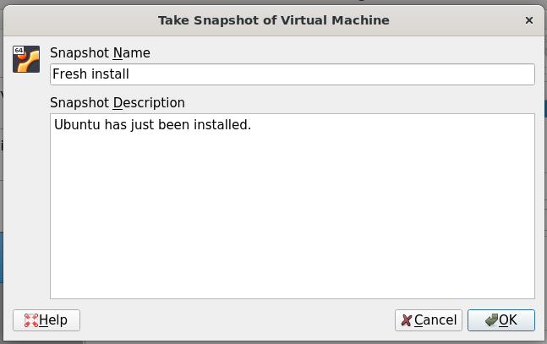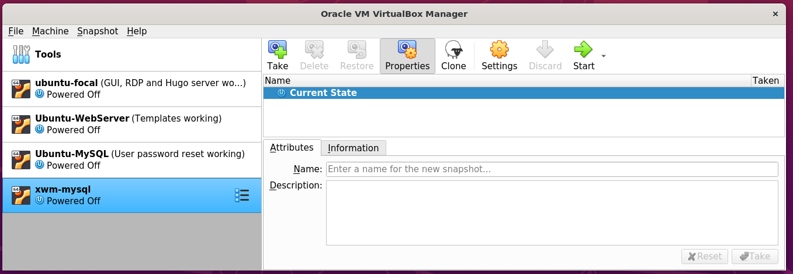

## Bridge the network connection

xwm-web is currently on it’s on virtual network.

To allow it to communicate with other devices on the network

right click xwm-web from Virtual Box’s left menu

and select settings

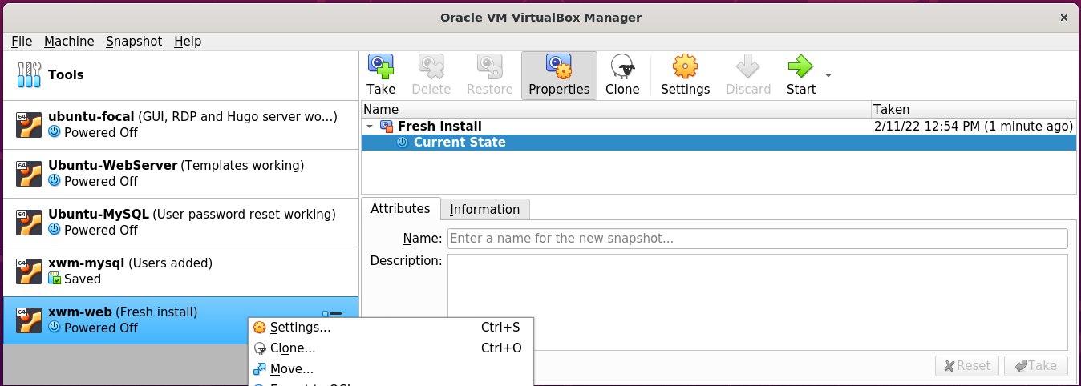

In Setting’s left menu

select Network

Set ‘Attached to’ to: Bridged-Adapter

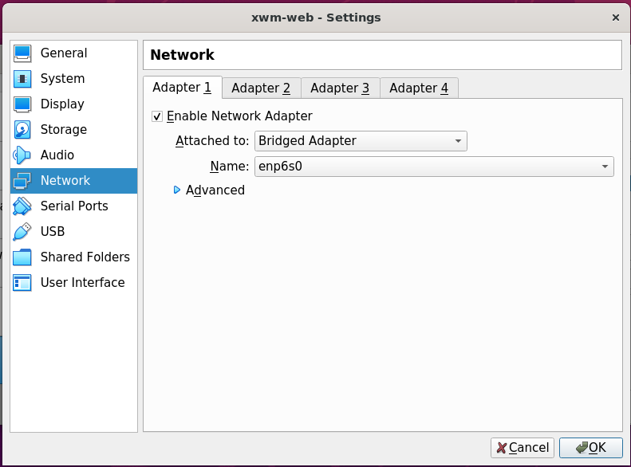

## Install deja-dup and do a backup

https://www.howtoinstall.me/ubuntu/18-04/deja-dup/

Start he virtual machine xwm-web

and terminal, run the following command:

sudo apt update

sudo apt install deja-dup

#### Example – Install deja dup

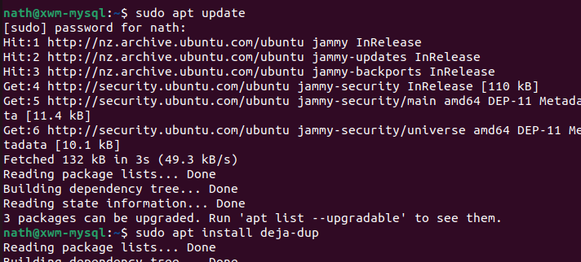

Once installed search for Backup

from Ubuntu’s Show Applications *(Start)* menu.

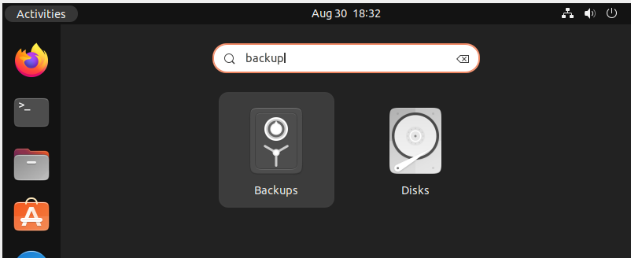

Click Create My First Backup

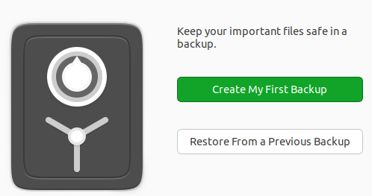

For the meantime, leave the default setting of my home folder: Home(nath)

as folders to be backed up.

In the future I will also need to back up the MySQL folders.

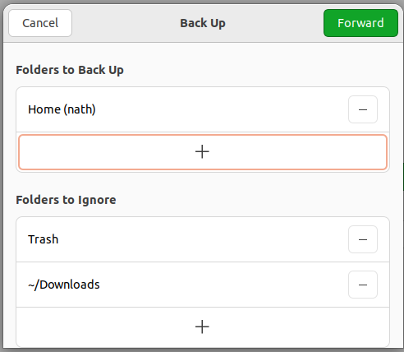

*Next, Select the storage location …*

Save backups to the USB drive

connected to the host machine Ubuntu-LAMP

Storage Location: Network Server

Network Location: smb://ubuntu-lamp.local/vm_backups

Folder: xwm-web

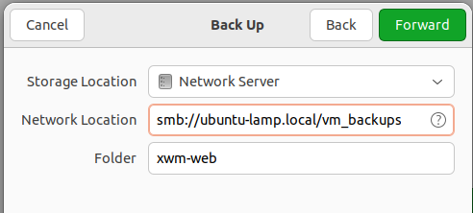

Authenticate as the user nath

on Ubuntu-LAMP

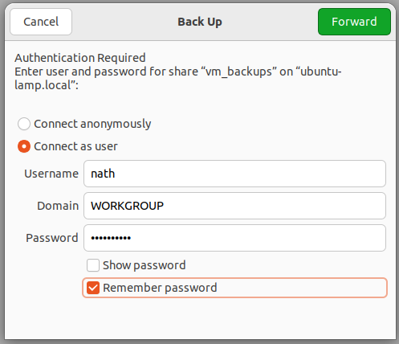

Create the password for the backup

for the virtual machine xwm-web

and select Remember password

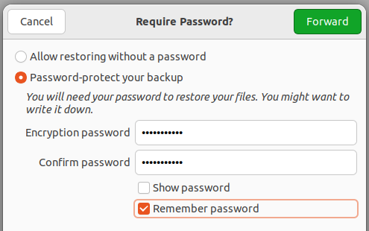

Once the backup completes

select Back up automatically

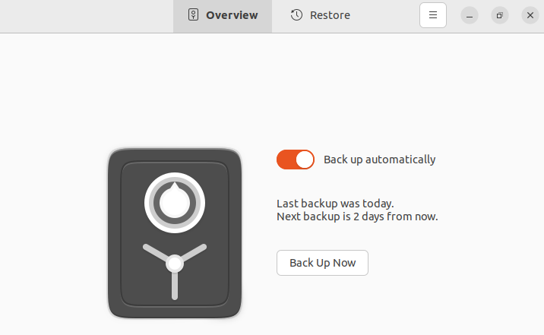

Take a snapshot of the virtual machine

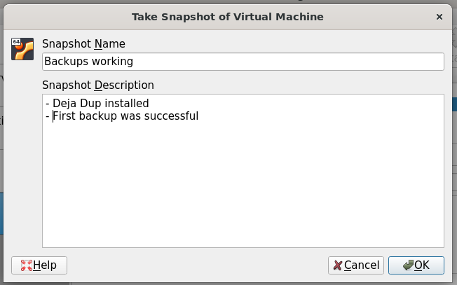

## Remote desktop using xRDP

Install xRDP *(and ‘snake oil’)*

then restart the server

sudo apt update

sudo apt -y install xrdp

sudo adduser xrdp ssl-cert

sudo systemctl restart xrdp

#### Example – install xRDP

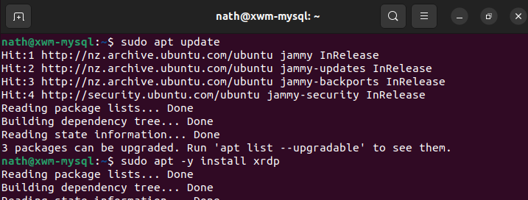

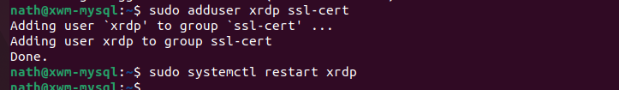

### Configure the firewall for RDP

To allow RDP connections, run the command:

sudo ufw allow 3389

sudo ufw enable

sudo ufw status

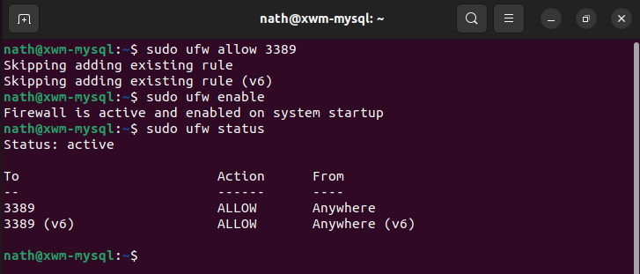

To allow the settings to refresh, restart xwm-web

*Next, Remote onto xwm-mysql …*

## Remote onto xwm-mysql

From Naths-Legion

Remote-desktop onto xwm-mysql

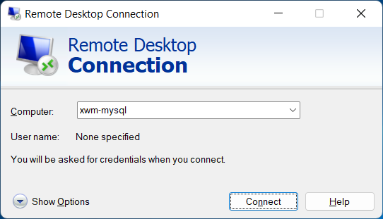

After accepting the connection certificate

xwm-web can be logged on to using remote desktop

from other devices *(eg Naths-Legion)*

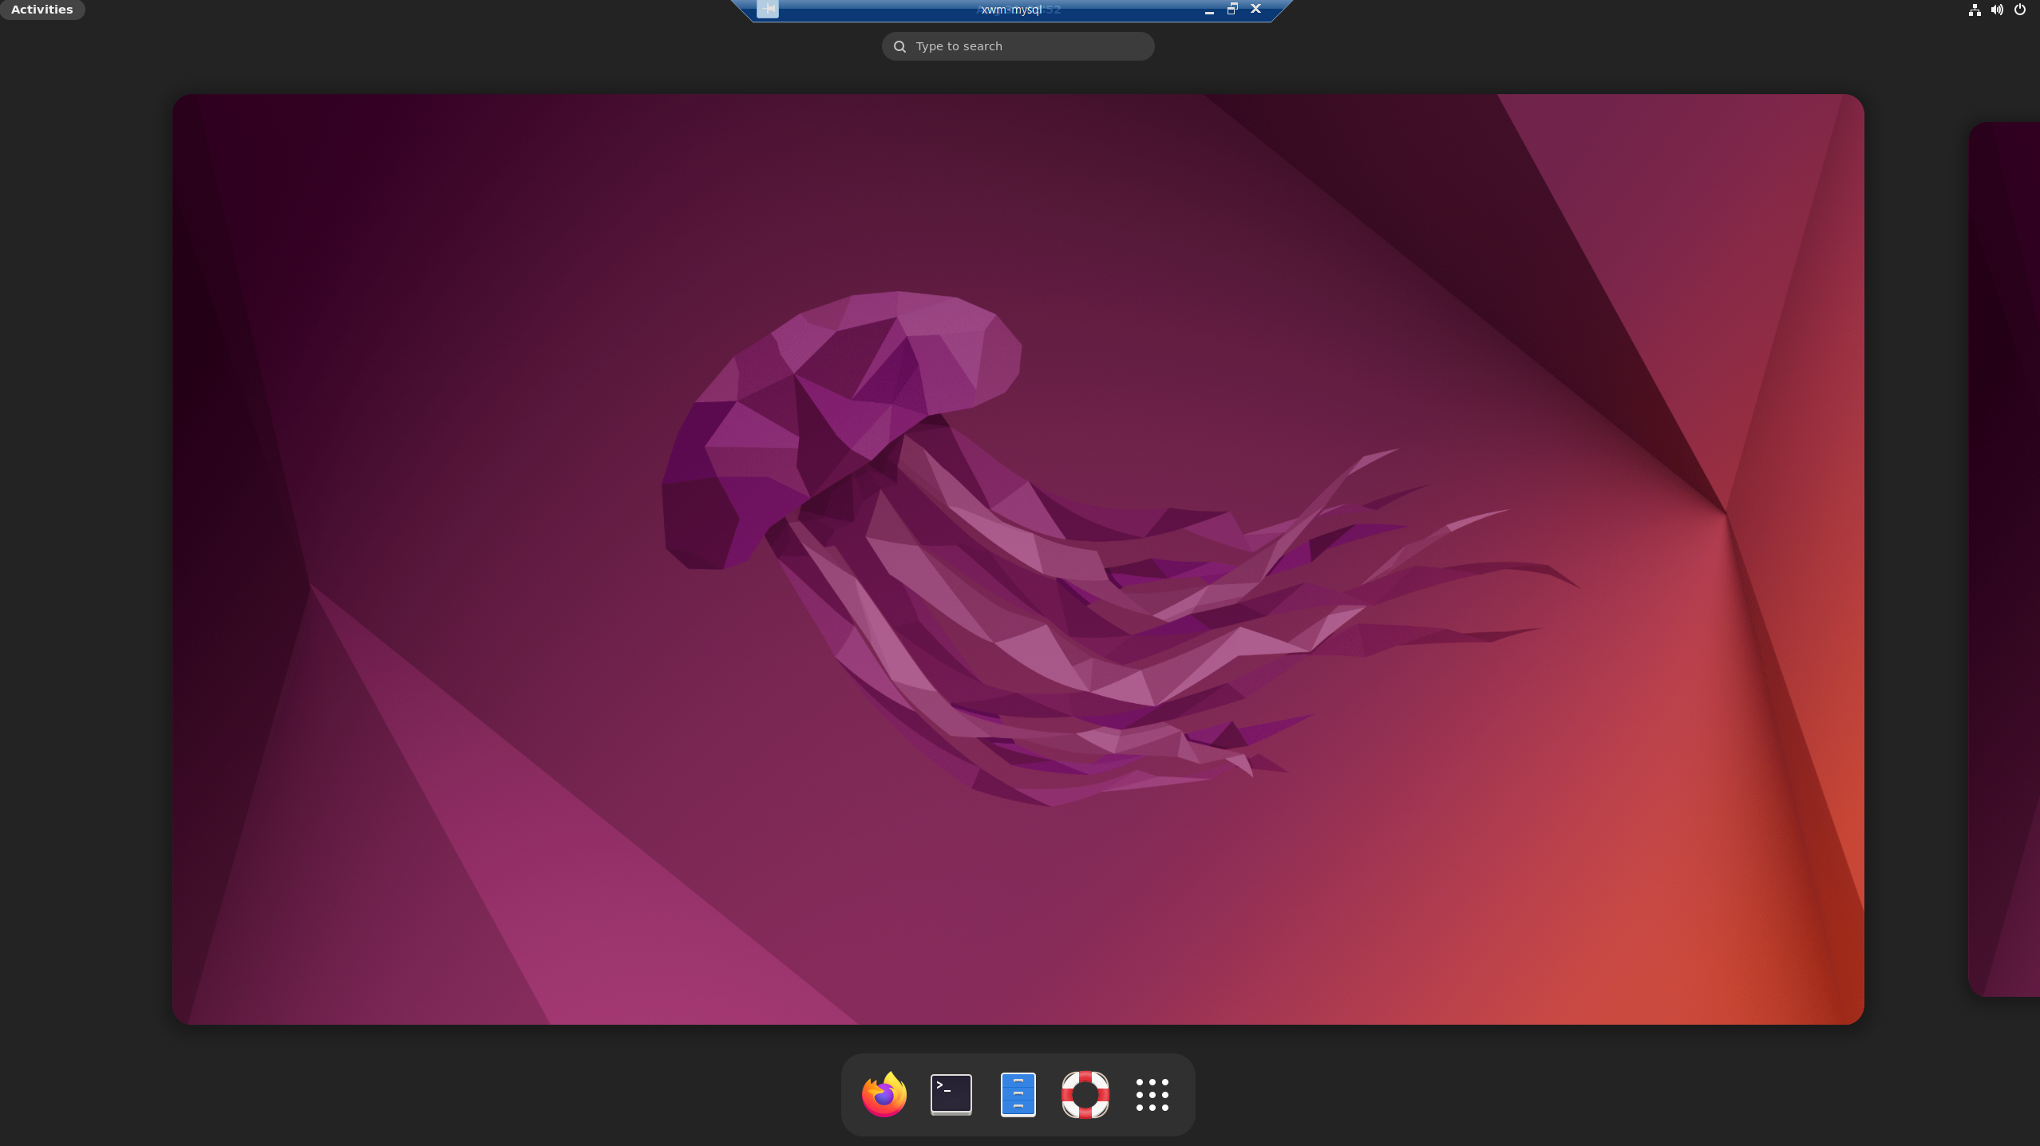

Create a snapshot and backup xwm-web

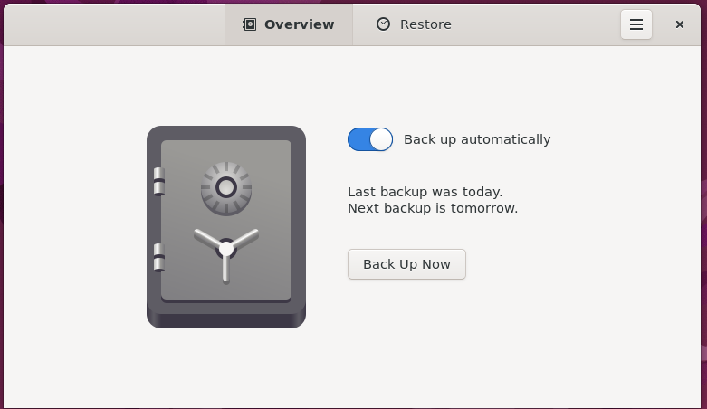

# Install Apache

## Overview

Apache is an open-source web server

that’s available for Linux servers free of charge.

The following goes through the steps

to set up the Apache server.

## Install Apache

To install Apache, install the latest meta-package apache2

by running:

sudo apt update

sudo apt install apache2

After letting the command run

all of the required packages are installed

Test it, by typing in the IP address for the web server

into a web browser.

IP: 192.168.178.48 *(for the virtual machine* ***xwm-web****)*

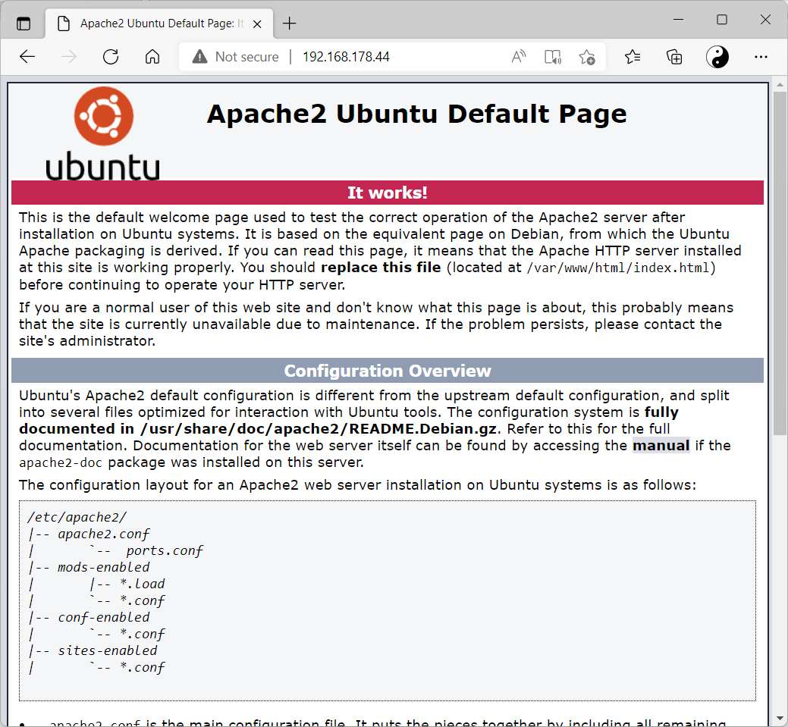

If you see this page

it means Apache has been successfully installed.

### Setting Up Virtual Hosts

When using the Apache2 web server

you can use ***virtual hosts*** to encapsulate configuration details

and host more than one domain from a single server.

We will set up a domain called: xwm-web

Instead of modifying **/var/www/html**,

create a directory structure within /var/www for the nathsweb site,

leaving /var/www/html in place as the default directory

to be served if a client request doesn’t match any other sites.

Create the directory for xwm-web as follows:

sudo mkdir /var/www/*your_domain*

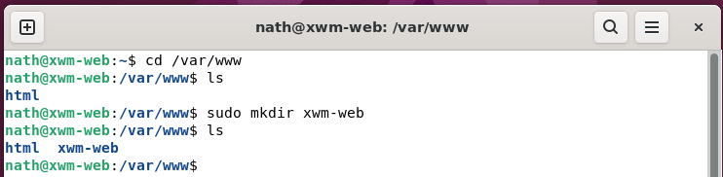

Next, assign ownership of the directory

with the $USER environment variable

sudo chown -R $USER:$USER /var/www/*sitename*

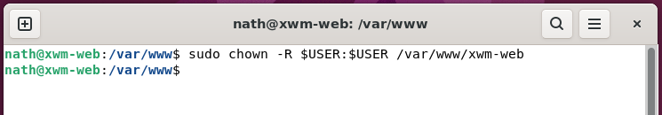

The permissions of your web roots should be correct if you haven’t modified your umask value,

which sets default file permissions.

To ensure that your permissions are correct

and allow the owner to read, write, and execute the files

while granting only read and execute permissions to groups and others,

you can run the following command:

sudo chmod -R 755 /var/www/*sitename*

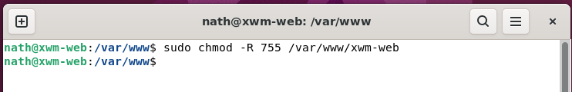

Next, create a sample index.html page

using Nano

sudo nano /var/www/your_domain/index.html

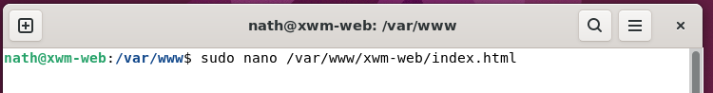

Add the following sample HTML

<html>

<head>

<title>Welcome to nathsweb</title>

</head>

<body>

<h1>Success! The nathsweb domain virtual host is working!</h1>

</body>

</html>

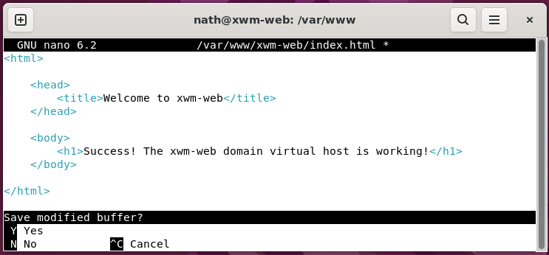

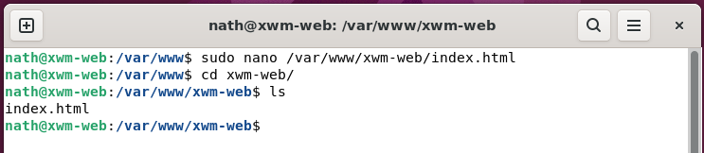

*Next, edit the virtual host file …*

In order for Apache to serve this content,

it’s necessary to create a virtual host file

with the correct directives.

Instead of modifying the default configuration file

located at **/etc/apache2/sites-available/000-default.conf**,

make a new one at **/etc/apache2/sites-available/xwm-web**

sudo nano /etc/apache2/sites-available/xwm-web.conf

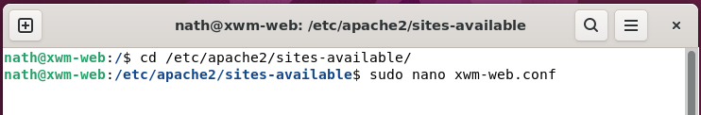

Copy the following configuration block, which is similar to the default,

but updated for our new directory and domain name.

<VirtualHost *:80>

ServerAdmin NathsLAMP@hotmail.com

ServerName xwm-web

ServerAlias www.xwm-web

DocumentRoot /var/www/xwm-web

ErrorLog ${APACHE_LOG_DIR}/error.log

CustomLog ${APACHE_LOG_DIR}/access.log combined

</VirtualHost>

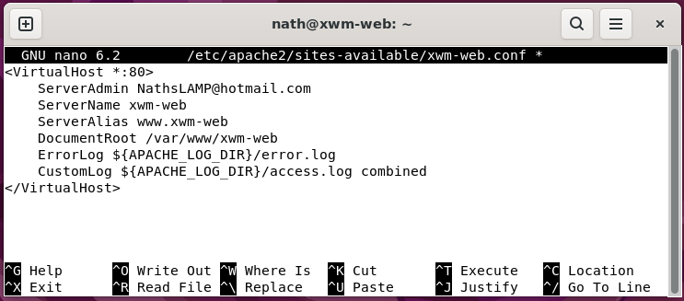

Notice that we’ve updated the **DocumentRoot** to our new directory

and updated **ServerAdmin** to an email that the xwm-web site administrator can access.

We’ve also added two directives:

**ServerName** which establishes the base domain

that should match for this virtual host definition.

**ServerAlias** which defines further names

that should match as if they were the base name.

Enable the file with the tool a2ensite

sudo a2ensite xwm-web.conf

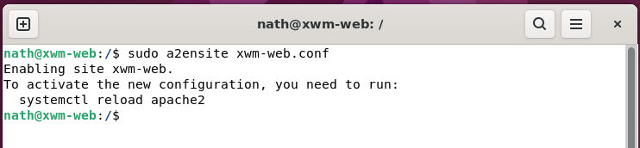

Restart Apache to implement your changes:

sudo systemctl restart apache2

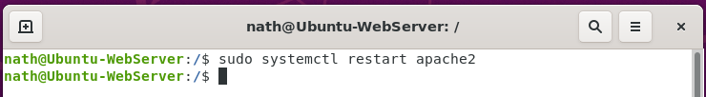

## Test the site

1. Restart the server
2. Clear the Firefox browser cache by clicking:

Settings > Privacy & Security > Cookies & Site Data > Clear Data

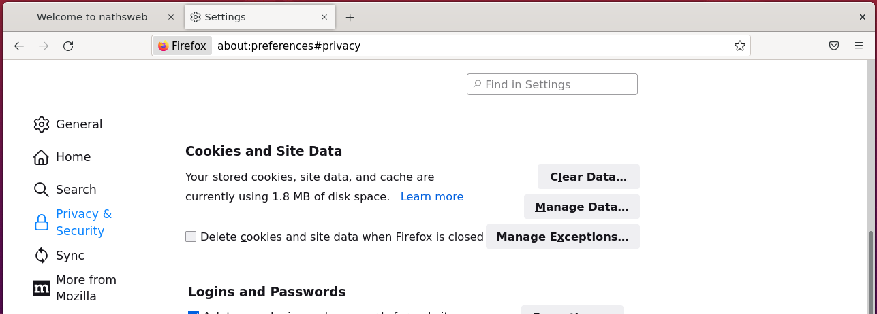

1. The following will display the website

URL: <http://xwm-web>

#### Test – xwm-web is displayed on local web browser

Test from xwm-web - okay

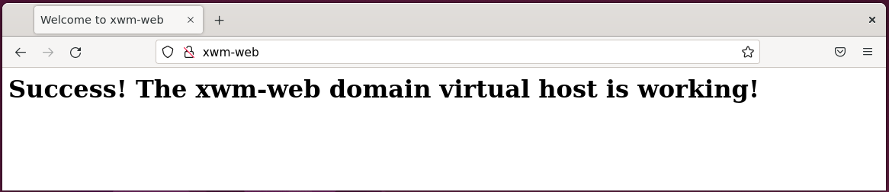

Using the IP address will also work from other devices on the same subnet

providing the firewall has been configured

to allow http data.

Configure the firewall to allow http and https.

sudo ufw allow http

sudo ufw allow https

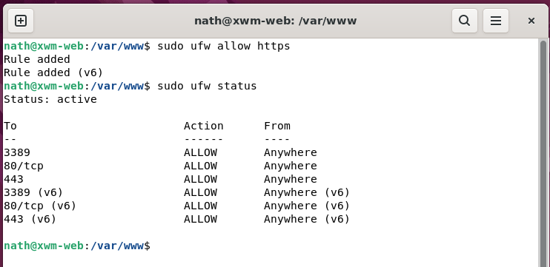

#### Test – xwm-web is displayed on another device’s web browser

Test from Naths-Legion - okay

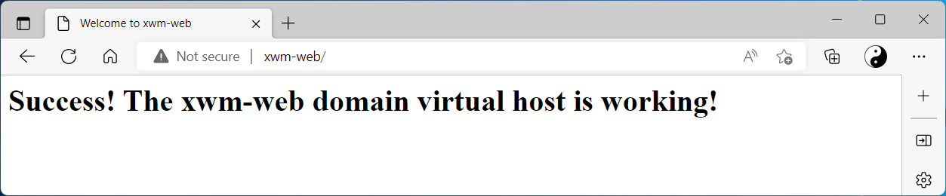

Take a snap shot and backup the virtual machine xwm-web

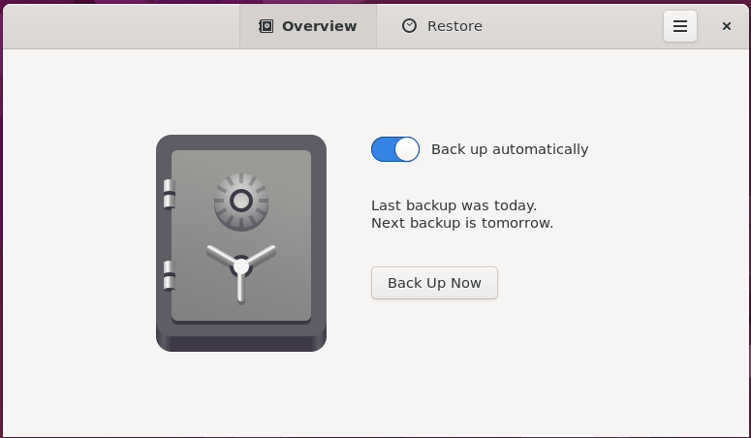

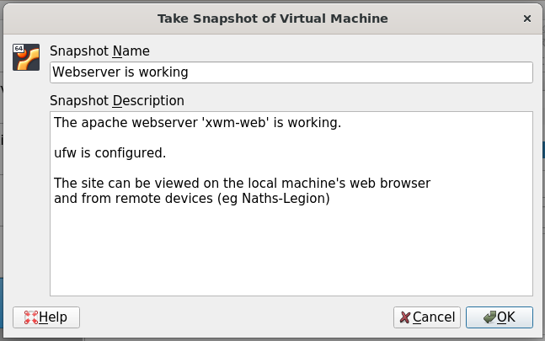

## Install Visual Studio code

To install Visual Studio Code

run the following command

sudo snap install code --classic

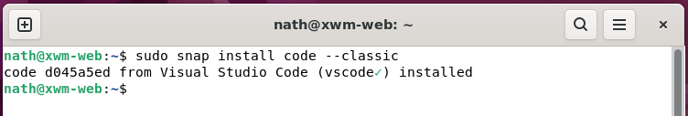

Once installed Visual Studio Code can be run from the start menu

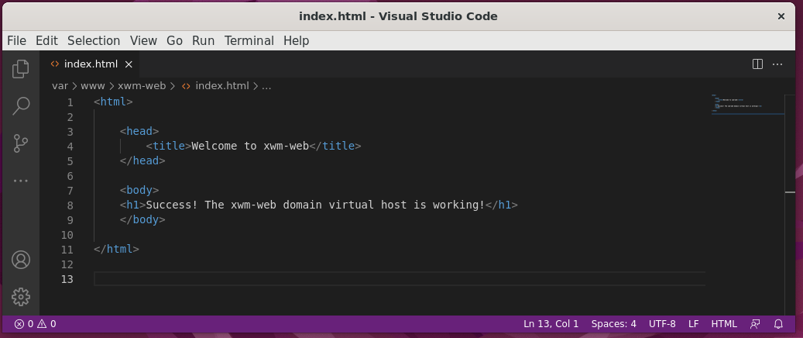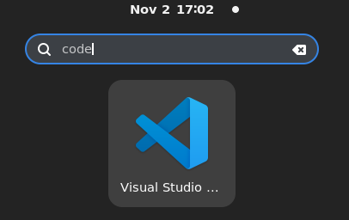

Take a snap shot and backup the virtual machine xwm-web



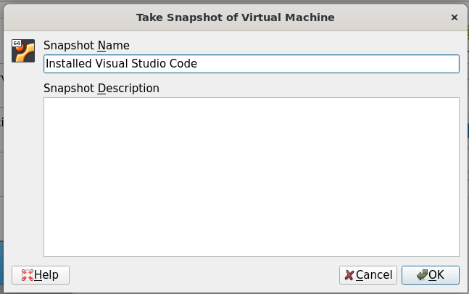

# Install MySQL

Although MySQL will not be running on xwm-web

it’s really handy to have it installed

so remote tests to the MySQL server can be conducted.

When new code that communicates with the MySQL server xwm-mysql

is being developed, it’s important to know if issues are:

* code bugs
* a network issue
* a problem on the MySQL server

## Install MySQL on xwm-web

To install MySQL run the following command

sudo apt update

sudo apt install mysql-server

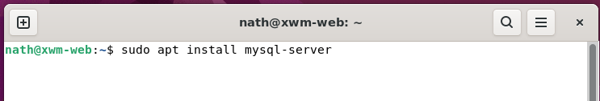

Check MySQL’s status, by running the command

sudo service mysql status

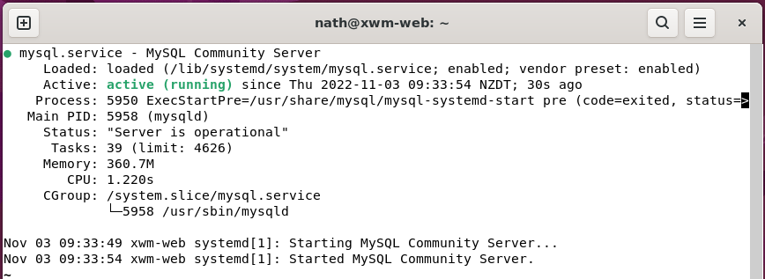

If the MySQL server is not running correctly

the following command will restart it:

sudo service mysql restart

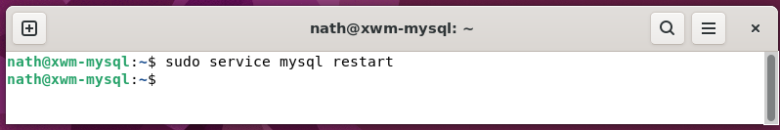

*Next, Connect to a remote MySQL server …*

## Connect to a remote MySQL server

Now MySQL server has been installed on the web server xwm-web

connect to the remote MySQL server xwm-mysql

using the following command

mysql -h xwm-mysql -u admin -p

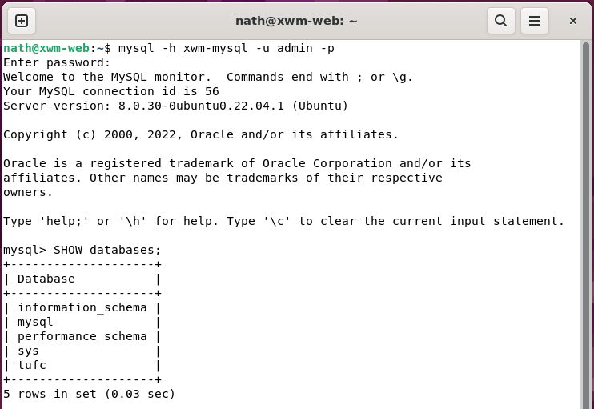

#### Create a snapshot and backup xwm-web

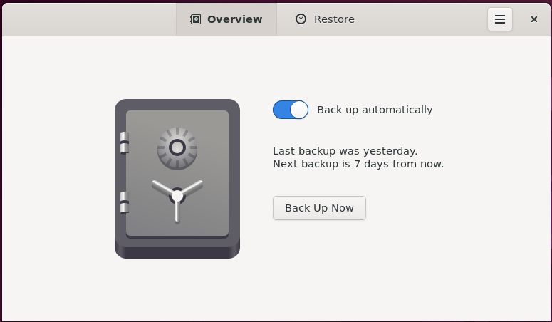

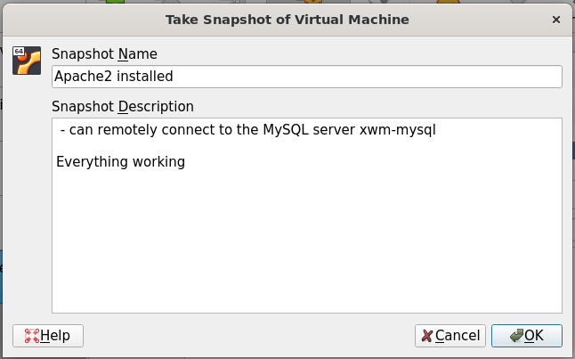

# Create the folder ‘examples’

I have a good understanding of the principles of:

* HTML
* CSS
* Javascript
* PHP

However, web design is not my field of expertise.

and this is the perfect opportunity for me to become more familiar.

I like the idea of creating the folder examples

in the root directory of the website xwm-web

That way I can quickly find examples of code

to create the design the website.

#### Example – Create the folder examples

Create the folder examples

cd /var/www/xwm-web/

mkdir examples

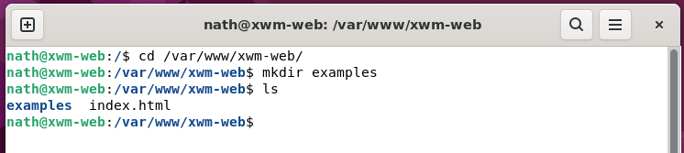

In the folder examples create the sub-folders:

html

css

javascript

php

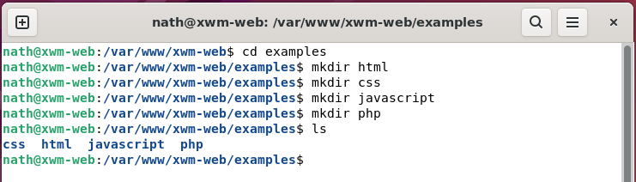

I will start the web page xwm-web design

by creating a few HTML page examples.

This will give me an opportunity to revise HTML

and provide good codes examples

when I need them in the future.

*Next, Create the HTML page ‘1–first_page.html’ …*

# HTML

### First HTML page

#### Example – HTML page creation

To create the HTML page 001–firstpage.html:

open VS Code

press Ctrl+N *(to create a new file)*

click *‘Select a language’*

then type *‘HTML’*

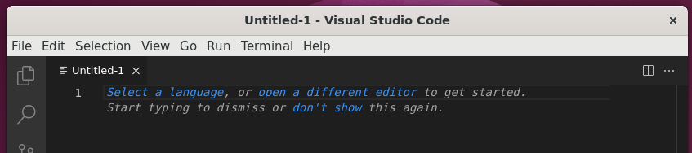

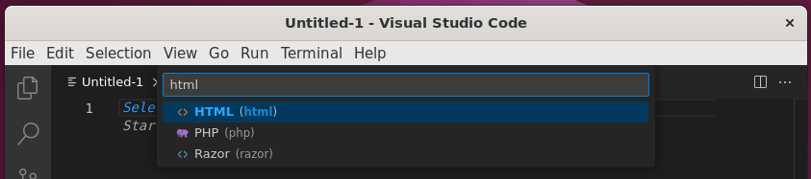

Save the file as: /var/www/xwm-web/examples/1-HTML/001-firstpage.html

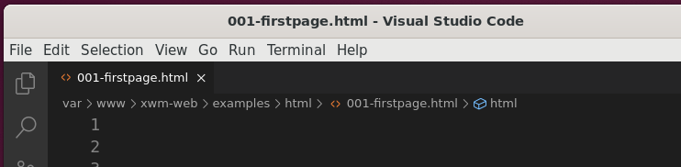

*Next, Create the first HTML page example …*

#### Example – Create the first HTML page

Location: /var/www/xwm-web/examples/html/001-firstpage.html

URL: http://xwm-web/examples/html/001-firstpage.html

As the first HTML page, enter the following code:

<!doctype html>

<html>

<head>

<title>Firstpage</title>

</head>

<body>

<h1>Firstpage</h1>

<p>This is the first HTML example.</p>

</body>

</html>

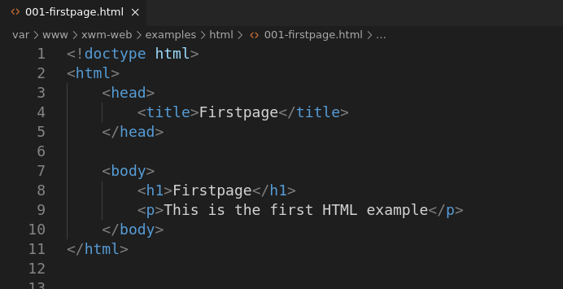

Enter the address of the page in to the web browser

in the format: *http://servername/folderpath/pagename*

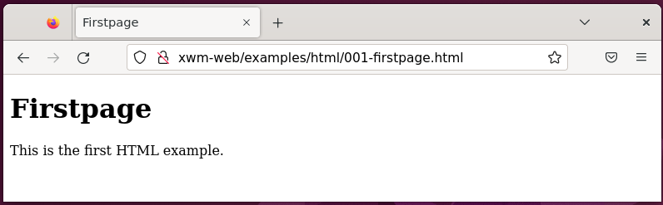

NOTE: The files path can be copied from the tab at the top of the GUI

containing the filename.

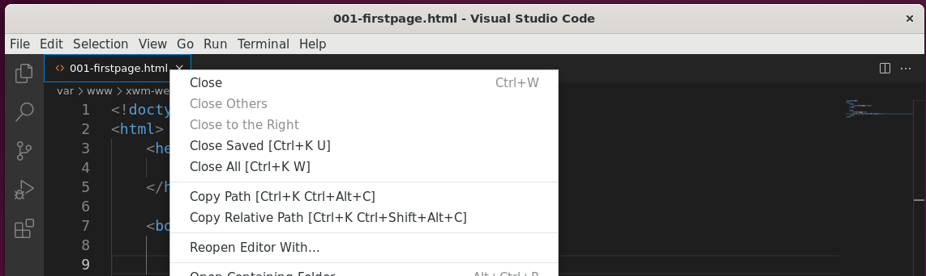

### Table

#### Example – Create a HTML table

Location: /var/www/xwm-web/examples/html/002-table.html

URL: http://xwm-web/examples/html/002-table.html

To create a HTML table, enter the following code:

<!doctype HTML>

<html>

<head>

<title>Table</title>

</head>

<body>

<h1>HTML Table</h1>

<table>

<tr>

<th>Company</th>

<th>Founder</th>

</tr>

<tr>

<td>Microsoft</td>

<td>Bill Gates</td>

</tr>

<tr>

<td>Apple</td>

<td>Steve Jobs</td>

</tr>

<tr>

<td>Tesla</td>

<td>Elon Musk</td>

</tr>

</table>

</body>

</html>

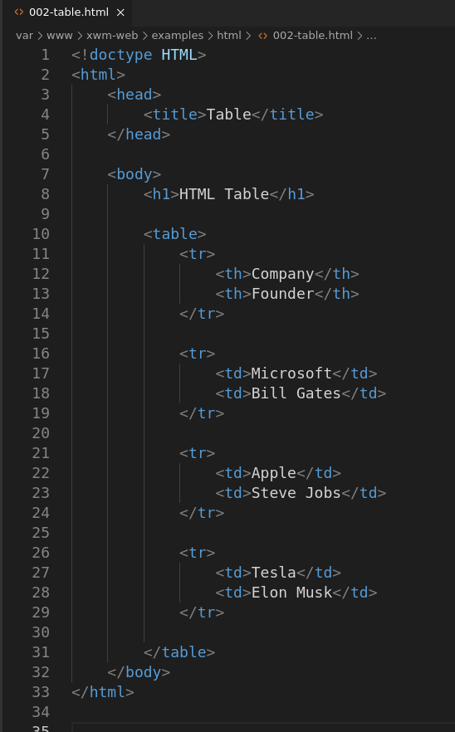

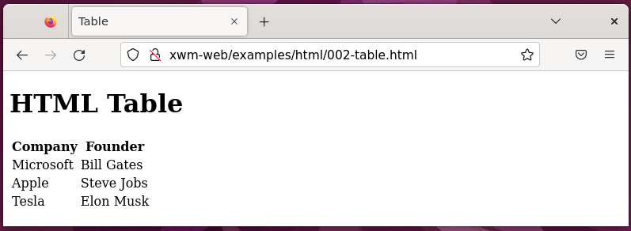

### Link

#### Example – Create a HTML link

Location: /var/www/xwm-web/examples/html/002-table.html

URL: http://xwm-web/examples/html/002-table.html

To create a HTML table, enter the following code:

<!doctype html>

<html>

<head>

<title>HTML Link</title>

</head>

<body>

<h1>HTML Link</h1>

<p>Here is a link to the <a href="/index.html">index</a> page.</p>

</body>

</html>

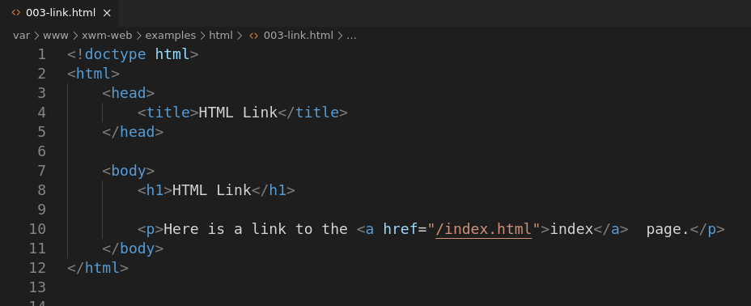

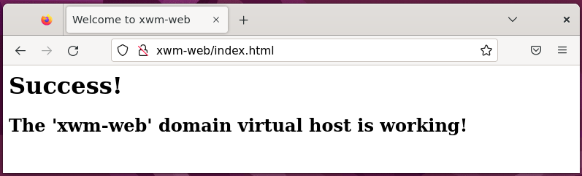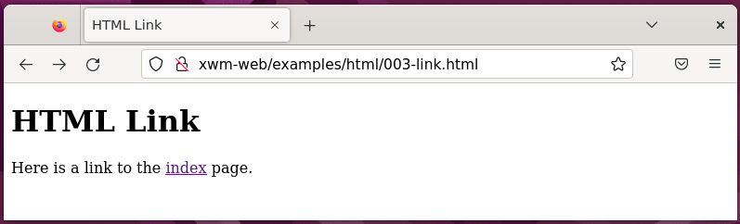

### Image

#### Example – Create an Image

Location: /var/www/xwm-web/examples/html/003-image.html

URL: http://xwm-web/examples/html/003-image.html

Create the folder: /var/www/xwm-web/images

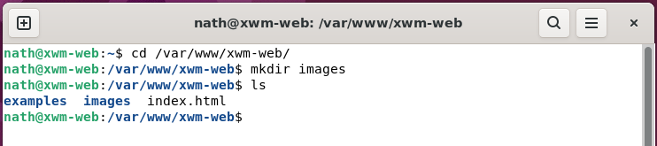

In the new folder /var/www/xwm-web/images

add the image Flex.jpg

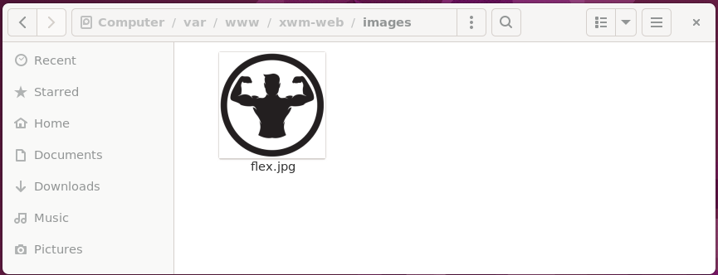

#### Example – Display an image

To display the image flex.jpg

in the file /var/www/xwm-web/examples/html/003-image.html

enter the following code:

<!doctype html>

<html>

<head>

<title>Image</title>

</head>

<body>

<h1>Display an image</h1>

<img src="/images/flex.jpg" alt="Image of flex.jpg"

width="250" height="250">

</body>

</html>

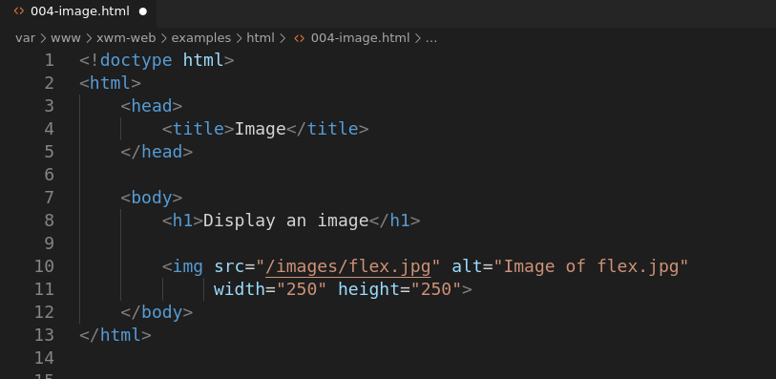

# CSS

CSS complements HTML

by providing a look and feel to web pages.

### CSS Comments

Comments in CSS are opened with /* and closed with */

### Inline CSS

#### Example – Inline CSS

Location: /var/www/xwm-web/examples/css/001-inline_css.html

URL: http:// xwm-web/examples/css/001-inline_css.html

To add CSS to a single element, use inline CSS

as shown in the following example.

<!doctype html>

<html>

<head>

<title>Inline CSS</title>

</head>

<body>

<h1>Inline CSS</h1>

<div style="font-weight: bold;">This is an example webpage. </div>

<br>

<div>That uses <span style="font-style: italic;"> Inline CSS.</span></div>

</body>

</html>

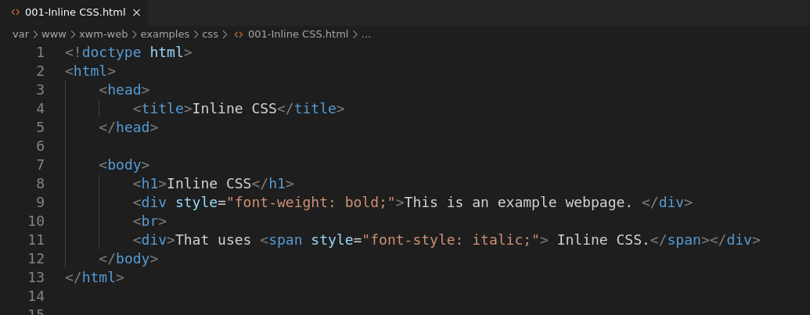

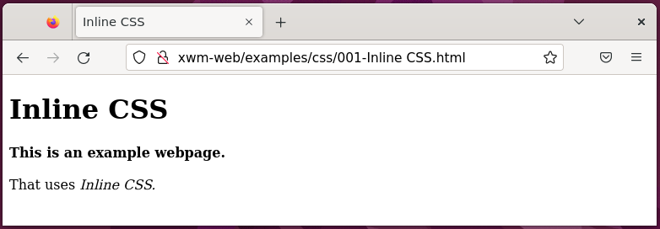

*Next, Internal CSS …*

### Internal CSS

#### Example - Internal CSS

Location: /var/www/xwm-web/examples/css/002-internal_css.html

URL: http://xwm-web/examples/css/002-internal_css.html

<!DOCTYPE html>

<html>

<head>

<title>Internal CSS</title>

<style type="text/css">

div{

font-weight: bold;

}

span{

font-style: italic;

}

</style>

</head>

<body>

<h1>Internal CSS</h1>

<p>This is an example webpage. </p>

<br>

<div>That uses <span>Internal CSS.</span></div>

</body>

</html>

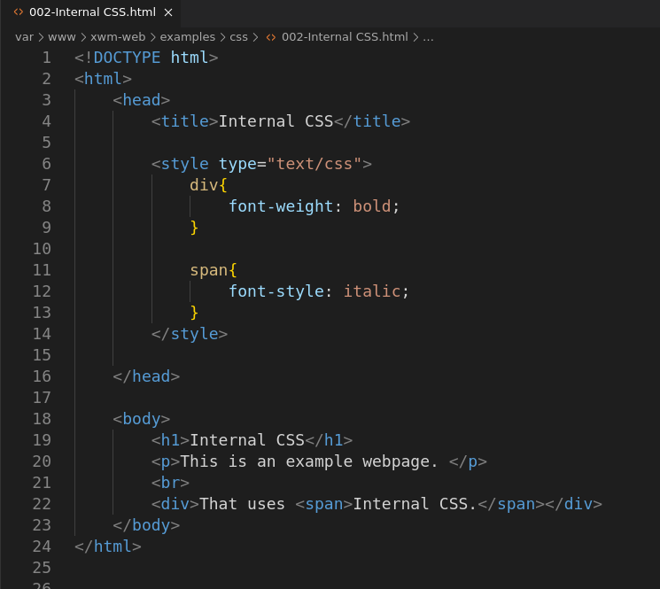

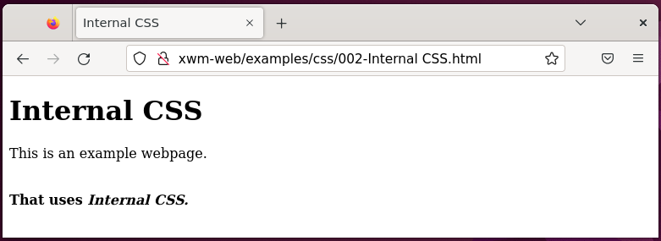

### External CSS

You can also use external style sheets

to share CSS among multiple pages

using the element <link>

You don’t need to include opening or closing <style> elements

within an external style sheet.

*Example - External CSS*

Location 1: /var/www/xwm-web/examples/css/003-external_css.html

Location 2: /var/www/xwm-web/examples/css/003-external_css.css

URL: http://xwm-web/examples/css/003-external_css.html

003-external_css.html

<!DOCTYPE html>

<html>

<head>

<Title>External Style Sheet</Title>

<link rel="stylesheet" href="003-external_css.css">

</head>

<body>

<h1>External Style Sheet</h1>

<div>This page has an external style sheet</div>

</body>

</html>

003-external_css.css

body{

font-family: Arial, Helvetica, sans-serif;

}

div{

font-style: italic;

}

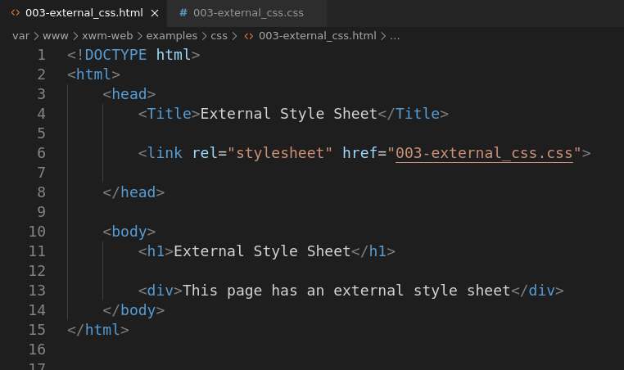

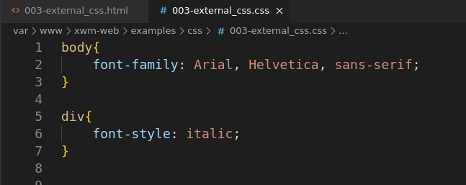

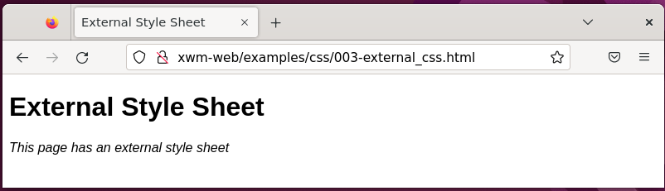

### Element selectors

#### Example – Element selector

body{

font-family: Arial, Helvetica, sans-serif;

}

div{

font-weight: bold;

font-style: italic;

}

### Individual element selector

Individual element selectors are defined

using a hash symbol ‘**#**’

When using an id it should only be used once

on the entire page.

#### Example - Individual element selector

Location: /var/www/xwm-web/examples/css/04-select_individual_elements.html

URL: http://xwm-web/examples/css/04-select_individual_elements.html

<!DOCTYPE html>

<html>

<head>

<title>Select Individual Elements</title>

<style>

#myName{

font-weight: bold;

}

</style>

</head>

<body>

<h1>Select Individual Elements</h1>

<p>My name is <span id="myName">Nath</span> </p>

</body>

</html>

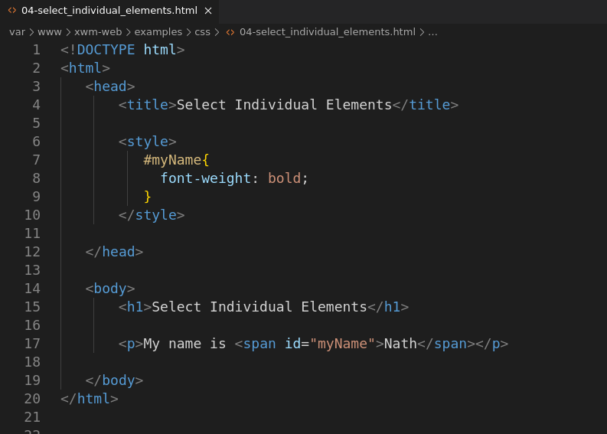

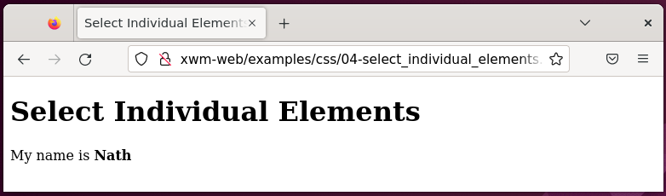

*Next, Class …*

### Class (multiple element selector)

The CSS selector **class**

is used to select multiple elements

and apply a style to them.

Classes are defined with a dot ‘**.**’

at the beginning of the classes name.

#### Example – CSS Class

Location: /var/www/xwm-web/examples/css/005-css_class.html

URL: html://xwm-web/examples/css/005-css_class.html

<!DOCTYPE html>

<html>

<head>

<title>CSS Class</title>

<style>

.boldAndItalic{

font-weight: bold;

font-style: italic;

}

</style>

</head>

<body>

<h1>CSS Class</h1>

<div class="boldAndItalic" > This text has a CSS class.</div>

<br>

<div>This text has no CSS class.</div>

</body>

</html>

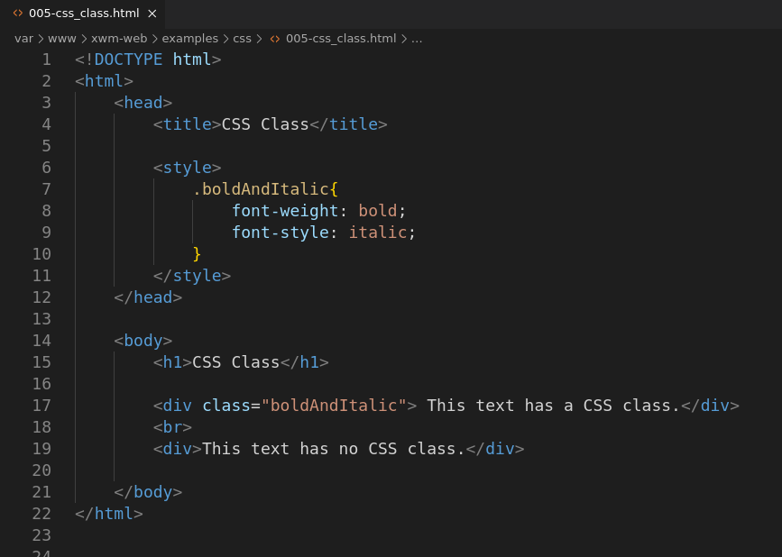

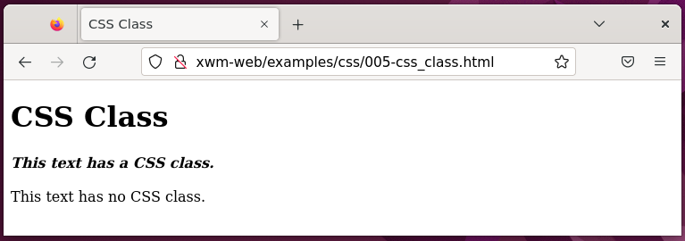

### Font-Family Selection

#### Example – Font-Family Selection

Location: /var/www/xwm-web/examples/css/006-font_family_selection.html

URL: http://xwm-web/examples/css/006-font_family_selection.html

<!doctype html>

<html>

<head>

<Title>Font-Family Selection</Title>

<Style>

body{

font-family: Arial, Helvetica, sans-serif;

}

</Style>

</head>

<body>

<h1>Font-Family Selection</h1>

<p>This page has font-family set to 'Arial, Helvetica, sans-serif', <br>

on the element selector 'body'.</p>

</body>

</html>

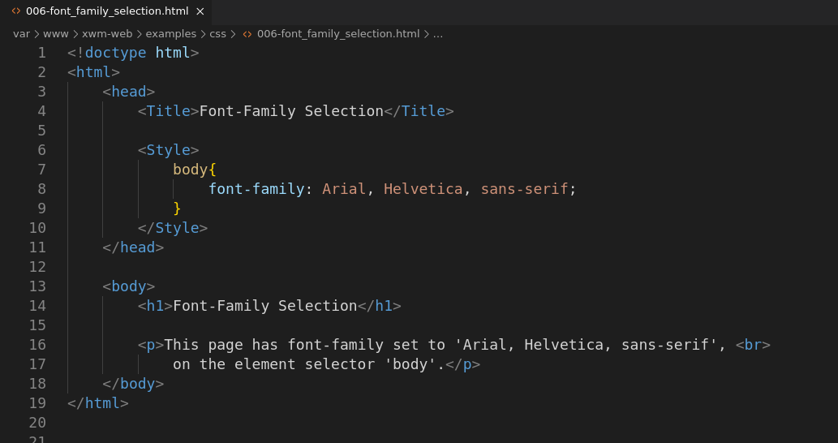

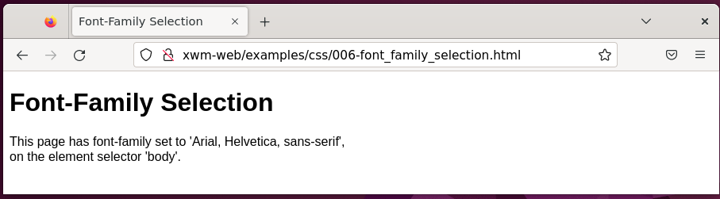

### Font Size

Font sizes can be set in one of four units:

* Percentage %
* Pixels px
* Points pt
* Em’s em

#### Example – Font Size

Location: /var/www/xwm-web/examples/css/007-font_size.html

URL: http://xwm-web/examples/css/007-font_size.html

<!doctype html>

<html>

<head>

<title>Font Size</title>

<style>

body{

font-size: 110%;

}

span{

font-size: 125%;

}

</style>

</head>

<body>

<h1>Font Size</h1>

<p>This page has <span>font-size</span> set using percentages. <p>

<p>Font sizes can be set in one of four units: <p>

<table>

<tr>

<td>Pixels</td>

<td>px</td>

</tr>

<tr>

<td>Points</td>

<td>pt</td>

</tr>

<tr>

<td>Em's</td>

<td>em</td>

</tr>

<tr>

<td>Percentage</td>

<td>%</td>

</tr>

</table>

</body>

</html>

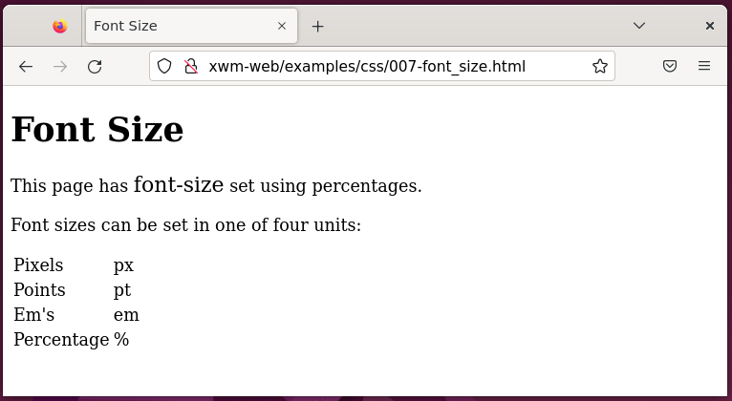

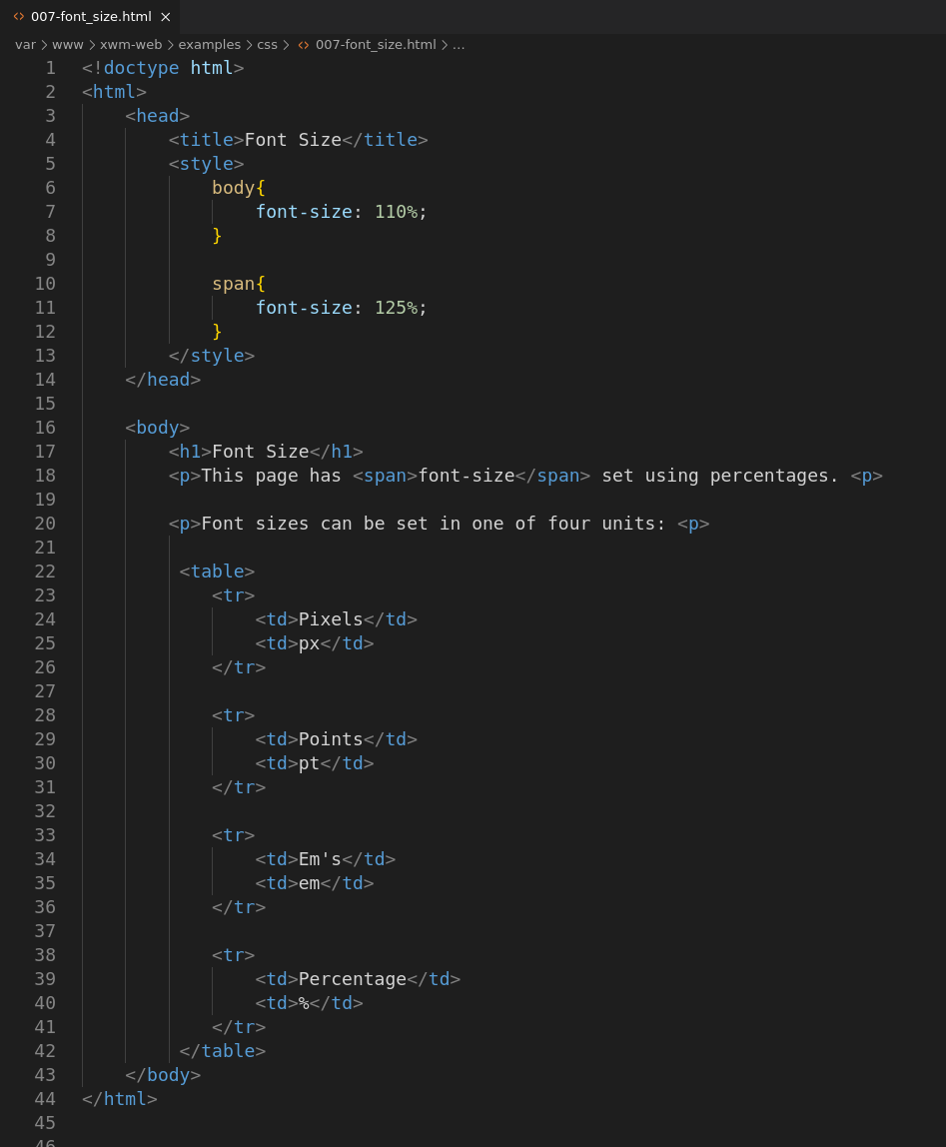

### Font Color

You can use a friendly name for common colours, such as:

* Red
* Blue
* Green

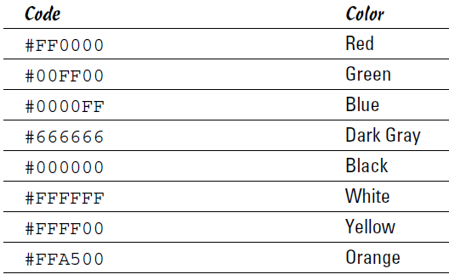or you can use a hex code

#### Example – Setting colours

Location: /var/www/xwm-web/examples/css/008-color.html

URL: http://xwm-web/examples/css/008-color.html

<!doctype html>

<html>

<head>

<title>Color</title>

<style>

h1{

color: blue;

}

</style>

</head>

<body>

<h1>Color </h1>

<p style="color: red;" > The literal colour: 'red'</p>

<p style="color: #00FF00;">The hex colour green: #00FF00</p>

</body>

</html>

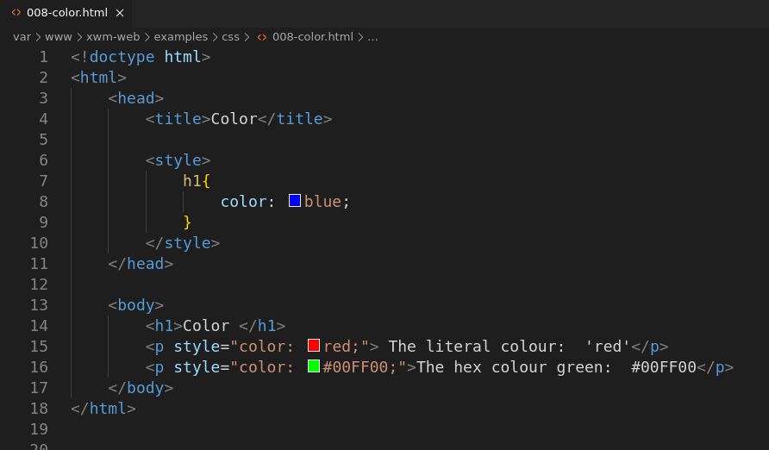

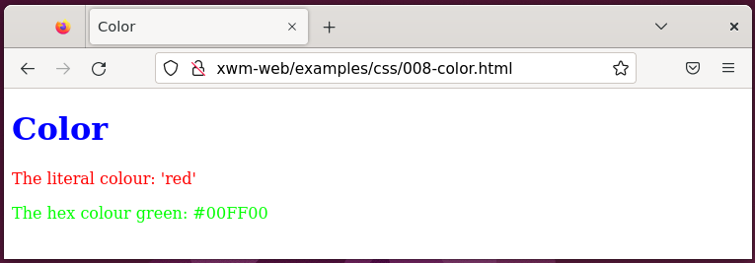

### Borders

When creating a border with CSS, you set three things:

* thickness
* style
* color

These three items are set in a list

and separated by a space.

border: 1px solid black;

### Border Styles

#### Example – Border

Location:

URL:

<!doctype html>

<html>

<head>

<title>Border</title>

<style>

.myBorder{

border: 1px solid blue;

padding: 5px;

}

</style>

</head>

<body>

<h1>Borders</h1>

<p class="myBorder" >This text has a blue border</p>

</body>

</html>

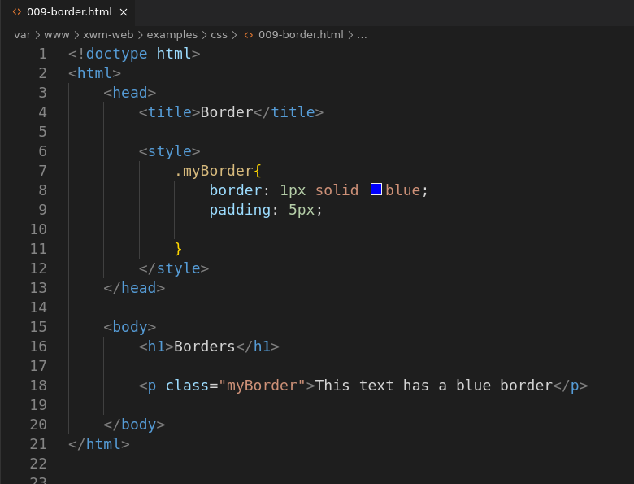

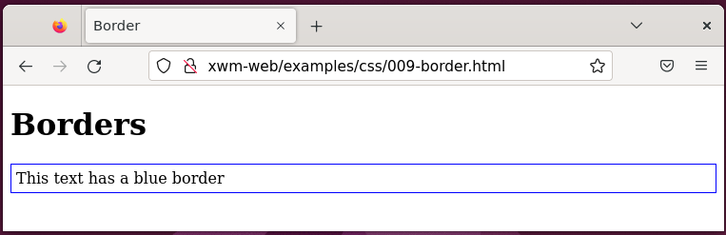

### List (list styles)

The bullet style for a list

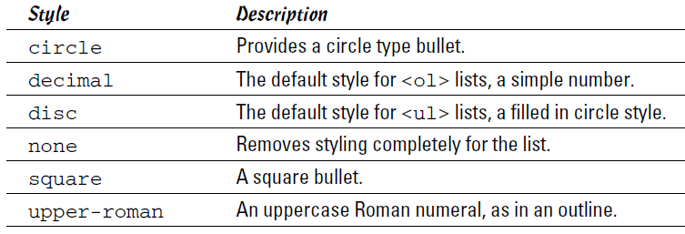is determined by the CSS property list-style-type

#### Example – List styles

Location: /var/www/xwm-web/examples/css/010-list_styles.html

URL: http://xwm-web/examples/css/010-list_styles.html

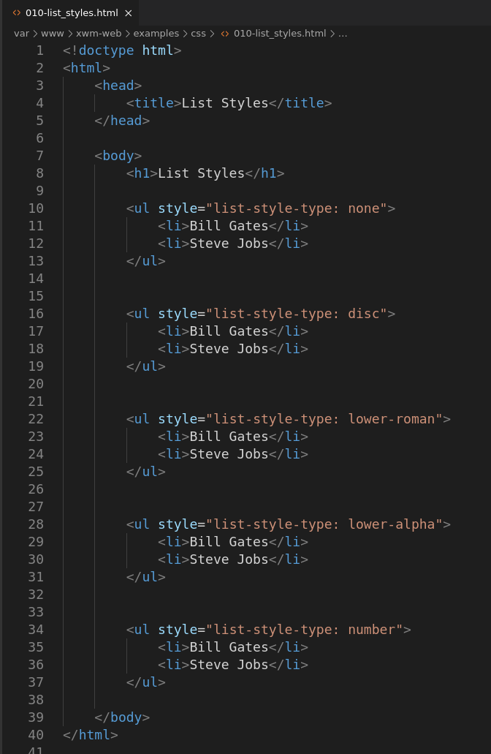<!doctype html>

<html>

<head>

<title>List Styles</title>

</head>

<body>

<h1>List Styles</h1>

<ul style="list-style-type: none" >

<li>Bill Gates</li>

<li>Steve Jobs</li>

</ul>

<ul style="list-style-type: disc" >

<li>Bill Gates</li>

<li>Steve Jobs</li>

</ul>

<ul style="list-style-type: lower-roman" >

<li>Bill Gates</li>

<li>Steve Jobs</li>

</ul>

<ul style="list-style-type: lower-alpha" >

<li>Bill Gates</li>

<li>Steve Jobs</li>

</ul>

<ul style="list-style-type: number" >

<li>Bill Gates</li>

<li>Steve Jobs</li>

</ul>

</body>

</html>

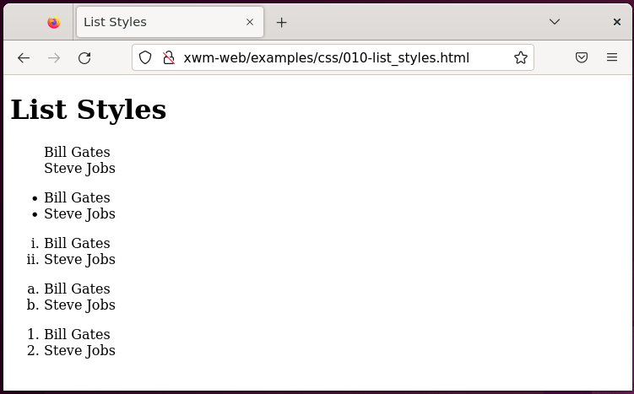

### Add a Background

You can change the color of the background using CSS

or use a background image.

#### Example – Background colour

Location: /var/www/xwm-web/examples/css/011a-background_color.html

URL: <http://xwm-web/examples/css/011a-background_color.html>

<!DOCTYPE html>

<html>

<head>

<title>Background Color</title>

<style>

body{

background-color: lightblue;

}

</style>

</head>

<body>

<h1>Background Color</h1>

<p style="background-color: lightgrey;" >This page and text have backgound colors.</p>

</body>

</html>

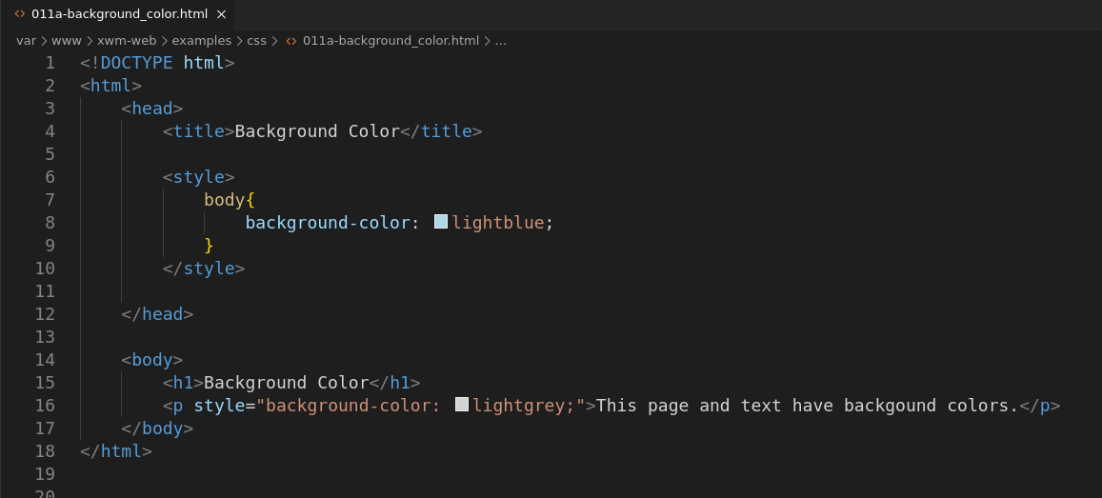

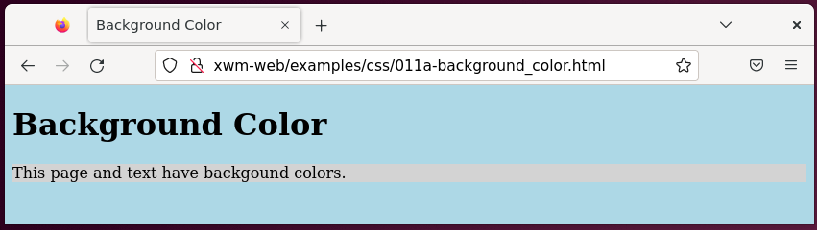

### Background image

Images can be set as a background

using CSS.

#### Example – Background Image

Location: /var/www/xwm-web/examples/css/012-background_image.html

URL: http:// xwm-web/examples/css/012-background_image.html

<doctype html>

<html>

<head>

<title>Background Image</title>

<style>

body{

background-image: url("/images/flex.jpg");

background-repeat: no-repeat;

background-color: lightgray;

background-position: center top;

}

</style>

</head>

<body>

<h1>Background Image</h1>

<p style="color: red;">Here is some text over over the background image</p>

</body>

</html>

</doctype>

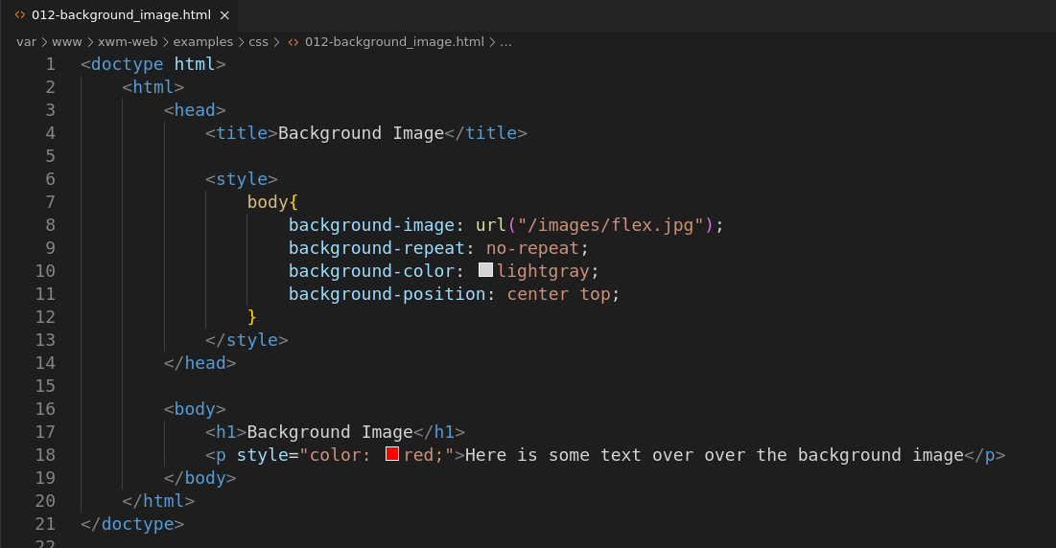

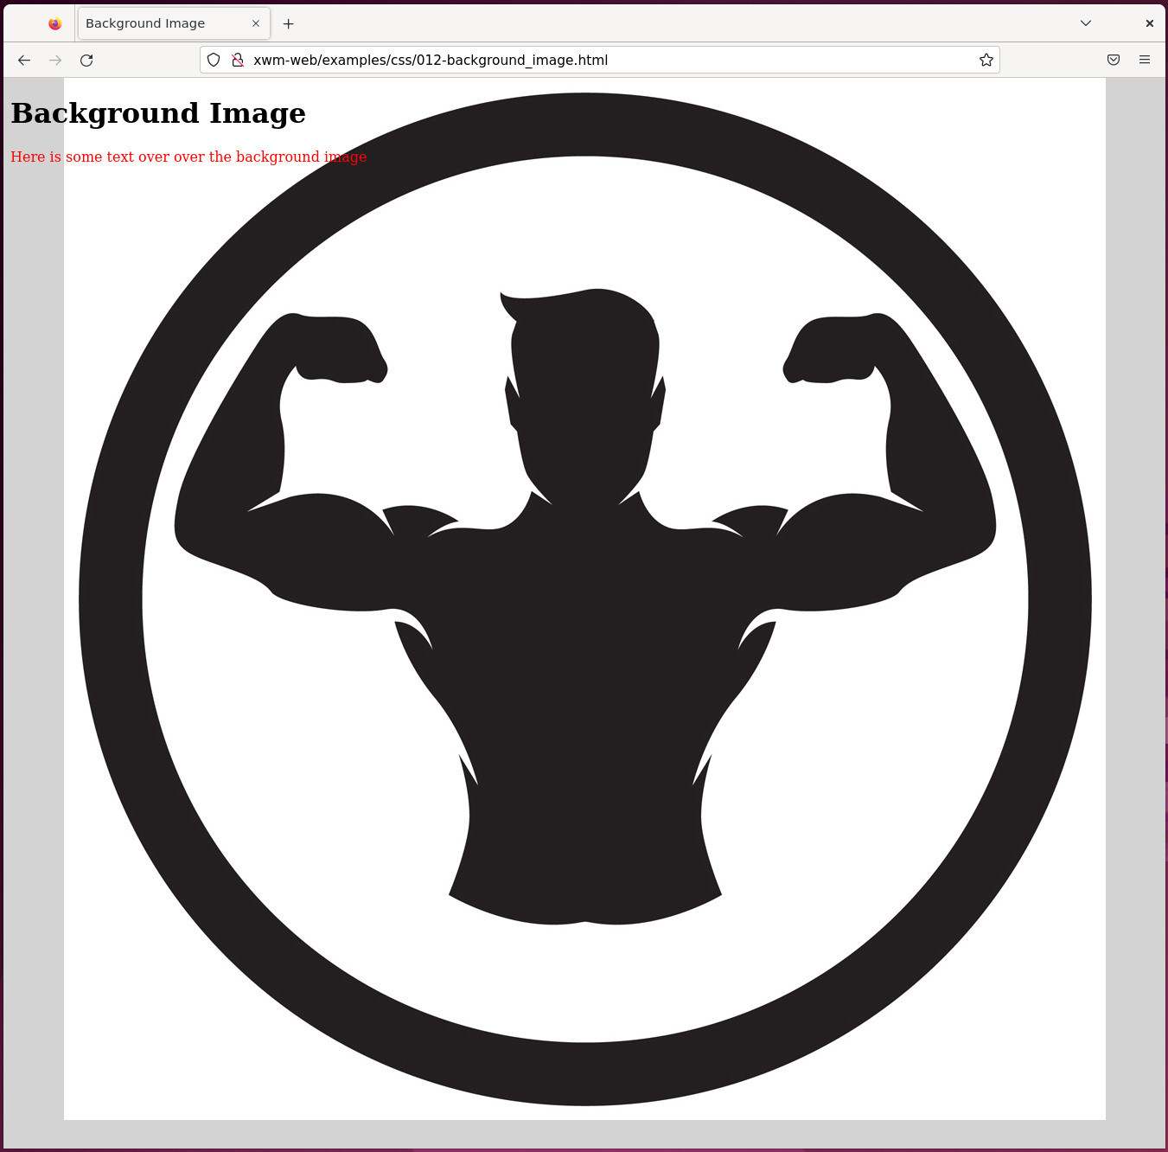

## Page Layouts

You can create column effects,

where there’s a menu on one side

and content in the other column.

You can control that alignment with CSS.

#### Example: Page Layout – Single Column

Location: /var/www/xwm-web/examples/css/013-page_layout_single_column.html

URL: http://var/www/xwm-web/examples/css/013-page_layout_single_column.html

<!doctype html>

<html>

<head>

<title>Page Layout - Single Column</title>

<style>

body{

font-family: Arial, Helvetica, sans-serif;

}

#container{

margin: 0 auto; /* Places the container at the top/middle of the page */

width: 400px;

background:lightgray;

}

#content{

clear: left; /* Nothing to the left of this */

padding: 20px;

}

</style>

</head>

<body>

<h1>Page Layout - Single Column</h1>

<div id="container">

<div id="content">

<h2>Heading One</h3>

<p>This is where story one goes.</p>

<h2>Heading Two</h3>

<p>This is where story two goes.</p>

</div>

</div>

</body>

</html>

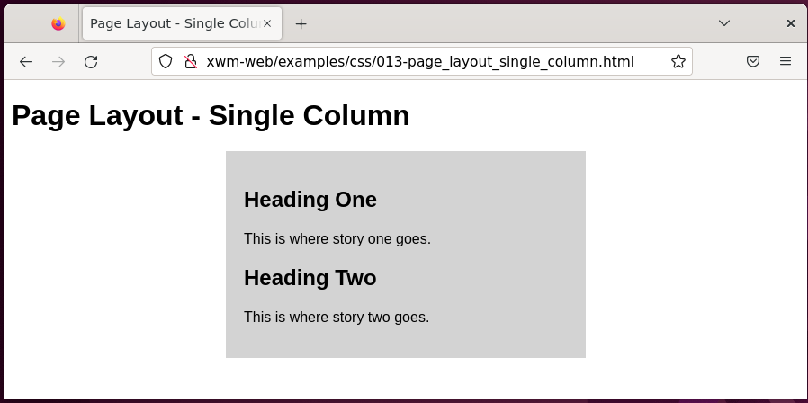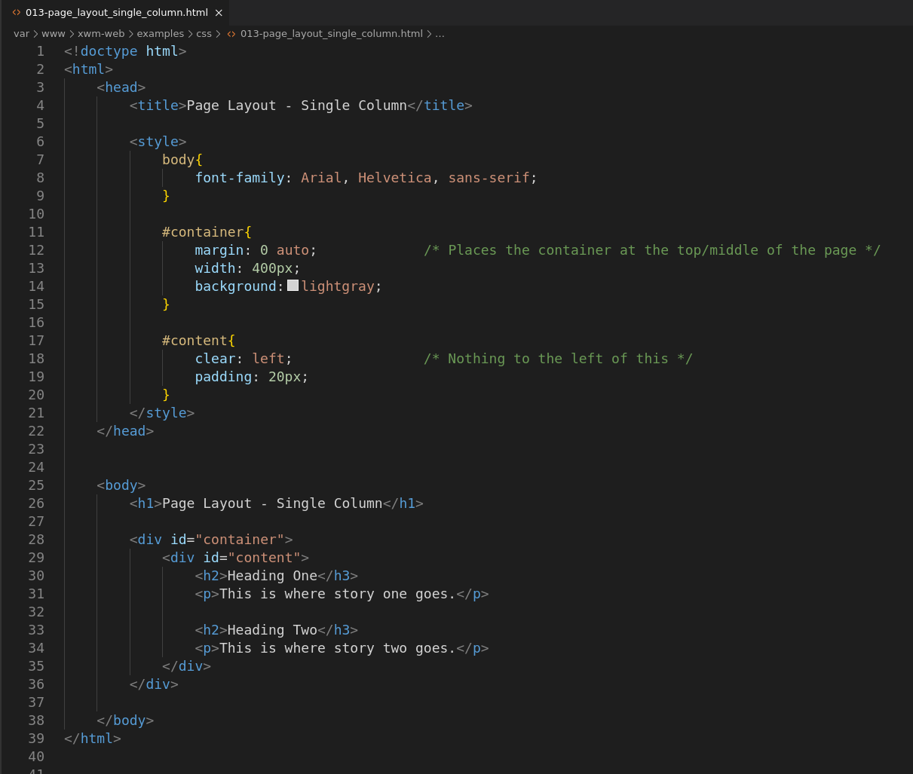

### Liquid layout

With a **liquid layout** the dimensions of div change

depending on the size of the browser.

#### Example: Page Layout – Liquid

Location: /var/www/xwm-web/examples/css/014-page_layout_liquid.html

URL: http://xwm-web/examples/css/014-page_layout_liquid.html

<!doctype html>

<html>

<head>

<title>Page Layout - Single Column</title>

<style>

body{

font-family: Arial, Helvetica, sans-serif;

}

#container{

margin: 0 50px;

/* As ‘width’ is not defined, the container resizes depending on the width of the page */

background:lightgray;

}

#content{

clear: left; /* Nothing can appear to the left of this */

padding: 20px;

}

</style>

</head>

<body>

<h1>Page Layout - Single Column</h1>

<div id="container">

<div id="content">

<h2>Heading One</h3>

<p>This is where story one goes.</p>

<h2>Heading Two</h3>

<p>This is where story two goes.</p>

</div>

</div>

</body>

</html>

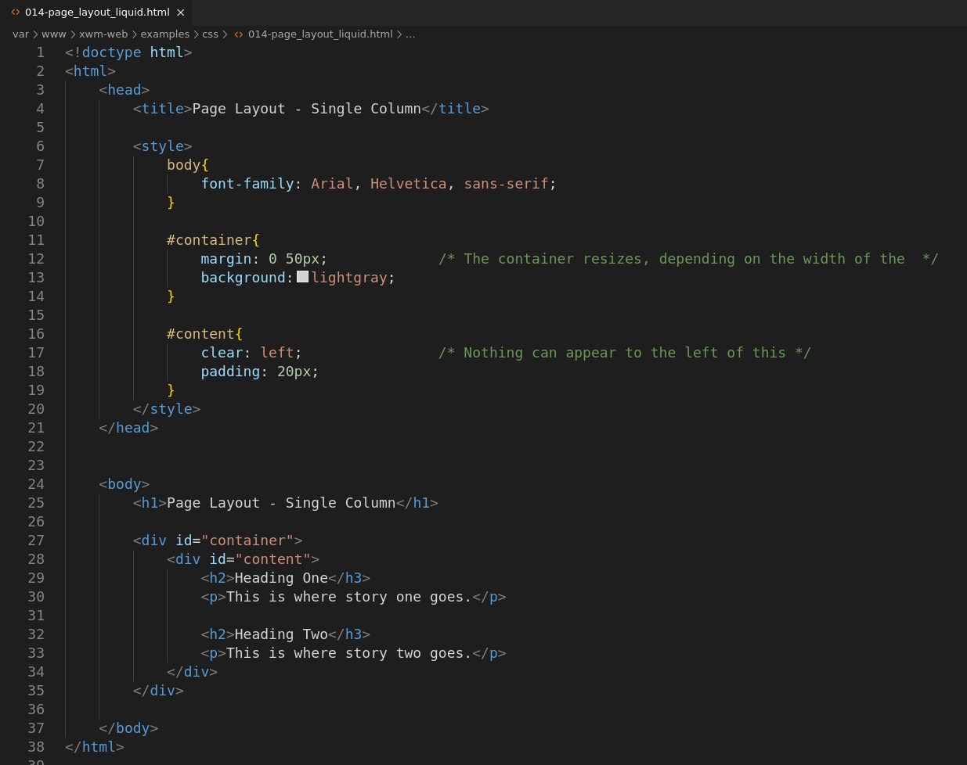

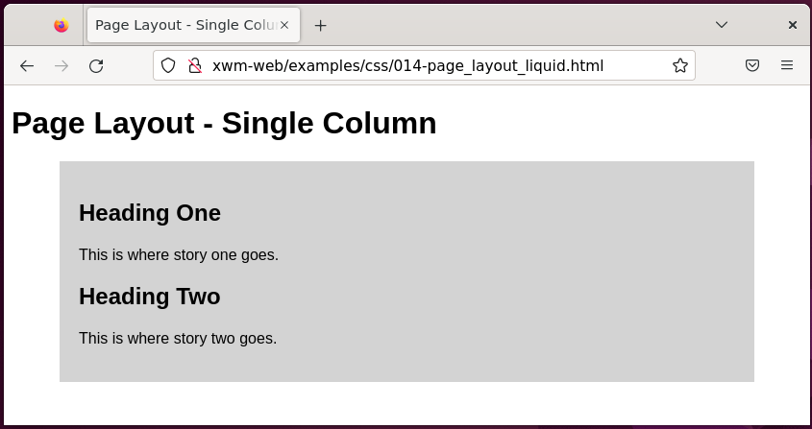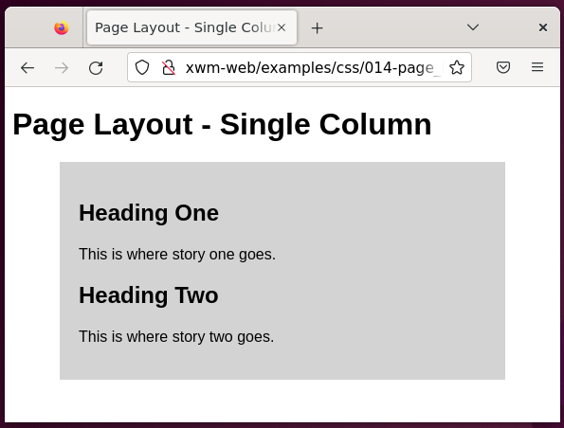

### Two-Column Fixed-Width

#### Example: Two-Column Fixed-Width

Location: /var/www/xwm-web/examples/css/015-page_layout_two_column.html

URL: http//xwm-web/examples/css/015-page_layout_two_column.html

<!DOCTYPE html>

<html>

<head>

<title>Page Layout - Two Column</title>

<style>

body{

font-family: Arial, Helvetica, sans-serif;

}

#container{

margin: 0 auto;

width: 900px;

}

#mainContainer{

float: left;

width: 900px;

}

#sidebar{ /* Menu on the left */

clear: left;

float: left;

display: inline;

background-color: lightgrey;

padding: 10px 50px 50px 25px;

}

#content{ /* Content to the right of the menu */

float: left;

display: inline;

width: 500px;

padding: 20px 0;

margin: 0 0 0 30px;

}

</style>

</head>

<body>

<div id="container">

<div id="mainContainer">

<h1>Page Layout - Two Columnn</h1>

<div id="sidebar">

<h2>Menu</h2>

<ul>

<li>Home</li>

<li>Contact</li>

<li>About</li>

</ul>

</div> <!-- End 'sidebar'-->

<div id="content">

<h2>Title One</h2>

<p>This is where story one goes</p>

<h2>Title Two</h2>

<p>This is where story two goes</p>

</div> <!-- End 'content'-->

</div> <!-- End 'mainContainer'-->

</div> <!-- End 'content'-->

</body>

</html>

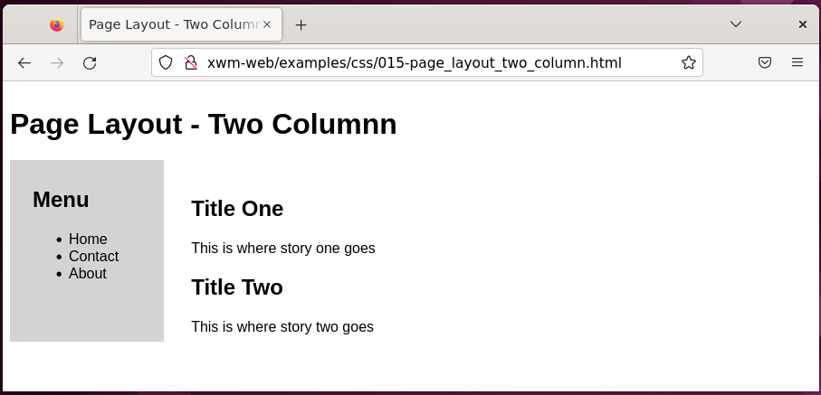

*Next, Two-Column screenshot …*

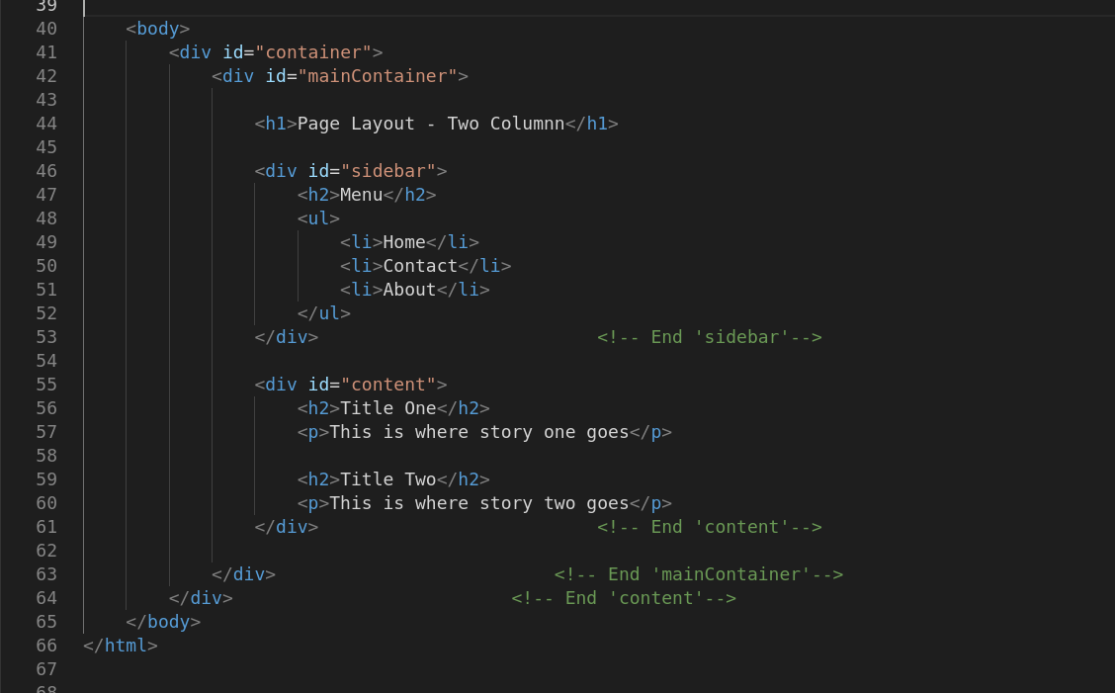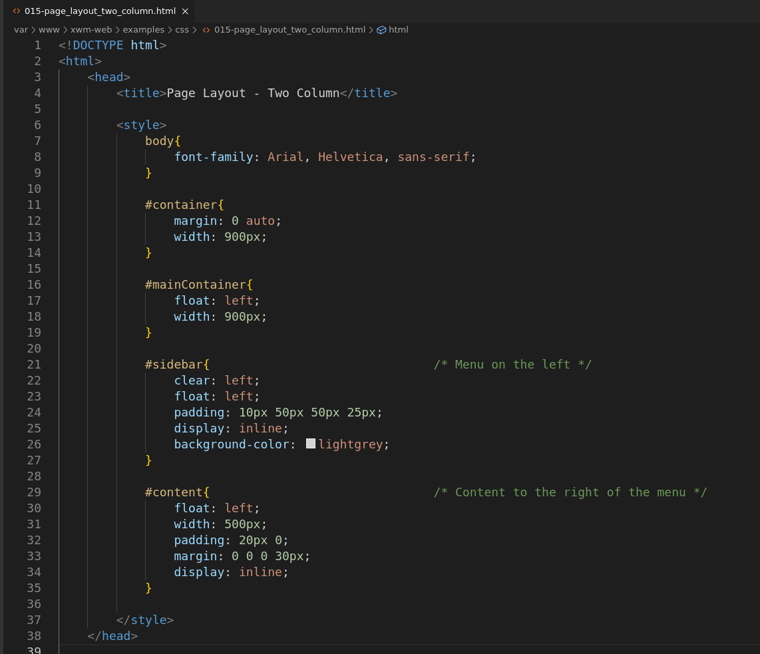

### Display

The display property sets how the element should be displayed.

Certain elements are known as *block-level* elements

and display the entire width of the page.

The <div> element is a good example of this.

Because you want to make the columns appear next to each other,

you need to change this block display behaviour to inline

so that the element doesn’t extend the full width of the page.

Three frequently used values for the property display:

* block *(to extend the element the full width)*
* inline *(to make the element use only its own width for display)*
* none *(which removes the element from display entirely)*

### Two-Column Liquid

To allow the page to resize

use percentages *(%)* to define dimensions

instead of fixed values *(eg px)*

#### Example: Two-Column Liquid

Location: /var/www/xwm-web/examples/css/016-page_layout_two_column_liquid.html

URL: <http://xwm-web/examples/css/016-page_layout_two_column_liquid.html>

<!--

To allow the page to resize

define dimensions using percentages (%)

instead of fixed values (eg px).

-->

<!DOCTYPE html>

<html>

<head>

<title>Page Layout - Two Column Liquid</title>

<style>

body{

font-family: Arial, Helvetica, sans-serif;

}

#container{

margin: 0 auto;

width: 100%;

}

#mainContainer{

float: left;

width: 100%;

}

#sidebar{ /* Menu on the left */

clear: left;

float: left;

display: inline;

background-color: lightgrey;

width: 15%;

padding: 0 0 0 2%;

margin 0 5%;

}

#content{ /* Content to the right of the menu */

float: left;

display: inline;

width: 65%;

padding: 0%;

margin: 0 5%;

}

</style>

</head>

<body>

<div id="container">

<div id="mainContainer">

<h1>Page Layout - Two Columnn Liquid</h1>

<div id="sidebar">

<h2>Menu</h2>

<ul>

<li>Home</li>

<li>Contact</li>

<li>About</li>

</ul>

</div> <!-- End 'sidebar'-->

<div id="content">

<h2>Title One</h2>

<p>This is where story one goes</p>

<h2>Title Two</h2>

<p>This is where story two goes</p>

</div> <!-- End 'content'-->

</div> <!-- End 'mainContainer'-->

</div> <!-- End 'content'-->

</body>

</html>

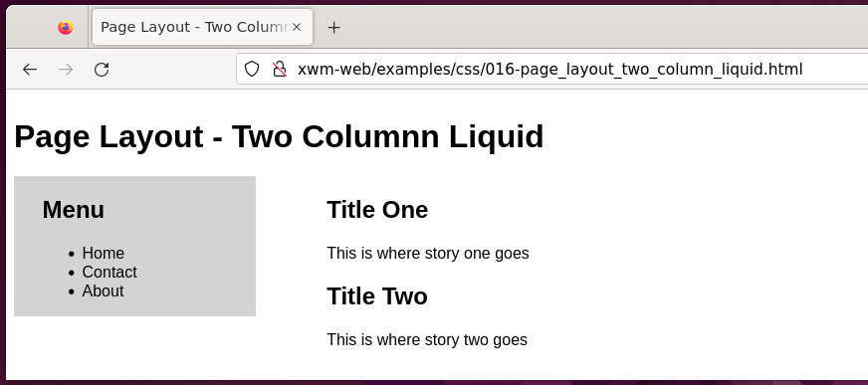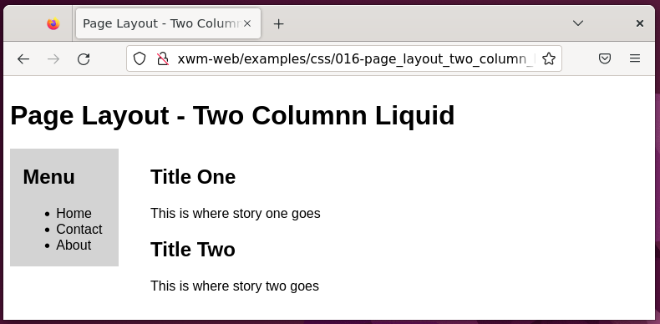

### Adding Headers and Footers

**Headers** are typically used to convey information

such as the name of the site or to provide a menu.

**Footers** are used to provide additional information such as copyright

and are also used to provide a map of links within a site,

known as a site map.

#### Example – Menu, Header and footer

Location 1: /var/www/xwm-web/examples/css/017-page_layout_menu_header_footer.html

Location 2: /var/www/xwm-web/examples/css/017-page_layout_menu_header_footer.css

URL: http://xwm-web/examples/css/017-page_layout_menu_header_footer.html

017-page_layout_menu_header_footer.html

<!DOCTYPE html>

<html>

<head>

<title>Nenu, Header and Footer</title>

<link rel="stylesheet" type="text/css" href="017-page_layout_menu_header_footer.css">

</head>

<body>

<div id="container">

<div id="header">

<h1>Menu, Header and Footer</h1>

</div> <!-- end 'header'-->

<div id="navigation">

<ul>

<li> <a href="#">Home</a> </li>

<li> <a href="#">Services</a> </li>

<li> <a href="#">About</a> </li>

<li> <a href="#">Contact</a> </li>

</ul>

</div> <!--- end 'menu'-->

<div id="mainContainer">

<div id="content">

<h3>Title One</h2>

<p>This is where story one goes.</p>

<h3>Title Two</h2>

<p>This is where story two goes.</p>

</div> <!-- end 'content'-->

<div id="menu">

<h3>Menu</h2>

<ul>

<li>Menu item 1</li>

<li>Menu item 2</li>

<li>Menu item 3</li>

</ul>

</div> <!-- end 'sidebar' -->

<div id="footer">

<p>Copyright (c) 2022 xmw-web</p>

</div> <!-- end 'footer'-->

</div> <!-- end 'mainContainer'-->

</div> <!-- end 'container'-->

</body>

</html>

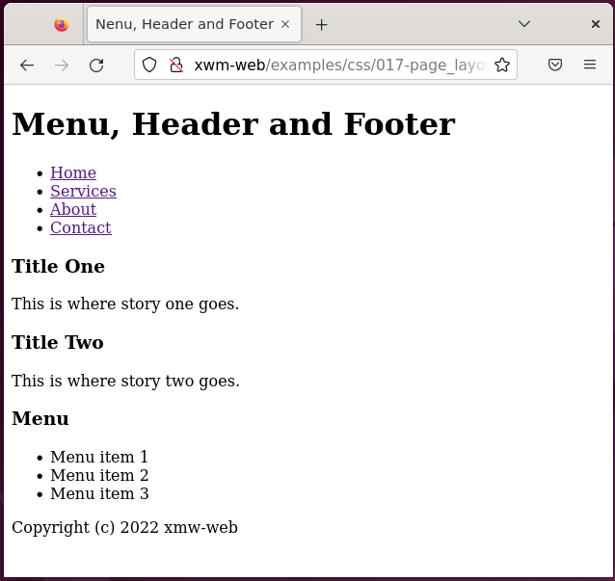

/var/www/xwm-web/examples/css/017-page_layout_menu_header_footer.css

body{

font-family: Arial, Helvetica, sans-serif;

}

#container{

margin: 0 auto;

width: 100%;

}

#header{

background-color: #abacab;

padding: 5px 10px;

}

#navigation{

float: left;

background-color: #0c0c0c;

width: 100%;

padding: 5px 0 10px 0;

}

#navigation ul li{

display: inline;

list-style-type: none;

}

#navigation li a{

display: block;

float: right;

text-decoration: none;

color: #ffffff;

padding: 3px 10px;

}

#navigation li a, #navigation li a:link, #navigation li a:visited

{

margin: 0 10px;

}

#navigation li a:hover {

background-color: #cccccc;

}

#mainContainer{

float: left;

width: 100%;

}

#content{

float: right;

clear: right;

width: 65%;

padding: 0px;

margin: 0 0 0 5%;

display: inline;

}

#menu{

display: inline;

float: left;

background-color: #cccccc;

top: 0;

width: 20%;

padding: 0 20px 100% 20px;

}

#footer{

position: fixed;

clear: left;

background-color: #cccccc;

text-align: center;

left: 0;

bottom: 0;

width: 100%;

padding: 10px;

margin: 0 10px;

}

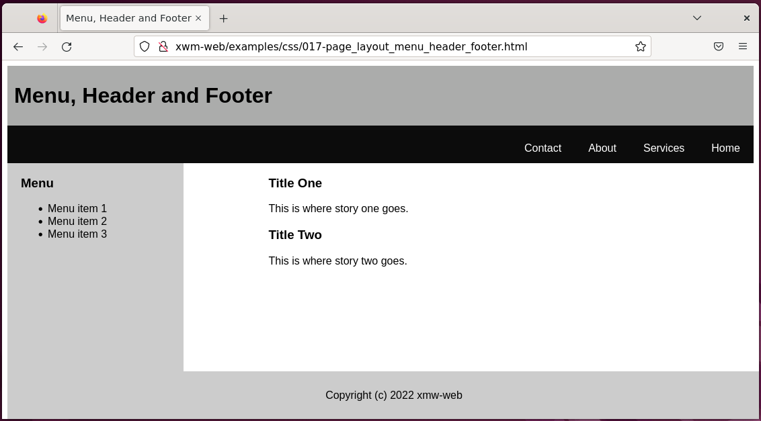

# JavaScript

The following are JavaScript examples

are saved to the folder /var/www/xwm-web/examples/javascript

### Use JavaScript

Javascript is added to html pages using scripts.

#### Example – JavaScript script

Location: /var/www/xwm-web/examples/javascript/001-adding_scripts.html

<!--

Javascript can be added:

1 - as an external file

2 - to the <head>

3 - to the <body>

-->

<!DOCTYPE html>

<html>

<head>

<script type="text/javascript" src="externalfile.js"></script> <!-- 1 - Add JavaScript as an external file -->

<script type="text/javascript" >

// 2 - Javascript can go here

</script>

</head>

<body>

<script type="text/javascript" >

// 3 - Javascript can also go here

</script>

</body>

</html>

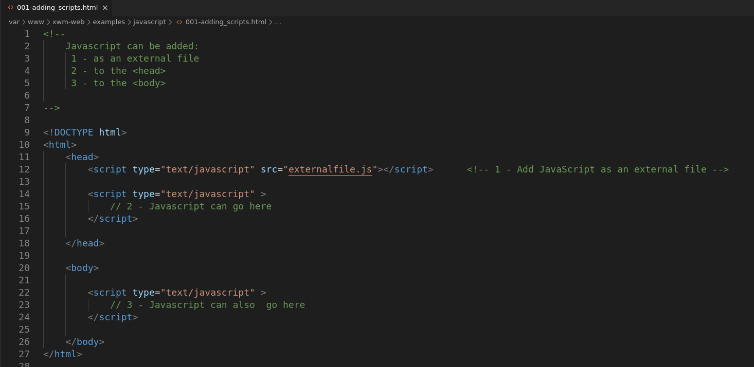

### Alert

Alerts can be used to inform the user

and are useful while doing diagnostics.

#### Example - Alert

Location: /var/www/xwm-web/examples/javascript/002-alert.html

URL: http://xwm-web/examples/javascript/002-alert.html

<!DOCTYPE html>

<html>

<head>

<title>JS Alert</title>

</head>

<body>

<h1>JS Alert</h1>

<script type="text/javascript">

alert("hello");

</script>

</body>

</html>

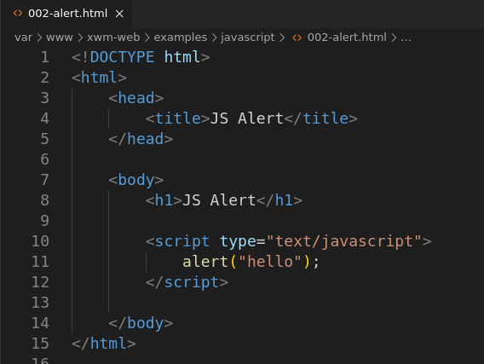

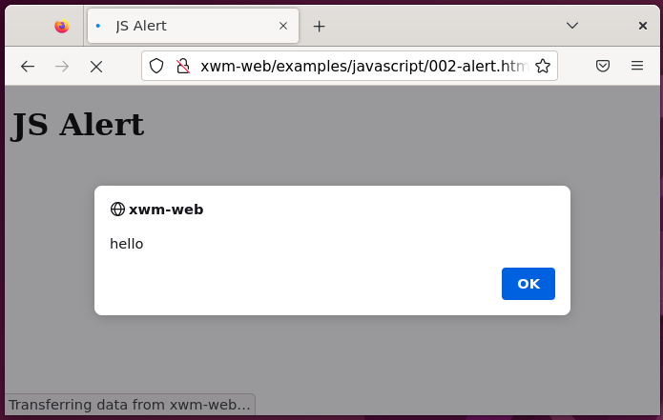

### Variables

Variables are defined in JavaScript with the keyword **var**

var myVariable;

#### Example – Using a variable

<!DOCTYPE html>

<html>

<head>

<title>Javascript Variable</title>

</head>

<body>

<h1>Javascript Variable</h1>

<script type="text/javascript">

var myVariable = 4;

alert(myVariable);

</script>

</body>

</html>

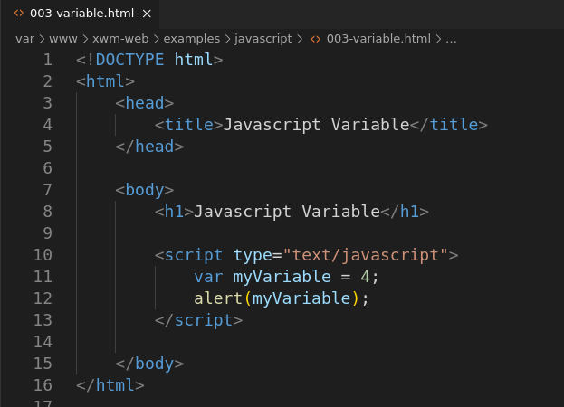

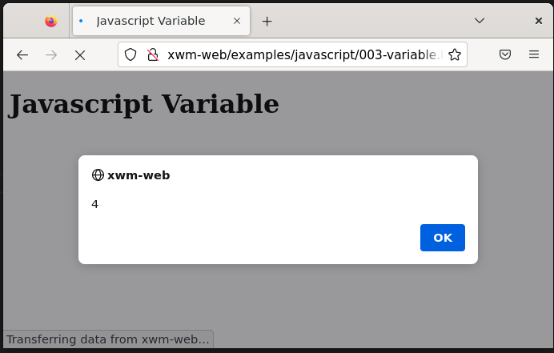

### Arrays

Arrays hold multiple values, called elements.

#### Example – Array

<!DOCTYPE html>

<html>

<head>

<title>JavaScript Array</title>

</head>

<body>

<h1>JavaScript Array</h1>

<script type="text/javascript">

var myArray=["Bill", "Steve", "Elon"]; // Create an array

for(i=0; i<myArray.length; i++) { // Display each element

alert(myArray[i]);

}

</script>

</body>

</html>

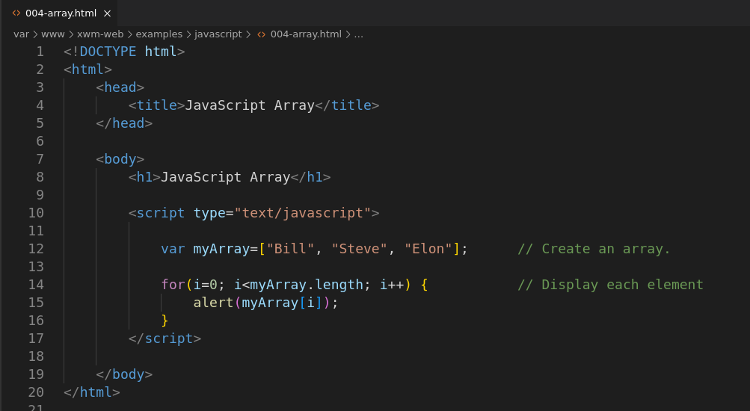

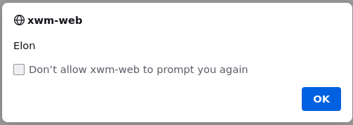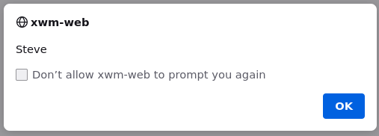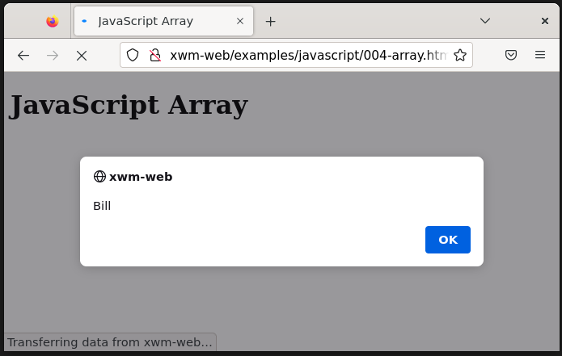

### String

String can be concatenated.

#### Example – String

<!DOCTYPE html>

<html>

<head>

<title>JavaScript Concatentate Strings</title>

</head>

<body>

<script type="text/javascript">

var jointString = "Wonderful" + " guitar!";

alert(jointString);

</script>

</body>

</html>

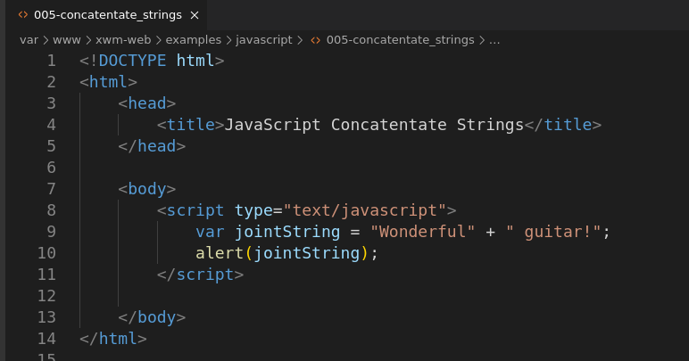

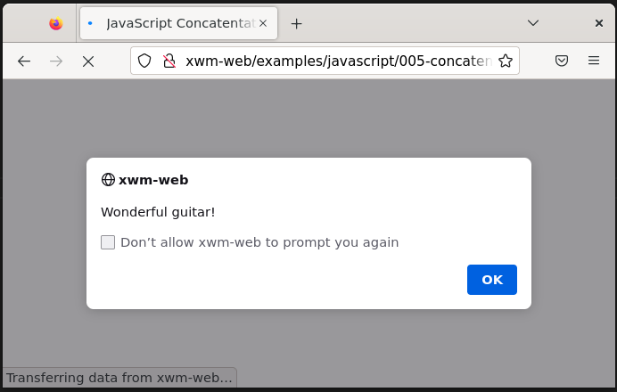

### If/Else *(conditionals)*

JavaScript decisions are called **conditionals**

#### Example – If/Else

Location: /var/www/xwm-web/examples/javascript/006-if_else.html

URL: http://xwm-web/examples/javascript/006-if_else.html

<!DOCTYPE html>

<html>

<head>

<title>If/ELse</title>

</head>

<body>

<h1>If/Else</h1>

<script type="text/javascript">

var temp = 25;

var weather = "fine";

if(temp > 30) {

alert("Too hot.");

}

else if (weather == "rain") {

alert("Too wet.")

}

else {

alert("Mow the lawn.")

}

</script>

</body>

</html>

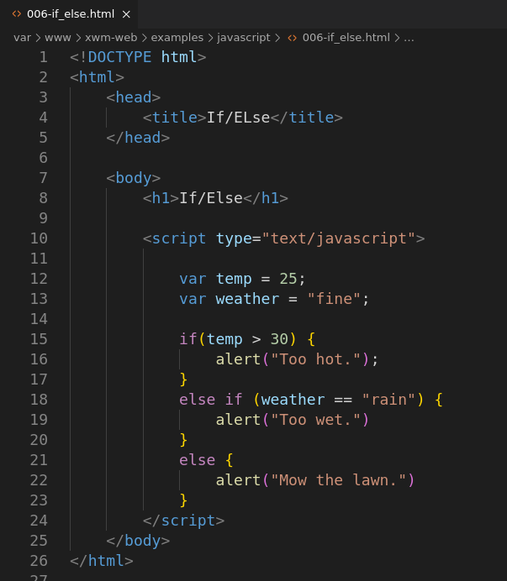

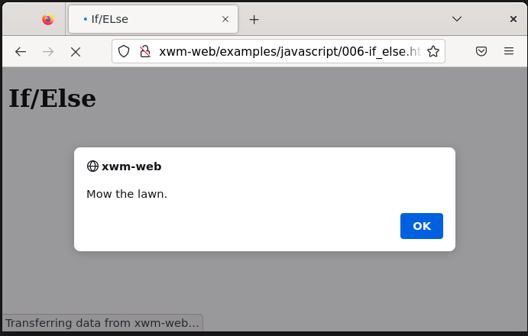

### For Loop

If you want to do something multiple times in JavaScript

a common way to do it is with a **for** loop.

#### Example – For Loop

Location: /var/www/xwm-web/examples/javascript/007-for_loop.html

URL: http://xwm-web/examples/javascript/007-for_loop.html

<!DOCTYPE html>

<html>

<head>

<title>For Loop</title>

</head>

<body>

<h1>For Loop</h1>

<script type="text/javascript">

for (i=0; i<5; i++)

{

alert("The variable 'i' is set to " + i)

}

</script>

</body>

</html>

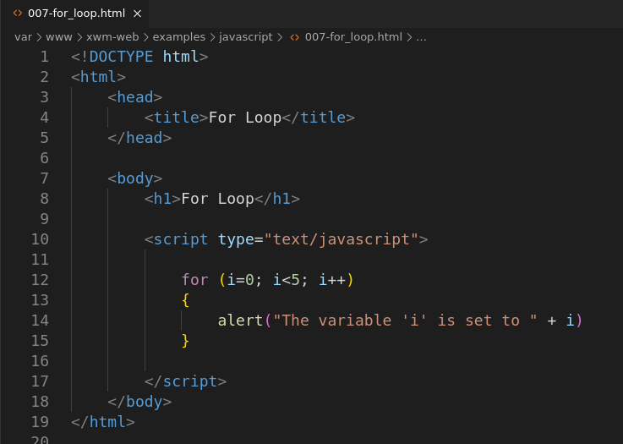

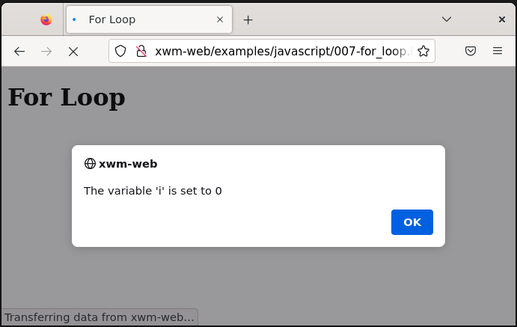

### For loop an array

The length of an array can be used in a for statement

to determine the number times the for statement loops.

#### Example – For loop an array

Location: /var/www/xwm-web/examples/javascript/008-for_loop_an_array.html

URL: http://xwm-web/examples/javascript/008-for_loop_an_array.html

<!DOCTYPE html>

<html>

<head>

<title>For loop an array</title>

</head>

<body>

<script type="text/javascript">

var people = ["Steve", "Bill", "Elon"]

for(i=0; i<people.length; i++) {

alert(people[i]);

}

</script>

</body>

</html>

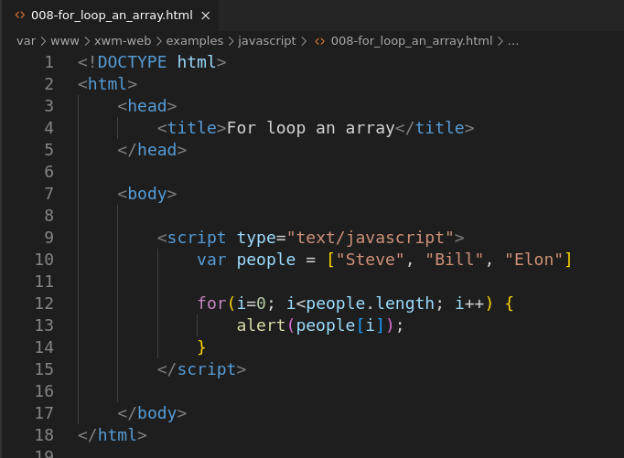

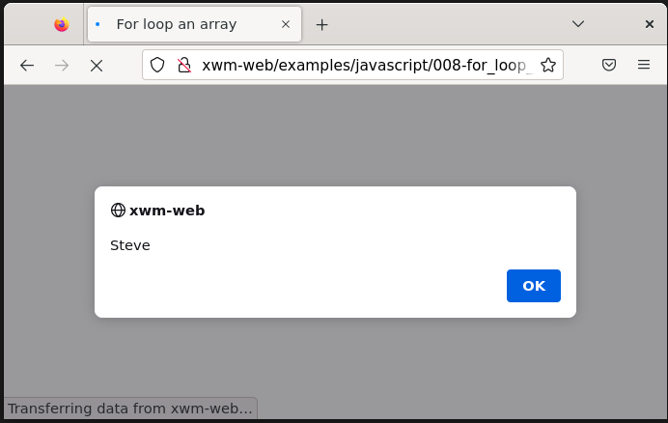

### While loop

A while loop executes as long as the condition is true

while (i < 10) {

// Do something interesting

// Don’t forget to increment the counter!

}

Something needs to be done inside of the loop

to break out of the loop.

#### Example – While loop

Location: /var/www/xwm-web/examples/javascript/009-while_loop.html

URL: http://xwm-web/examples/javascript/009-while_loop.html

<!DOCTYPE html>

<html>

<head>

<title>While Loop</title>

</head>

<body>

<h1>While Loop</h1>

<script type="text/javascript">

var i = 0; // Set 'i' to 0

while(i < 4) {

alert("loop count: " + i); // Display 'i'

i++; // Increment 'i'

}

</script>

</body>

</html>

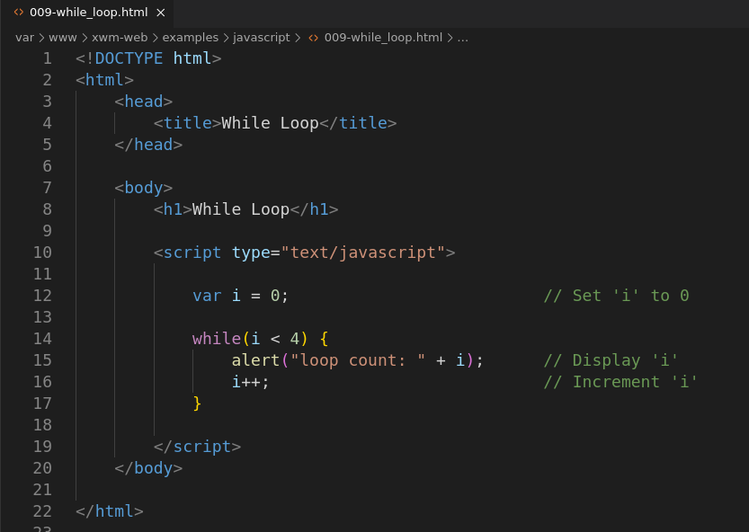

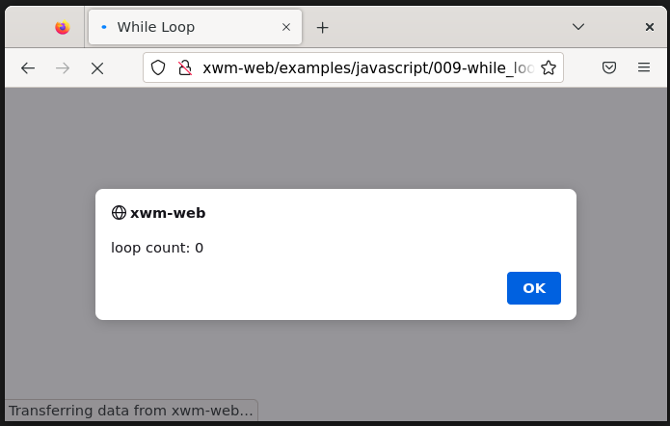

*Next, Functions …*

## Functions

### Creating functions

Functions are created as follows:

function myFunction() {

// Function code goes here

}

### Adding function arguments (p204)

Functions accept input, called **arguments**

#### Example – A function with two arguments

function addNumbers(num1, num2) {

alert(num1 + num2);

}

#### Example – Simple function

Location: /var/www/xwm-web/examples/javascript/010-function.html

URL: http:// xwm-web/examples/javascript/010-function.html

<!DOCTYPE html>

<html>

<head>

<title>Simple Function</title>

</head>

<body>

<h1>Simple Function</h1>

<p>A simple function, that adds two numbers.</p>

<script type="text/javascript">

addNumbers (3, 4); // Call the function

function addNumbers(num1, num2) { // Function signature

sum = num1 + num2; // Add the arguments

alert(num1 + " + " + num2 + " = " + sum ); // Display the result

}

</script>

</body>

</html>

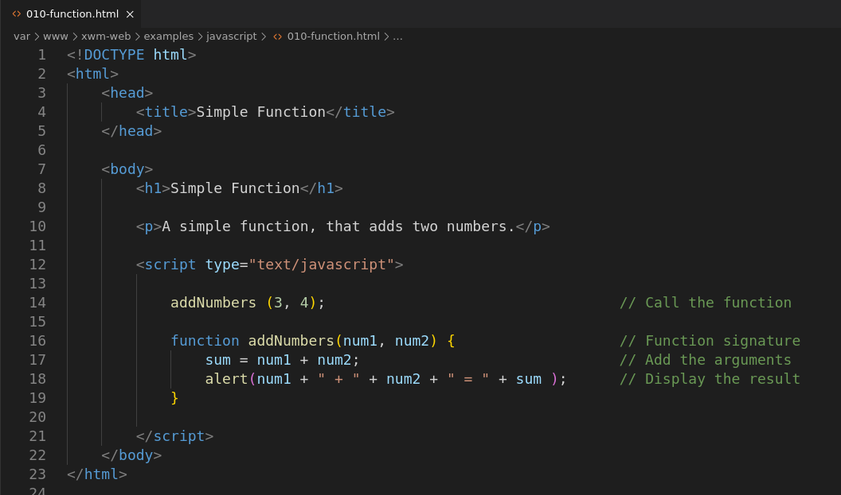

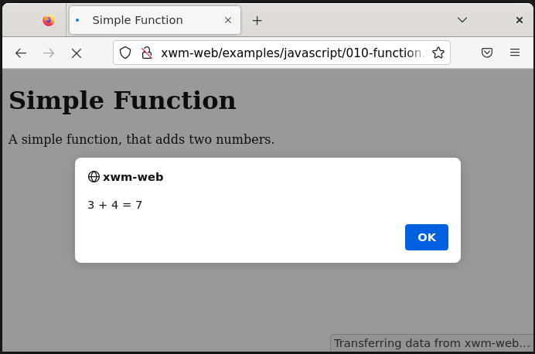

### Testing numbers

JavaScript includes a function

to test whether something is a number, called **isNaN()**

which stands for *is Not a Number.*

This can be added anywhere to make sure a value is a number

like the case above.

You use the function isNaN()

within an if conditional statement

and then react accordingly.

#### Example – Use isNaN() to check numbers

Location: /var/www/xwm-web/examples/javascript/011-check_for valid_numbers .html

URL: http:// xwm-web/examples/javascript/011-check_for valid_numbers .html

<!DOCTYPE html>

<html>

<head>

<title>isNaN()</title>

</head>

<body>

<h1>isNaN()</h1>

<p>isNaN() can be used to make sure variables are numbers.</p>

<script type="text/javascript">

addNumbers(3, 4); // Call the method addNumbers()

function addNumbers(num1, num2){ // Method signature.

if(isNaN(num1)) { // Check 'num1' is valid.

alert("num1 is not a number: " + num1);

}

else if(isNaN(num2)) { // Check 'num2' is valid.

alert("num2 is not a number: " + num2);

}

else { // If both numbers are okay,

sum = num1 + num2;

alert(num1 + " + " + num2 + " = " + sum); // display the result.

}

}

</script>

</body>

</html>

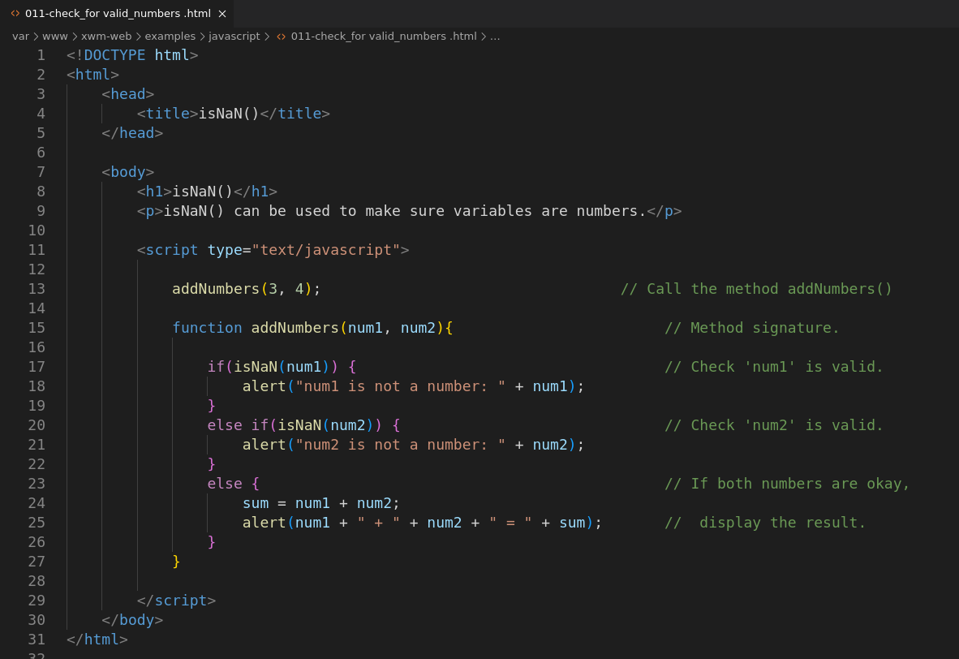

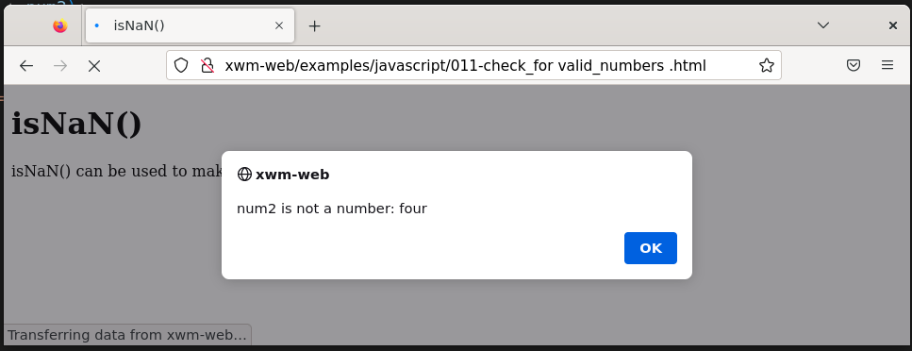

## Returning a result from function

The keyword **return** is used

to return a result from a function.

#### Example – Return a result from a function

Location: /var/www/xwm-web/examples/javascript/012-function_return_a_result.html

URL: http://xwm-web/examples/javascript/012-function_return_a_result.html

<!DOCTYPE html>

<html>

<head>

<title>Return a Result</title>

</head>

<body>

<h1>Return a result from a function</h1>

<p>Use the key word 'return' <br>to return a result from a function</p>

<script type="text/javascript">

num1 = 3;

num2 = 4;

sum = addNumbers(num1, num2); // Call the method that returns a value

alert("Sum = " + sum); // Display the returned value

function addNumbers(num1, num2) { // Method signature

return num1 + num2; // Return the sum from the method

}

</script>

</body>

</html>

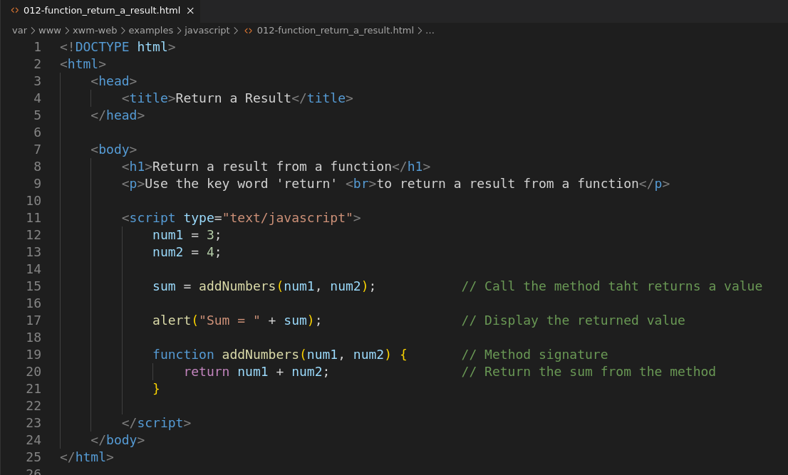

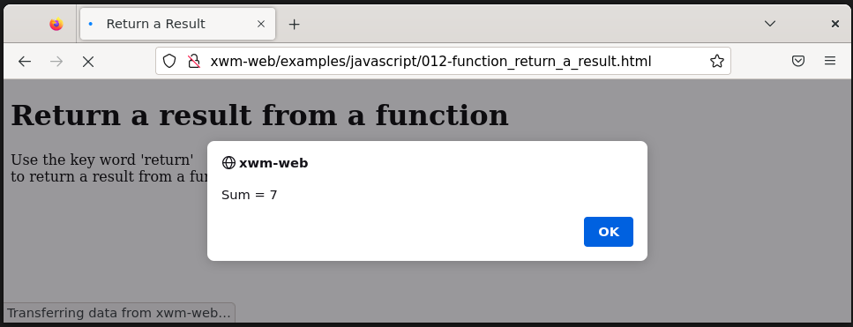

## Objects

**Objects** hold multiple values.

Their values are accessed through **properties**

Objects are created using curly braces **{}**

When you define an object

you can define one or more properties, for example:

var ball = {

“color”: “white”,

“type”: “baseball”

};

#### Example – Create an object

Location: /var/www/xwm-web/examples/javascript/013-object_creation.html

URL: http://xwm-web/examples/javascript/013-object_creation.html

<!doctype html>

<html>

<head>

<title>Object Creation</title>

</head>

<body>

<h1>Object Creation</h1>

<p>Objects values are accessed through properties. </p>

<script type="text/javascript">

var ball={ // Create the object

"color": "white", // Define the object's properties

"type": "football"

};

alert("The ball's color is: " + ball.color); // Display an object property

</script>

</body>

</html>

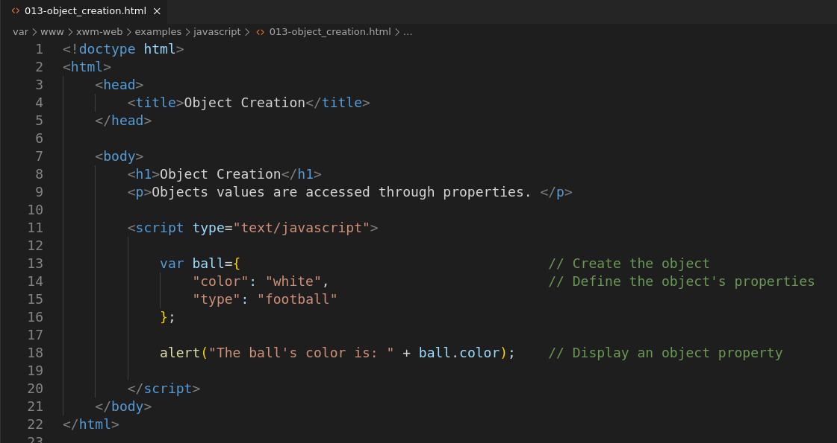

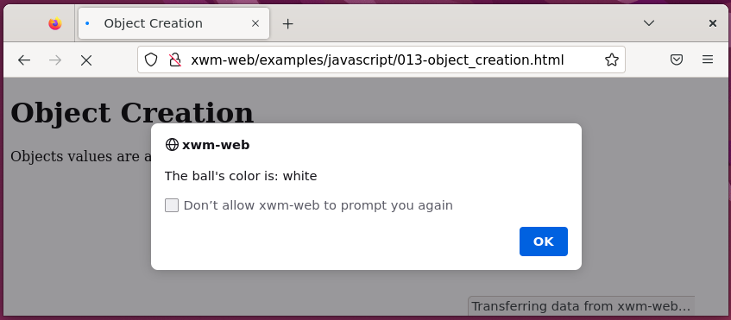

### Add a property to an object

Add a property to an object after it’s been created

using dot notation.

ball.weight = 15;

#### Exercise – Add a property to an object

Location: /var/www/xwm-web/examples/javascript/014-object_add_a_property.html

URL: /var/www/xwm-web/examples/javascript/014-object_add_a_property.html

<!doctype html>

<html>

<head>

<title>Add a object property</title>

</head>

<body>

<h1>Add a object property</h1>

<p>Object properties can be added <br>using dot notation. </p>

<script type="text/javascript">

var ball={ // Create the object

"color": "white", // Define the object's properties

"type": "football"

};

ball.wieght = 425; // Add a new object property using dot notation.

alert("The ball's wieght is: " + ball.wieght + "grams"); // Display the new object property

</script>

</body>

</html>

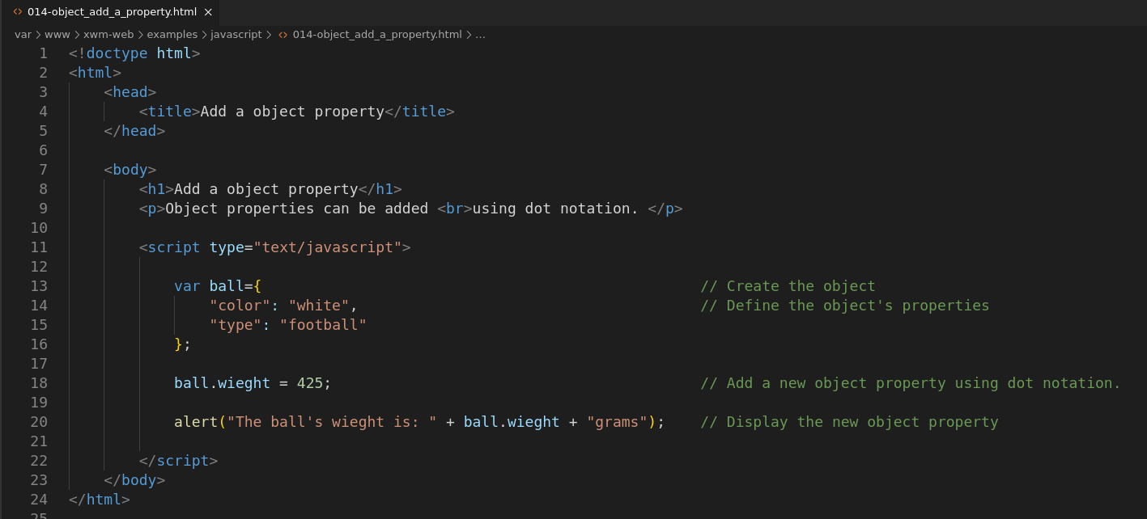

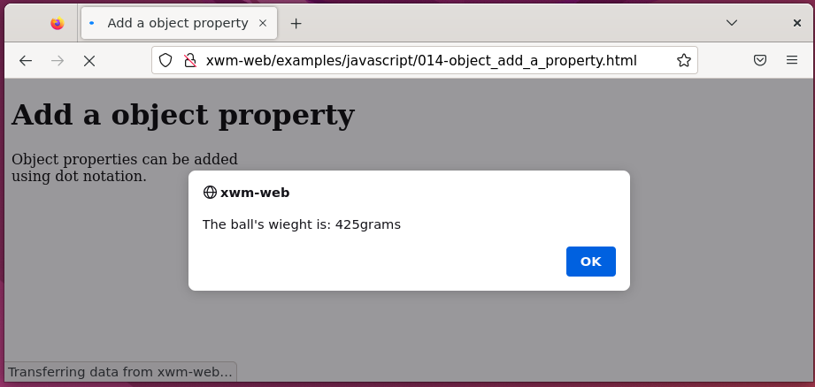

## Working with Documents

You can add *(or change)* HTML on a page

in real time using JavaScript.

### Using ‘GetElementById’ to access an element

The most specific way to access an element

is using its id

id attributes can be placed on any element

and are unique throughout the page.

In this way, each element can be accessed directly.

#### Example – Basic HTML demonstrating DOM

Location: /var/www/xwm-web/examples/javascript/015-use_id_to_get_content.html

URL: http://xwm-web/examples/javascript/015-use_id_to_get_content.html

<!doctype html>

<html>

<head>

<title>Use 'id' to get content</title>

</head>

<body>

<h1>Use 'id' to get content</h1>

<p>Use an 'id' to get an elements content</p>

<div id="firstDiv">Hello</div> <!-- Create an HTML element with an 'id' -->

<script type="text/javascript">

var selectedDiv = document.getElementById("firstDiv"); // Select teh element

alert("The content of 'firstDiv' is: " + selectedDiv.innerHTML); // Display the element content

</script>

</body>

</html>

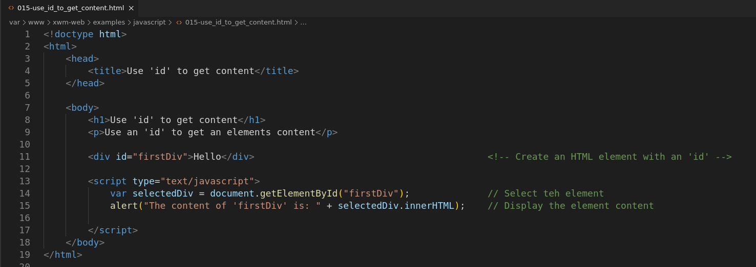

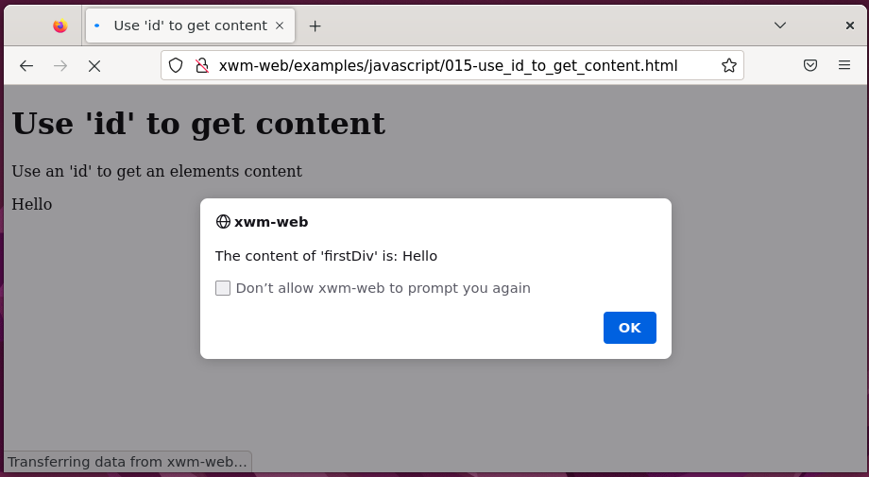

#### Example – Change text in a <div>

Location: /var/www/xwm-web/examples/javascript/016-change_an_elements_text.html

URL: http:// xwm-web/examples/javascript/016-change_an_elements_text.html

<!DOCTYPE html>

<html>

<head>

<title>Change an Elements Text</title>

</head>

<body>

<h1>Change an Elements Text</h1>

<p>The method getElementById() <br>

and change an elements text.</p>

<div id="firstDiv">Hello</div> <!-- Original text. -->

<script type="text/javascript">

var selectedDiv = document.getElementById("firstDiv"); // Select the element 'firstDiv'.

selectedDiv.innerHTML = "This text has changed!"; // Change it's text.

selectedDiv.style.border = "3px solid black"; // Style the element using javascript.

</script>

</body>

</html>

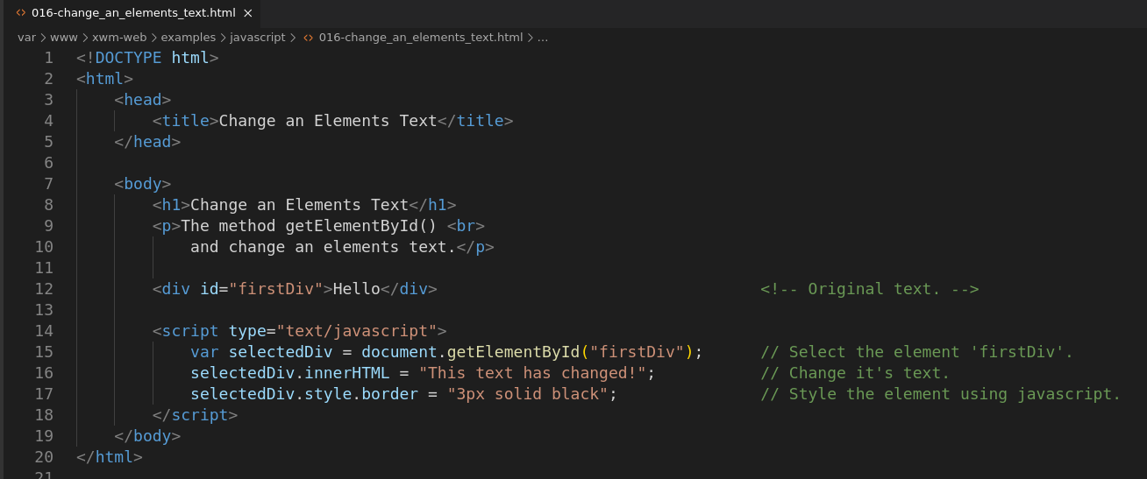

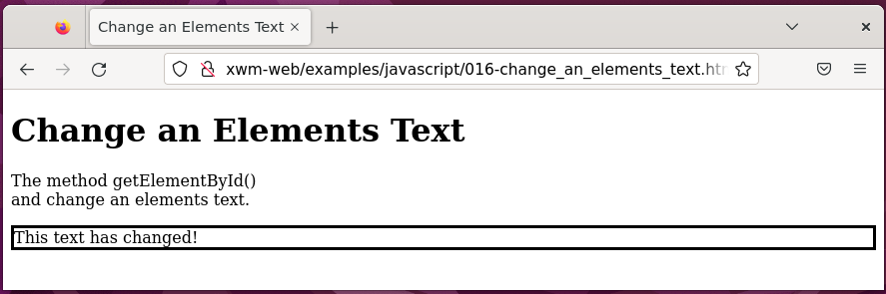

#### Example - Get Browser Details

Location: /var/www/xwm-web/examples/javascript/017-get_browser_details.html

URL: http:// xwm-web/examples/javascript/017-get_browser_details.html

<!DOCTYPE html>

<html>

<head>

<title>Get Browser Details</title>

</head>

<body>

<h1>Get Browser Details</h1>

<p>The user's browser details can be obtained <br>

by calling 'navigator.userAgent'. </p>

<div id="outputDiv"></div> <!-- The div where the output will be displayed. -->

<script type="text/javascript">

var userAgent = navigator.userAgent; // Get the user's browser details.

outputDiv.innerHTML = "Current browser is: " + userAgent; // Display the browser details.

outputDiv.style.border = "3px solid black";

outputDiv.style.padding = "10px";

</script>

</body>

</html>

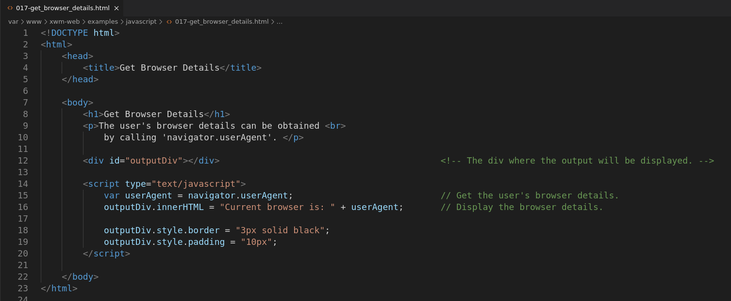

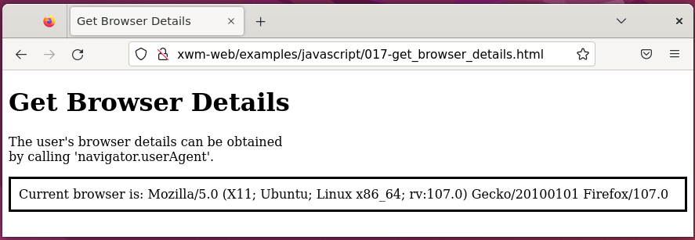

### Page Redirection

You’ve probably encountered a page that says:

*“Click here if you’re not automatically redirected”*

*and then automatically redirects you anyway.*

That is done in case your browser doesn’t have JavaScript enabled.

#### Example – Page Redirection

Location: /var/www/xwm-web/examples/javascript/018-page_redirection.html

URL: <http://xwm-web/examples/javascript/018-page_redirection.html>

Redirection

Location: /var/www/xwm-web/examples/html/001-firstpage.html

Path: /examples/html/001-firstpage.html

URL: <http://xwm-web/examples/html/001-firstpage.html>

<!DOCTYPE html>

<html>

<head>

<title>Page Redirection</title>

</head>

<body>

<h1>Page Redirection</h1>

<p>This page automatically redirects to: '001-firstpage.html'</p>

<div>

<a href="/examples/html/001-firstpage.html">Click here if you are not automatically redirected</a> <!-- Just incase redirection doesn't work-->

</div>

<script type="text/javascript">

window.location.replace("/examples/html/001-firstpage.html") // Automatically relocate to: 'firstpage.html'

</script>

</body>

</html>

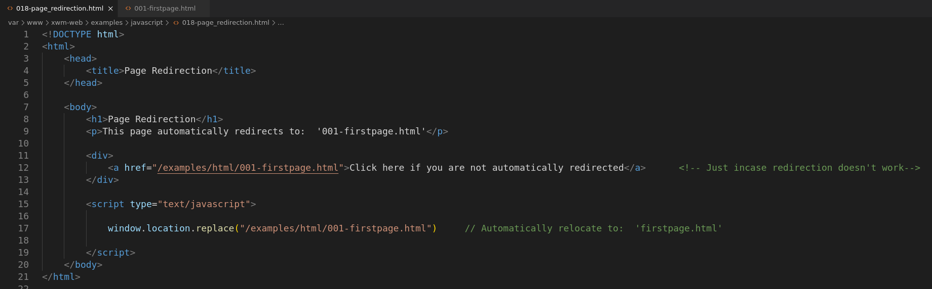

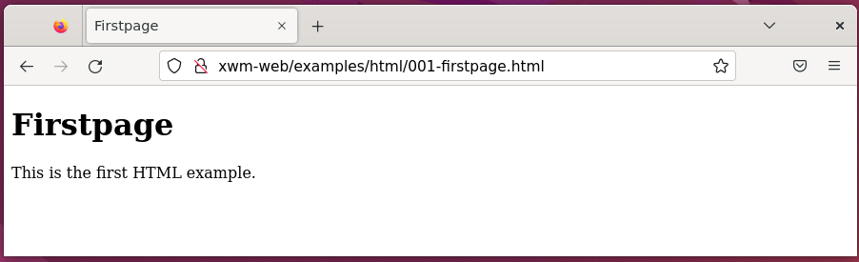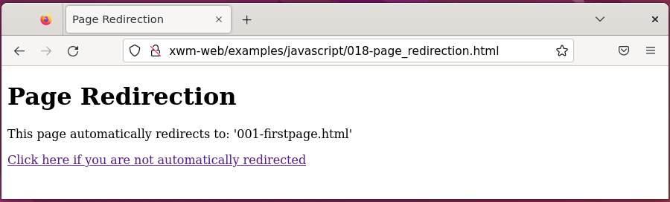

## jQuery

jQuery is a JavaScript library.

It is simply JavaScript that you add to your web page

to make writing JavaScript easier.

For instance, where you might use getElementById()

jQuery has things called *selectors* to access elements

on a web page for JavaScript to use.

### Installing jQuery)

There are two ways to use jQuery:

* either download it locally
* or on a **Content Delivery Network** (CDN).

The following examples use CDN-hosted jQuery.

### Using CDN-hosted jQuery

The CDN-hosted option for jQuery is great for development.

You don’t have to worry about downloading the file

or putting it in the right place.

It’s always available *(as long as the CDN is up)*

CDN-hosted versions are available from many large companies

like Google and Microsoft.

You don’t need to download anything

in order to use a CDN hosted jQuery.

You can find the links for the CDN-hosted versions at [www.jquery.com/download](http://www.jquery.com/download)

#### Microsoft Ajax Content Delivery Network

**https://docs.microsoft.com/en-us/aspnet/ajax/cdn/overview#jQuery_Releases_on_the_CDN_0**

### Adding jQuery to a Page

You need to reference jQuery on the webpage.

jQuery is just like any external JavaScript file.

This section shows how to add jQuery to your page

using CDN-hosted jQuery.

#### Example – Add jQuery using CDN

Location: /var/www/xwm-web/examples/javascript/019-jquery_added_using_cdn.html

<!DOCTYPE html>

<html>

<head>

<title>jQuery - Added Using CDN</title>

<script type="text/javascript" src="https://ajax.aspnetcdn.com/ajax/jQuery/jquery-3.6.0.js"></script> <!-- Add jQuery using CDN-->

</head>

<body>

</body>

</html>

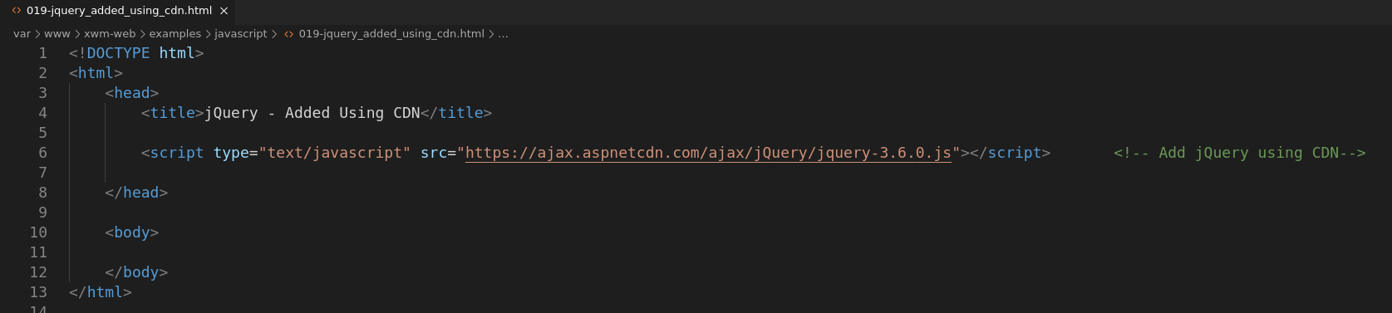

### Incorporating the jQuery ready() function

You can access HTML elements on a page using JavaScript

which means you can also access things like images

and forms on a web page.

A common problem when programming in JavaScript

is that the JavaScript program will run

before the page has loaded.

jQuery has a function called **ready()**

that waits for the page to load.

When you program with jQuery

it’s typical to place your code inside of the function ready()

so that you can ensure that everything on the page

is ready for you to use.

#### Example – Using the jQuery ready() function

Location: /var/www/xwm-web/examples/javascript/020-jquery_ready_function.html

URL: http://xwm-web/examples/javascript/020-jquery_ready_function.html

<!DOCTYPE html>

<html>

<head>

<title>jQuery ready() function</title>

<script type="text/javascript"

src="https://ajax.aspnetcdn.com/ajax/jQuery/jquery-3.6.0.js"> // jQuery CDN.

</script>

</head>

<body>

<h1>jQuery ready() function</h1>

<p>Nesting JavaScript in a jQuery ready() function <br>

allows a page to load, before javascript runs.</p>

<script type="text/javascript">

$(document).ready(function() { // Nest JavaScript code in a ready() function.

alert("This alert is nested \nin a ready() function.");

});

</script>

</body>

</html>

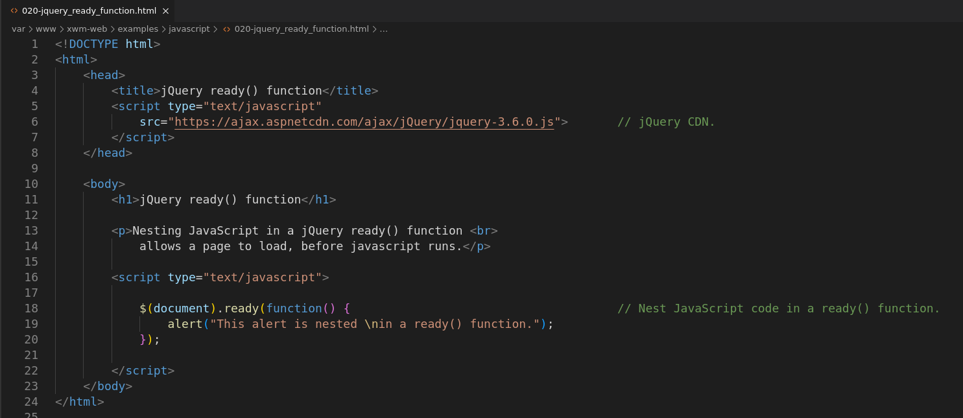

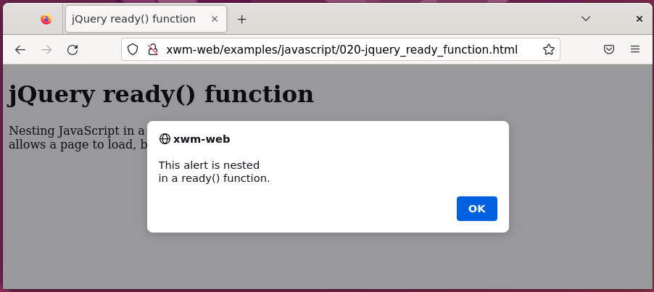

You use **$()** to use jQuery.

This is what tells the browser and JavaScript

that what follows is jQuery.

As jQuery has a function called **ready()**

it knows what to do.

For most uses of jQuery

you’ll see similar syntax to what you see here:

a **function()** with no name,

then code within it.

### Selecting Elements with jQuery

When you use the code $(document)

you use something called a selector.

Most of what you’ll do in jQuery happens through selectors.

For instance, you can select a piece of a web page

and then have jQuery perform an action on that piece.

That action could be:

* adding text
* changing HTML
* changing CSS
* just about anything

The basic flow for programming JavaScript with jQuery is:

1. Select an element on the web page
2. Do something with that element

There are three primary selectors in jQuery.

You can set up very complex selectors, based on the structure of the page

but most often you’ll use one of these three selectors:

* a class
* an id
* an element

Selectors look like their CSS counterparts.

In CSS, you access items by their id with a pound sign **#**

and you classes with a single dot **.**

In jQuery, you wrap it in the construct $()

and add quotation mark:

**$(“**#bookTitle**”)**

**$(“**.titleClass**”)**

#### jQuery ‘id’ selector

If you have HTML that looks like this:

<p id=”bookTitle”>My Book</p>

You could access the id with jQuery like this:

$(“#bookTitle”)

#### jQuery ‘class’ selector

If you have HTML that looks like this:

<p class=”titleClass”>This is some text</p>

The jQuery selector looks like this:

$(“.titleClass”)

#### jQuery ‘element’ selector

The other frequently used selector

selects all the elements of a certain type.

For example, the following selector selects all <div> elements

on the entire page:

$(“div”)

*Next, Example – jQuery Append a List …*

#### Example – jQuery add a list item

Location: /var/www/xwm-web/examples/javascript/021-jq_add_a_list_item.html

URL: http://xwm-web/examples/javascript/021-jq_add_a_list_item.html

<!DOCTYPE html>

<!DOCTYPE html>

<html>

<head>

<title>jQuery Append a List</title>

<script type="text/javascript" src="https://ajax.aspnetcdn.com/ajax/jQuery/jquery-3.6.0.js"></script>

</head>

<body>

<h1>jQuery - Append a List</h1>

<p>Add an item to a list, using jQuery.</p>

<ul id="theList"> <!-- The original list consists of two items-->

<li>'Item One'</li>

<li>'Item Two'</li>

</ul>

<script type="text/javascript">

$(document).ready(function() {

$("#theList").append("<li>Here is 'Item Three'</li>"); // The third item is added using jQuery, by selecting the list's 'id'

});

</script>

</body>

</html>

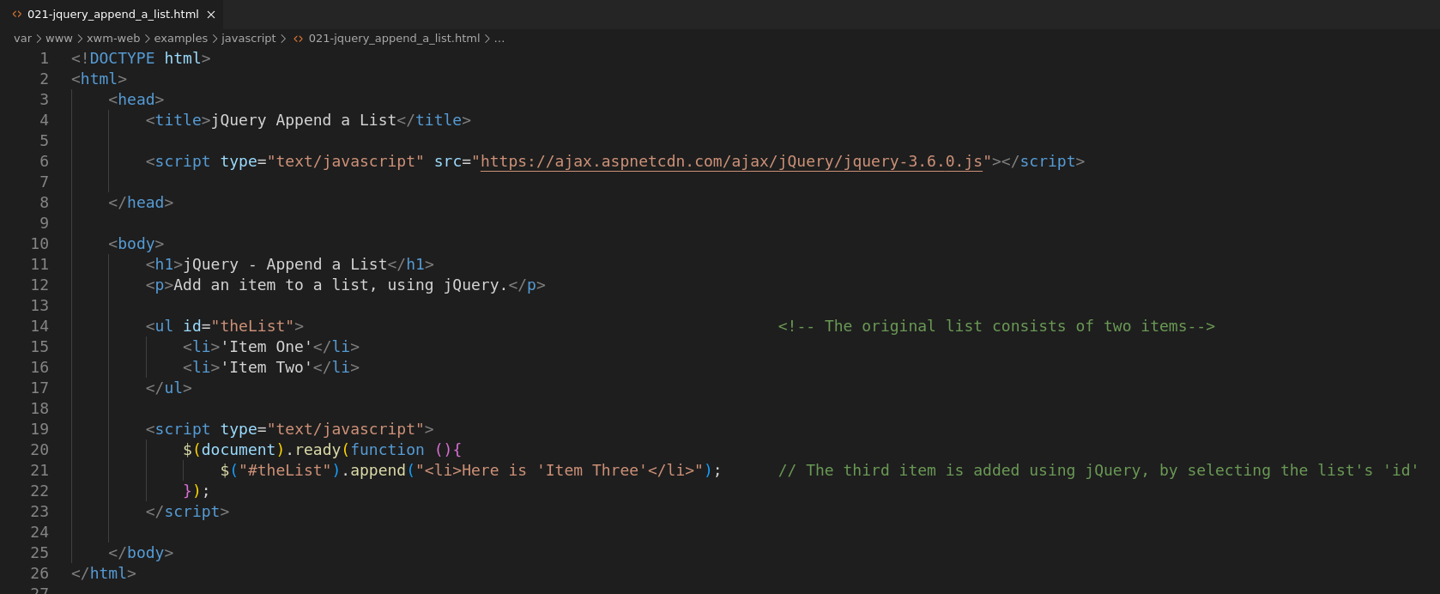

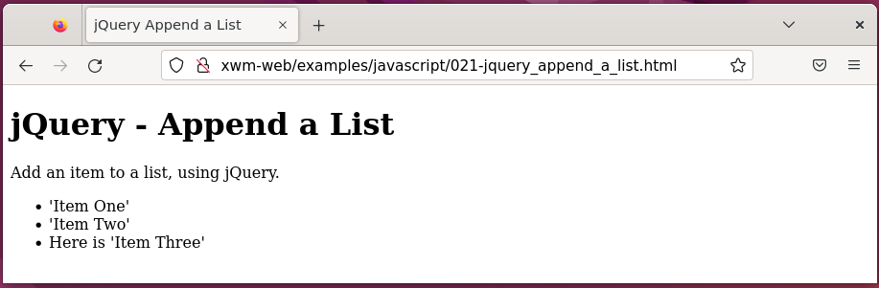

### Changing elements

What about when you want to change something

that already exists?

One way is to loop through each of the list items

and change them.

jQuery has its own way to loop

called **each()**

You can chain the each() function

with other jQuery functions.

Chaining is the term used in jQuery

to describe what you do when you connect functions with dots

to make each function apply to the chain.

The function append() is left in the following example

to show that the change applies not only to the HTML that was originally on the page

but also, to HTML that you add.

*Example - jQuery change html …*

#### Example - jQuery change text

Location: /var/www/xwm-web/examples/javascript/022-jq_change_html.html

URL: http:// xwm-web/examples/javascript/022-jq_change_html.html

<!DOCTYPE html>

<html>

<head>

<title>jQuery - Change HTML</title>

<script type="text/javascript" src="https://ajax.aspnetcdn.com/ajax/jQuery/jquery-3.6.0.js"></script>

</head>

<body>

<h1>jQuery - Change HTML</h1>

<p>HTML can be changed using jQuery.</p>

<ul id="theList"> <!-- Create the original list -->

<li>Original 1</li>

<li>Original 2</li>

</ul>

<script type="text/javascript">

$(document).ready(function() {

$("#theList").append("<li>Original 3</li>"); // Add an additional itme to the list.

$("#theList li").each(function() { // Modify the text of each list item.

var existingText = $(this).text().substr(9,1);

$(this).text("Item " + existingText);

});

});

</script>

</body>

</html>

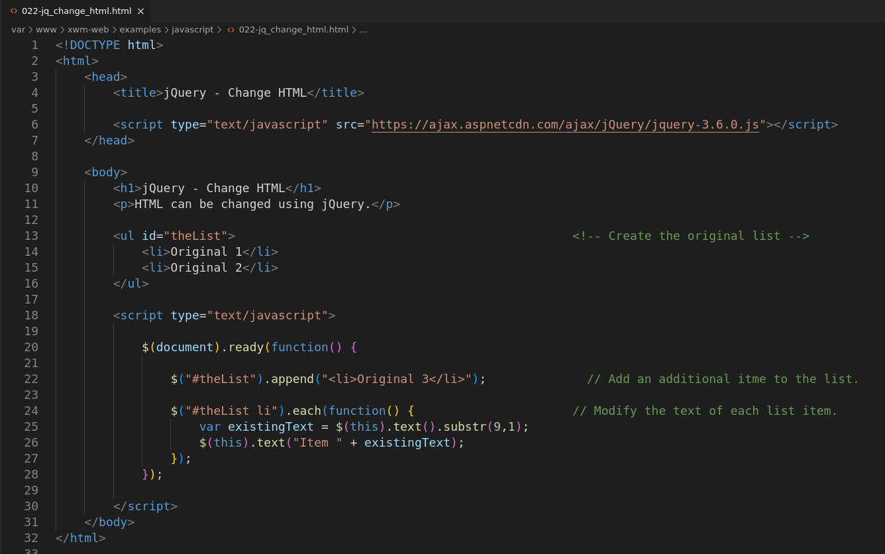

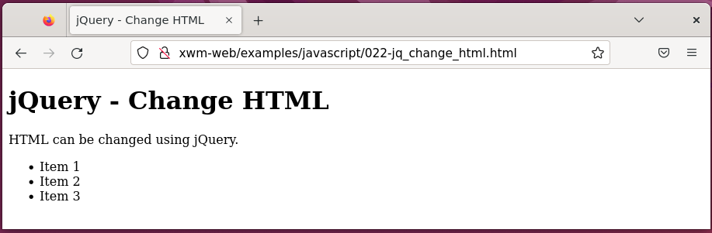

## Changing Attributes and Styles

jQuery makes retrieving and setting HTML attributes

and CSS styles easy.

This means you can change things like:

* an image source
* a CSS class
* or even CSS styles themselves

### Reading attributes

The definitions inside an HTML element

are called an ***attributes***

#### Example – Attributes

<a id=”exLink” class=”link” href=”http://www.example.com”>Website</a>

id, class and href are all attributes.

Using jQuery, you can find and set those attributes.

To read an attribute with jQuery you use the function **attr()**

#### Example – Read a http attribute

Location: /var/www/xwm-web/examples/javascript/023-jq_read_an_html_attribute.html

URL: http:// xwm-web/examples/javascript/023-jq_read_an_html_attribute.html

<!DOCTYPE html>

<html>

<head>

<title>jQuery - Read an HTML attribute</title>

<script type="text/javascript" src="https://ajax.aspnetcdn.com/ajax/jQuery/jquery-3.6.0.js"></script>

</head>

<body>

<h1>jQuery - Read an HTML attribute</h1>

<p>jQuery can be used to read HMTL attributes</p>

<a id="exLink" class="link" href="http://example.com">External website link</a>

<script type="text/javascript">

$(document).ready(function() {

alert($("#exLink").attr("href")); //Read the anchor attribute 'href', and display it in an alert()

});

</script>

</body>

</html>

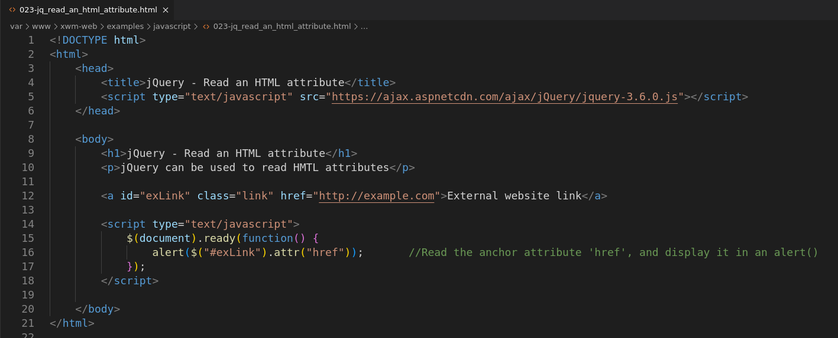

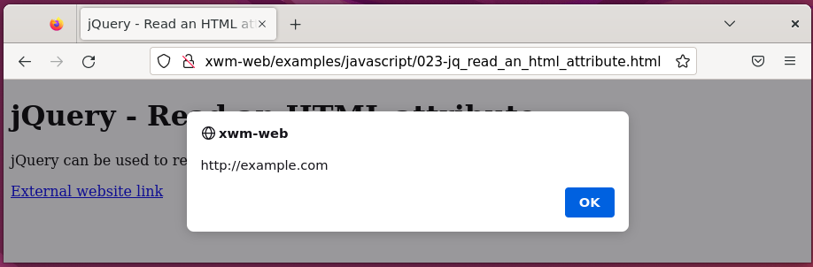

### Writing attributes

You can set the value of an attribute

using the **attr()** function.

For example, to change the value of the href address.

#### Example – Change ‘href’ address

$(“#exLink”).attr(“href”, “http://www.braingia.org”);

Images are added to a page using the **src** attribute.

This means that you can change the src attribute

to change an image, through JavaScript.

*Next, Change a html attribute example …*

#### 

#### Example – Change an image

Location: /var/www/xwm-web/examples/javascript/024-jq_change_an_html_attribute.html

URL: http:// xwm-web/examples/javascript/024-jq_change_an_html_attribute.html

<!DOCTYPE html>

<html>

<head>

<title>jQuery - Change a html attribute</title>

<script type="text/javascript" src="https://ajax.aspnetcdn.com/ajax/jQuery/jquery-3.6.0.js"></script>

</head>

<body>

<h1>jQuery - Change a html attribute</h1>

<p>jQuery can be used to change html attributes <br>

for example, an image. </p>

<img id="theImage" src="/images/flex.jpg" alt="Flex">

<script type="text/javascript">

$(document).ready(function() {

$("#theImage").attr("src", "/images/hearts.jpg"); // Change the image from 'flex.jpg' to 'hearts.jpg'

});

</script>

</body>

</html>

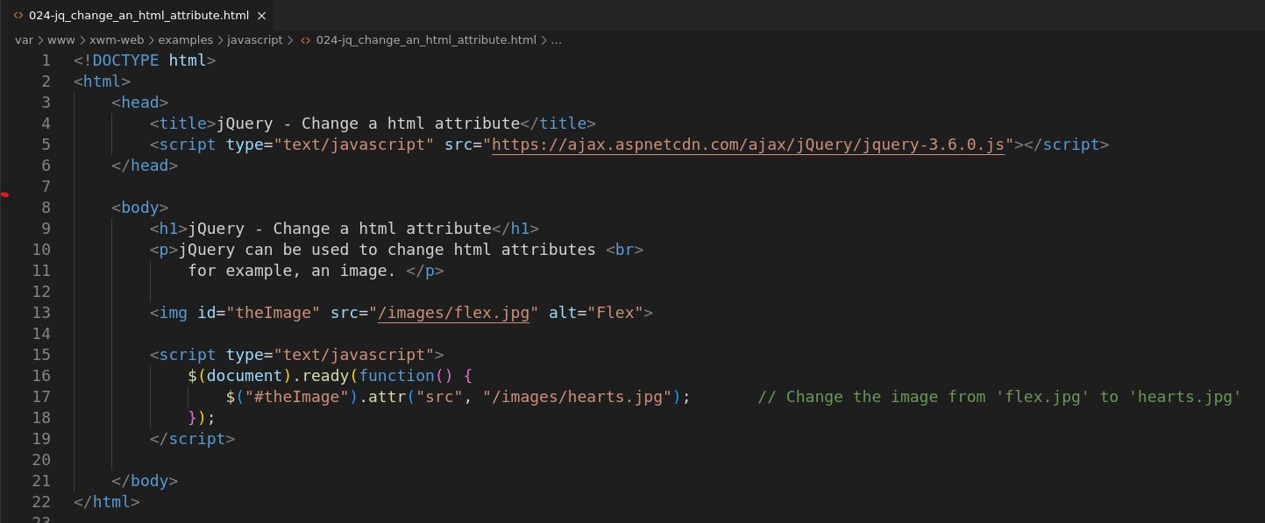

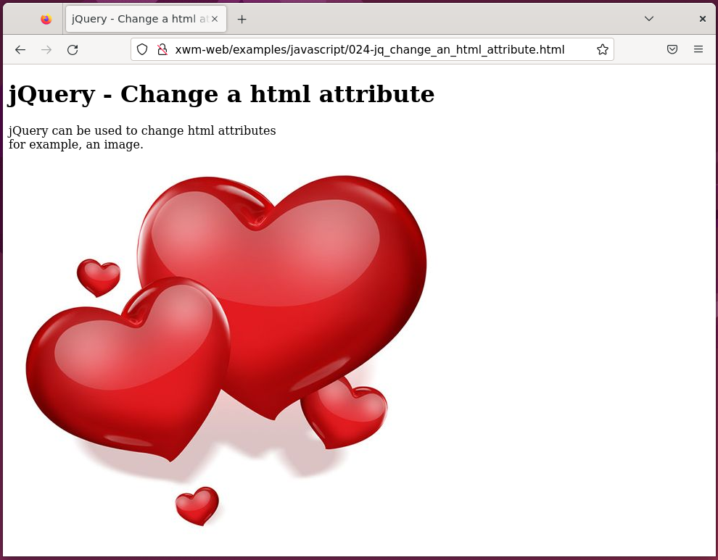

### setTimeout()

The function setTimeout() takes two arguments:

* the function that will be called when the timer expires
* how long to wait *(in milliseconds)*

#### Example – Using a timer

Location: /var/www/xwm-web/examples/javascript/025-jq_timer.html

URL: http://xwm-web/examples/javascript/025-jq_timer.html

<!DOCTYPE html>

<html>

<head>

<title>jQuery Timer</title>

<script type="text/javascript" src="https://ajax.aspnetcdn.com/ajax/jQuery/jquery-3.6.0.js"></script>

</head>

<body>

<h1>jQuery Timer</h1>

<p>The function setTimer() takes two arguments:</p>

<ul>

<li>the function that will be called when the timer expires </li>

<li>how long to wait (in milliseconds)</li>

</ul>

<img id="theImage" src="/images/flex.jpg" alt="flex"

width="250" height="250"> <!-- Original image -->

<script type="text/javascript">

function changeImage() { // Function to change the image

$("#theImage").attr("src", "/images/hearts.jpg"); // New image

$("#theImage").attr("alt", "hearts");

}

$(document).ready(function() {

setTimeout(changeImage, 2500); // Set the timer to change the image.

});

</script>

</body>

</html>

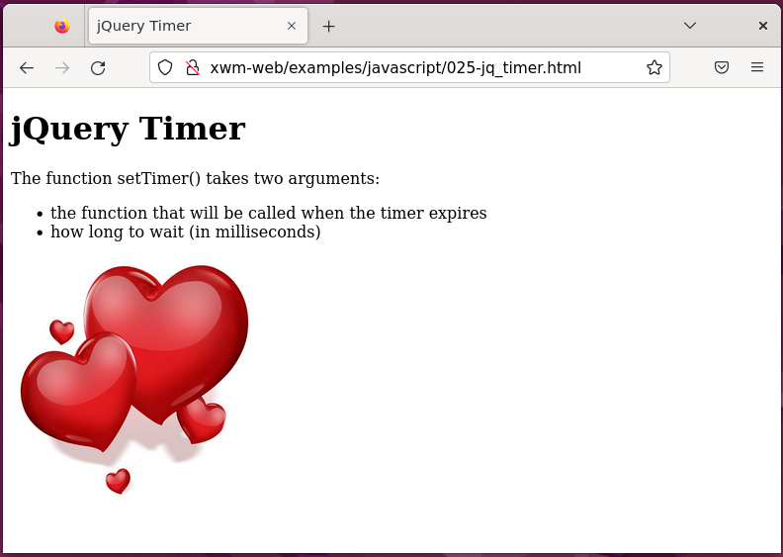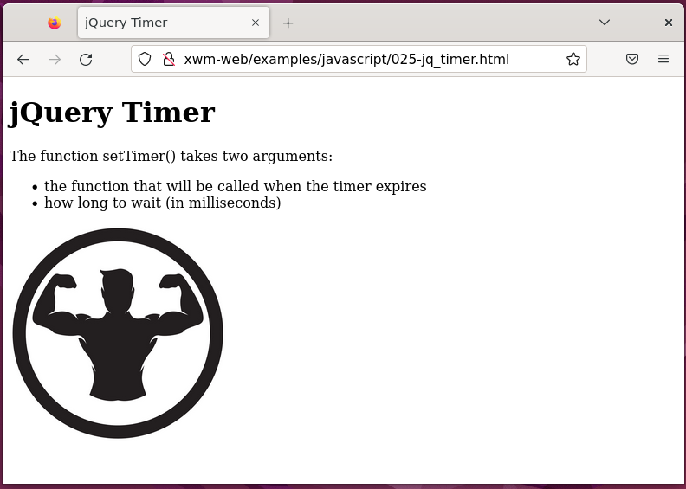

### Changing CSS

You can also change the styling information on a page,

either by setting the styles directly

or by changing the CSS class applied to an element.

class is another element attribute

so changing CSS also uses the attr() function.

#### Example – Add a class

Location: /var/www/xwm-web/examples/javascript/026-jq_add_css_styling.html

URL: http://xwm-web/examples/javascript/026-jq_add_css_styling.html

<!DOCTYPE html>

<html>

<head>

<title>jQuery - Add a Class</title>

<script type="text/javascript" src="https://ajax.aspnetcdn.com/ajax/jQuery/jquery-3.6.0.js"></script>

<style type="text/css">

.borderClass{ /* Create the CSS style */

border:4px solid red; /* (a class that defines a border) */

border-radius: 25px;

}

</style>

</head>

<body>

<h1>jQuery - Add a Class</h1>

<p>You can change the CSS styling on a page <br>

either by setting the styles directly <br>

or by changing the CSS class applied to an element. <br><br>

Class is another element attribute, <br>

so changing CSS also uses the attr() function. </p>

<img src="/images/hearts.jpg" alt="hearts"

id="theImage"

width="250" height="250">

<script type="text/javascript">

$(document).ready(function() {

$("#theImage").attr("class", "borderClass"); // Add the class to the image.

});

</script>

</body>

</html>

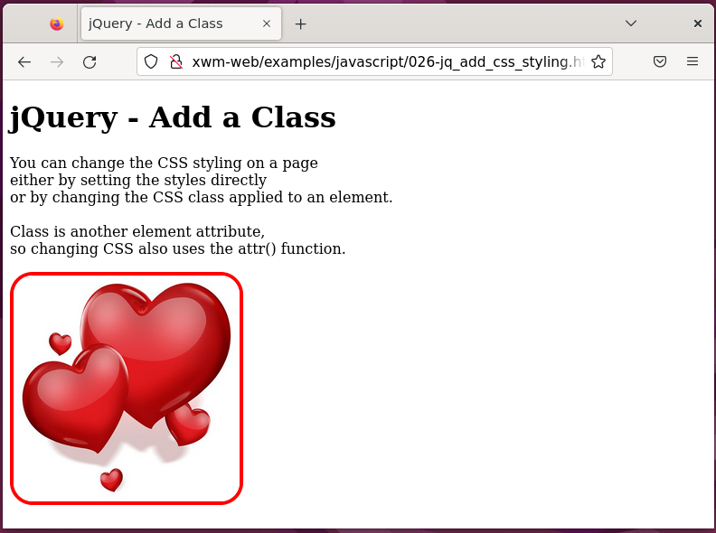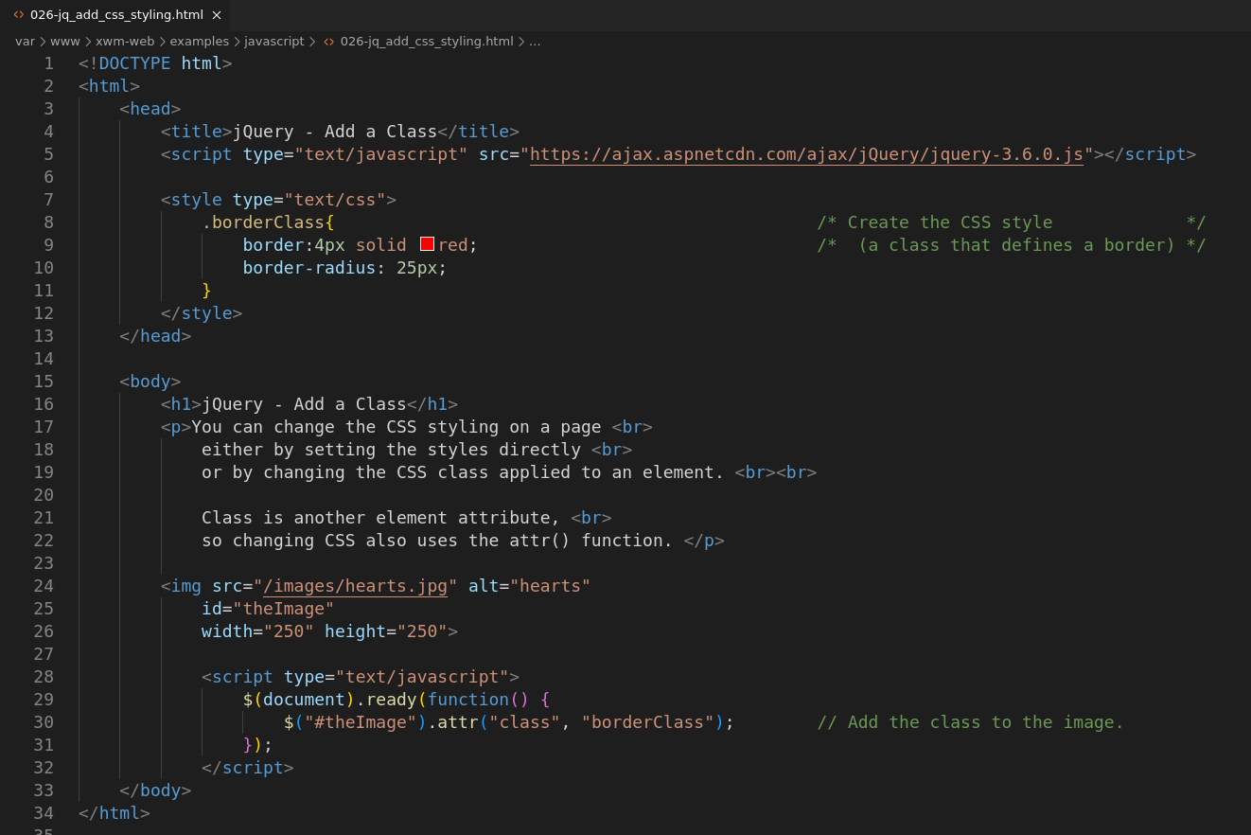AddClass()

But what to do if there’s already a class on the element?

You could first retrieve the classes using attr

and then append another one.

Or you could use the jQuery function for adding a class,

called **addClass()**

The addClass() function doesn’t interfere with any other classes

that are already applied to an element

it just adds another class to it.

Making the change to the code means changing the line:

$(“#theImage”).attr(“class”,”borderClass”);

to:

$(“#theImage”).**addClass**(“borderClass”);

With that simple change, the class .borderClass

would will be added and you don’t have to worry about removing other classes

that are applied to the element.

### Removing a class

The method **removeClass**

removes a class from an element.

Like addClass(), removeClass() doesn’t affect other classes on the element,

it only removes the specified class.

#### Example - Remove a class

$(“#theImage”).removeClass(“borderClass”);

*Next, Reacting to events with JavaScript and jQuery …*

## Reacting to Events with JavaScript and jQuery

Events are the things that happen in a web page

for example, a user might:

* move the mouse over a button
* click a button
* or submit a form

### Working with Forms

A frequent way to use JavaScript with forms

is to provide validation, either:

* as a user fills the form in
* or before it gets submitted to the server

#### Example – Form with no JavaScript

Location: /var/www/xwm-web/examples/javascript/027-form_layout_no_ javascript.html

URL: http://xwm-web/examples/javascript/027-form_layout_no_ javascript.html

<!DOCTYPE html>

<html>

<head>

<title>Form layout - No JavaScript</title>

<script type="text/javascript" src="https://ajax.aspnetcdn.com/ajax/jQuery/jquery-3.6.0.js"></script>

<style type="text/css">

.form_field { /* layout for each label/input pair */

clear: both;

padding: 10px;

width: 350px;

}

.form_field label { /* layout for labels */

float: left;

width: 150px;

text-align: right;

}

.form_field input { /* layout for inputs */

float: right;

width: 150px;

text-align: left;

}

#submit {

text-align: center; /* layout for the submit button*/

}

</style>

</head>

<body>

<h1>Form layout - no JavaScript</h1>

<hr>

<form action="#">

<fieldset>

<legend>Form Information</legend>

<div class="form_field"> <!-- Username -->

<label for="username">Name:</label>

<input type="text"

id="username" name="username">

</div>

<div class="form_field"> <!-- Email -->

<label for="email">E-mail:</label>

<input type="text"

id="email" name="username">

</div>

<div class="form_field"> <!-- Submit button -->

<input type="submit"

id="submit" name="submit"

value="Send Form">

</div>

</fieldset>

</form>

</body>

</html>

*Next, Screenshots …*

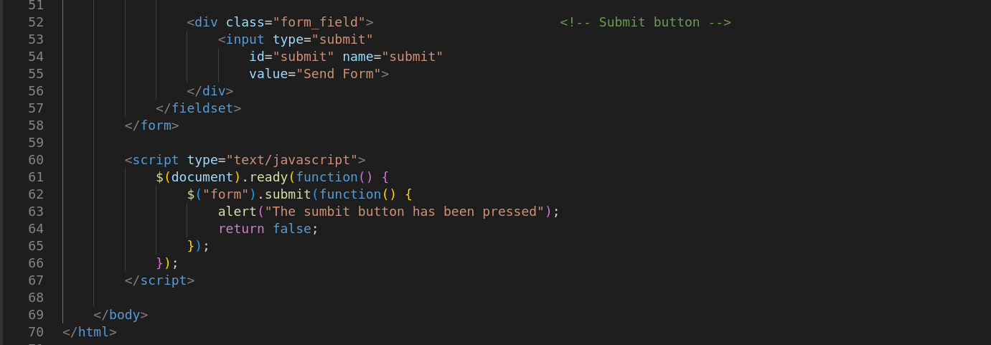 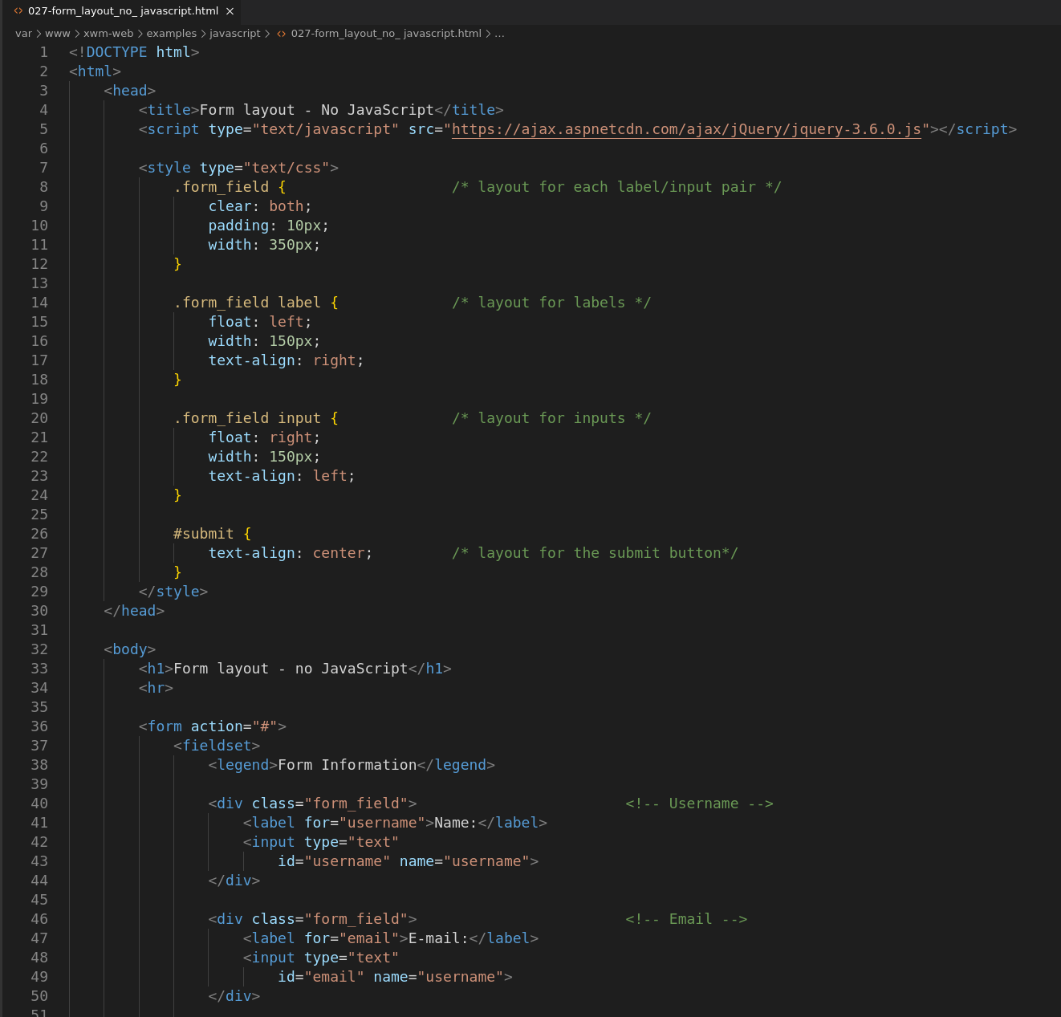

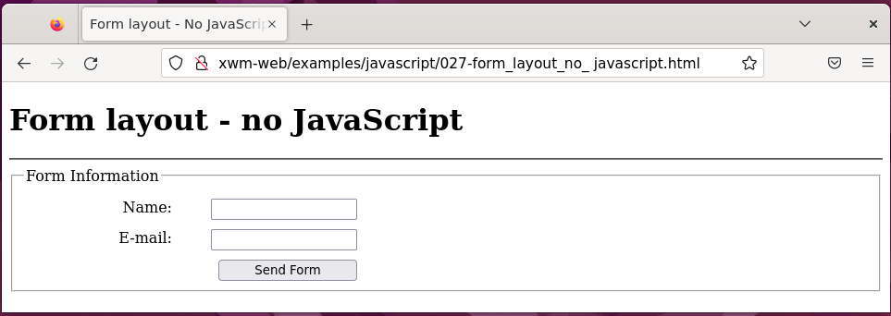

*Next, Respond to the submit button …*

#### Example - Respond to the submit button

Location: /var/www/xwm-web/examples/javascript/028-jq_repond_to_submit.html

URL: http:// xwm-web/examples/javascript/028-jq_repond_to_submit.html

<!DOCTYPE html>

<html>

<head>

<title>Form layout - No JavaScript</title>

<script type="text/javascript" src="https://ajax.aspnetcdn.com/ajax/jQuery/jquery-3.6.0.js"></script>

<style type="text/css">

.form_field { /* layout for each label/input pair */

clear: both;

padding: 10px;

width: 350px;

}

.form_field label { /* layout for labels */

float: left;

width: 150px;

text-align: right;

}

.form_field input { /* layout for inputs */

float: right;

width: 150px;

text-align: left;

}

#submit {

text-align: center; /* layout for the submit button*/

}

</style>

</head>

<body>

<h1>Form layout - no JavaScript</h1>

<hr>

<form action="#">

<fieldset>

<legend>Form Information</legend>

<div class="form_field"> <!-- Username -->

<label for="username">Name:</label>

<input type="text"

id="username" name="username">

</div>

<div class="form_field"> <!-- Email -->

<label for="email">E-mail:</label>

<input type="text"

id="email" name="username">

</div>

<div class="form_field"> <!-- Submit button -->

<input type="submit"

id="submit" name="submit"

value="Send Form">

</div>

</fieldset>

</form>

<script type="text/javascript">

$(document).ready(function() {

$("form").submit(function() {

alert("The sumbit button has been pressed");

return false;

});

});

</script>

</body>

</html>

*Next, Screenshots …*

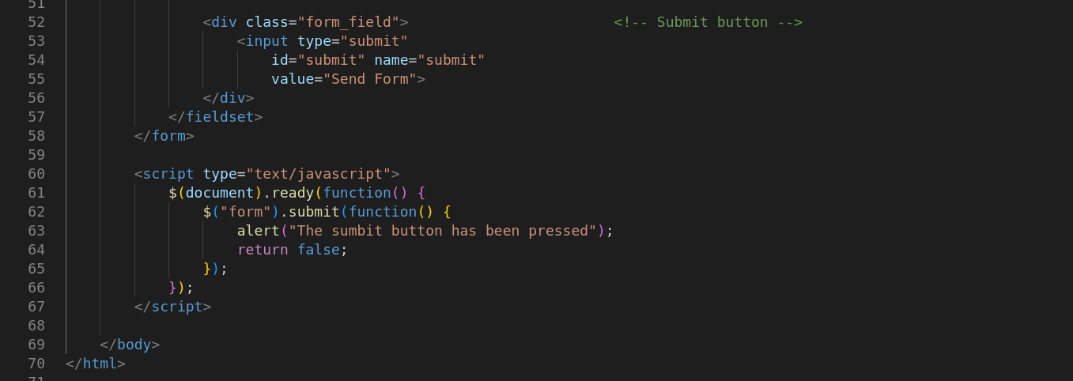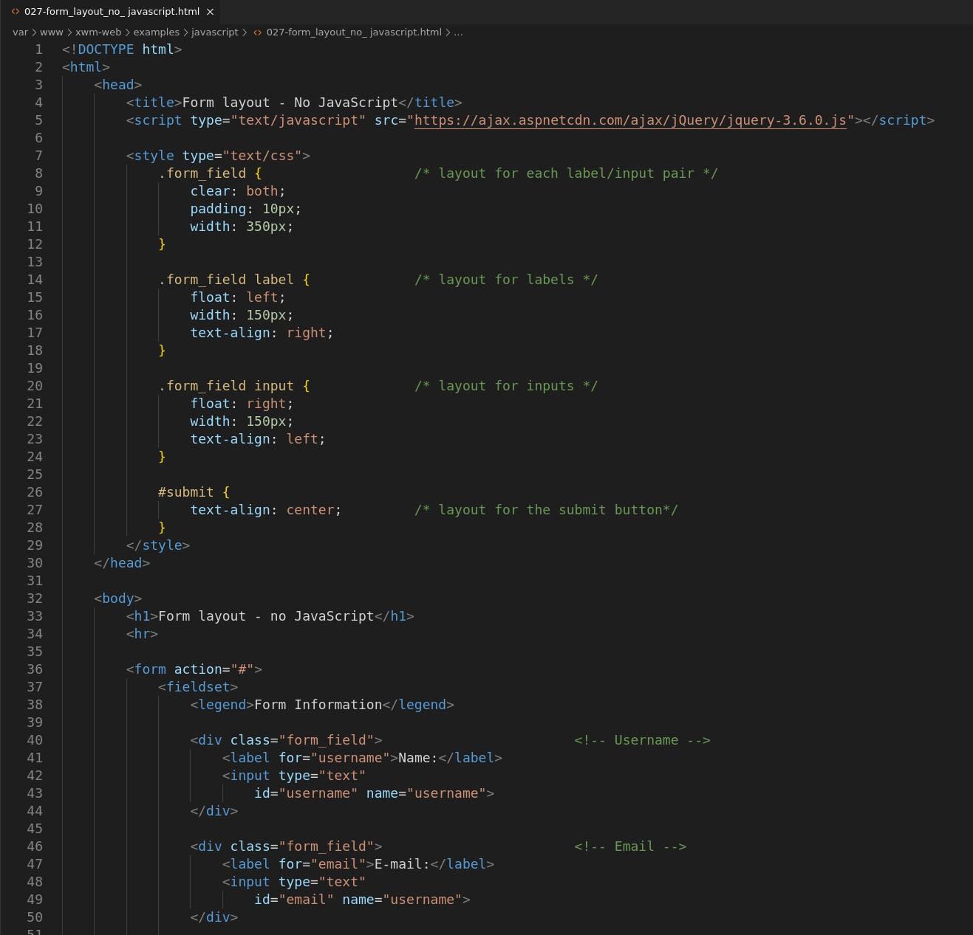

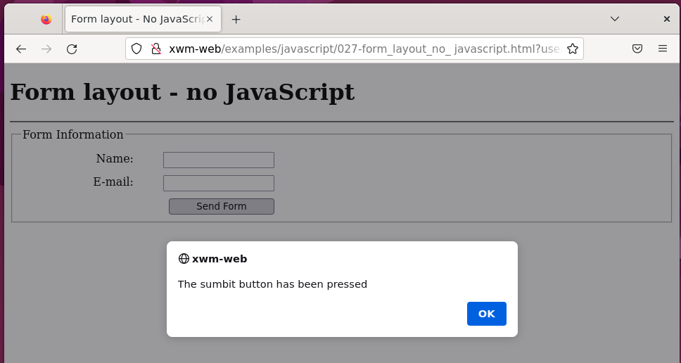

**NOTE:** Using this method, all forms on the page are selected.

If there was more than one form on the page

you’d need to give the form an id

so, you can select the right one.

### return false;

During a submit event

stop the form from being submitted to the server, use **return false;**

*(as shown in the previous example)*

### preventDefault()

**preventDefault()** can also be used

to stop an event’s the default action.

#### Example – Using a combination of ‘preventDefault()’ and ‘return false’

$(document).ready(function() {

$(“form”).submit(function(event) {

alert(“You submitted the form”);

event.preventDefault();

return false;

});

});

*Next, checking for blank fields …*

## Checking for blank fields (p246)

If the field Name is required

for the form to be sent to the server

you can update the JavaScript

to make sure that the field has been filled in.

Recall that the id of the field Name

is username

jQuery can select the id

and get the value for that field.

For that, you can use jQuery’s function **val()**

You can then encapsulate the code in an if statement

to check if the value is empty.

<script type="text/javascript">

$(document).ready(function() {

$("form").submit(function(event) {

if($("#username").val() == "") {

alert("'Name' can not be empty");

event.preventDefault();

}

else {

alert("The sumbit button has been pressed.");

return false;

}

});

});

</script>

*Next, Check for empty username example …*

#### Example - Check for empty username example

Location: /var/www/xwm-web/examples/javascript/029-form_check_for_empty_username.html

URL: http://xwm-web/examples/javascript/029-form_check_for_empty_username.html

<!DOCTYPE html>

<html>

<head>

<title>Form layout - No JavaScript</title>

<script type="text/javascript" src="https://ajax.aspnetcdn.com/ajax/jQuery/jquery-3.6.0.js"></script>

<style type="text/css">

.form_field { /* layout for each label/input pair */

clear: both;

padding: 10px;

width: 350px;

}

.form_field label { /* layout for labels */

float: left;

width: 150px;

text-align: right;

}

.form_field input { /* layout for inputs */

float: right;

width: 150px;

text-align: left;

}

#submit {

text-align: center; /* layout for the submit button*/

}

</style>

</head>

<body>

<h1>Form layout - no JavaScript</h1>

<hr>

<form action="#">

<fieldset>

<legend>Form Information</legend>

<div class="form_field"> <!-- Username -->

<label for="username">Name:</label>

<input type="text"

id="username" name="username">

</div>

<div class="form_field"> <!-- Email -->

<label for="email">E-mail:</label>

<input type="text"

id="email" name="username">

</div>

<div class="form_field"> <!-- Submit button -->

<input type="submit"

id="submit" name="submit"

value="Send Form">

</div>

</fieldset>

</form>

<script type="text/javascript">

$(document).ready(function() {

$("form").submit(function(event) {

if($("#username").val() == "") {

alert("'Name' can not be empty.");

event.preventDefault();

}

else {

alert("The sumbit button has been pressed.");

return false;

}

});

});

</script>

</body>

</html>

*Next, screenshots …*

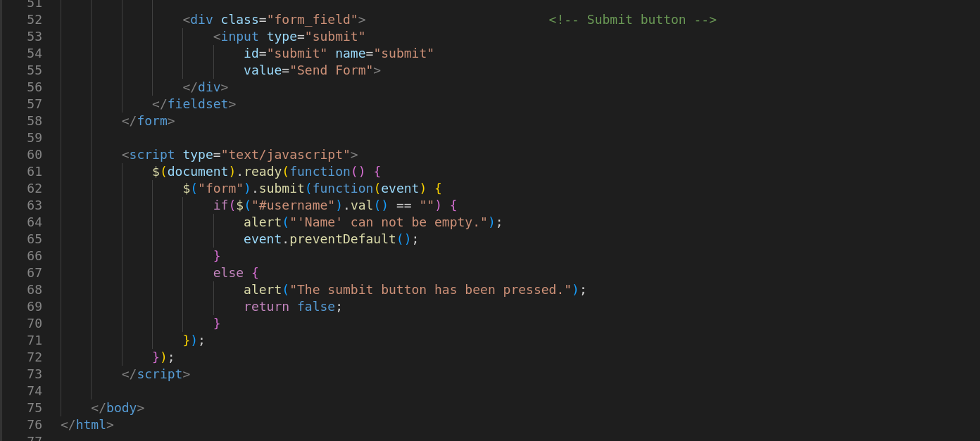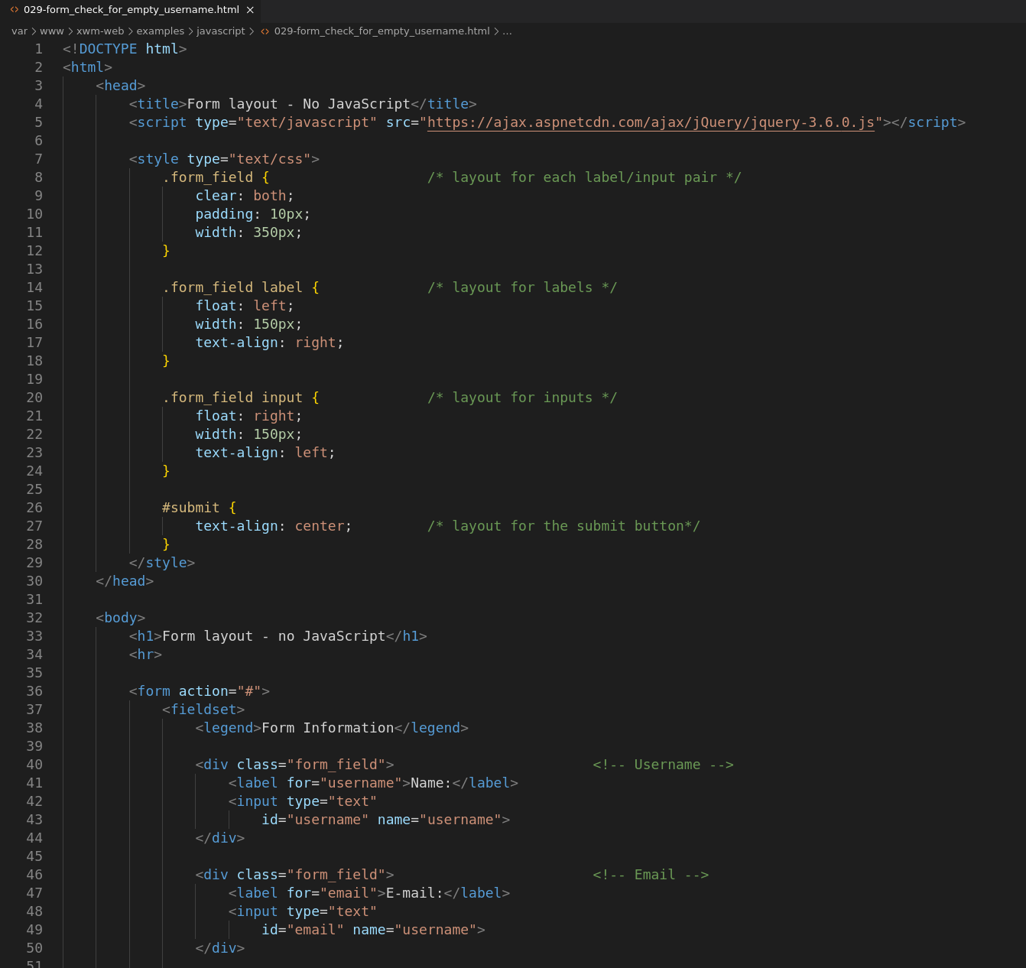

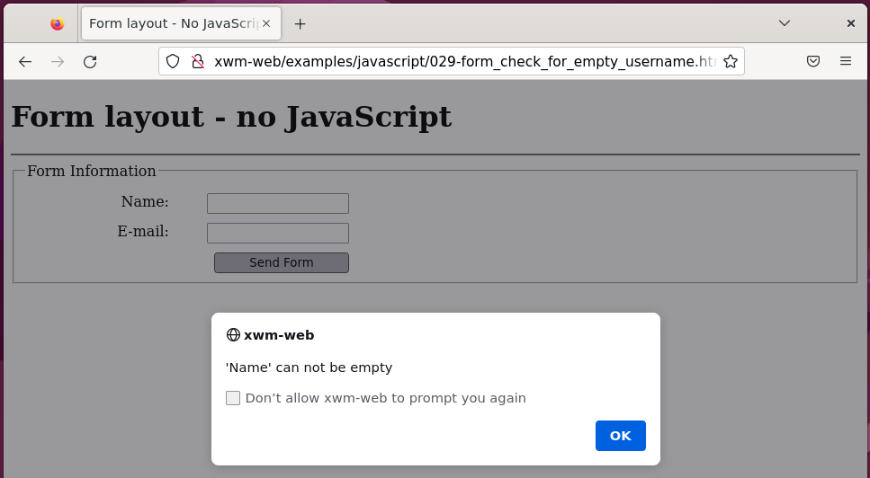

## Mouse Events

### Capturing mouse clicks

A common thing to do is capture mouse click events with JavaScript.

For example, when a person clicks on an image

you can react to it by loading a different image.

In the following example mouse click events

are captured using jQuery.

In the example:

If the 'plain' radio button is pressed

all of the options are unchecked.

If the 'deluxe' radio button is pressed

all of the options are checked.

If one of the option check boxes is selected

the 'custom' radio is checked.

*Next, Radio button and checkbox example …*

#### Example – Radio button and checkbox events

Location: /var/www/xwm-web/examples/javascript/030-form_click_events.html

URL: http://xwm-web/examples/javascript/030-form_click_events.html

<!DOCTYPE html>

<html>

<head>

<title>Form - Click Events</title>

<script type="text/javascript" src="https://ajax.aspnetcdn.com/ajax/jQuery/jquery-3.6.0.js"></script> <!-- required jQuery-->

<style type="text/css">

.form_field {

clear: both;

padding: 10px;

width: 350px;

}

.form_field label {

float: left;

width: 150px;

text-align: right;

}

.form_field input {

float: right;

width: 150px;

text-align: left;

}

#submit {

text-align: center;

}

</style>

</head>

<body>

<h1>Form - Radio Button and Checkbox Events</h1>

<form action="#">

<fieldset>

<legend style="font-size: 110%;">Car Trim and Package Information</legend>

<h3>Package: </h3> <!-- RADIO BUTTONS -->

<div class="form_field">

<input id="plain" type="radio" name="trim" value="plain"> <!-- plain -->

<label for="plain">Plain</label>

</div>

<div class="form_field">

<input id="deluxe" type="radio" name="trim" value="deluxe"> <!-- delux -->

<label for="deluxe">Deluxe</label>

</div>

<div class="form_field">

<input id="custom" type="radio" name="trim" value="custom" > <!-- custom-->

<label for="custom">Custom</label>

</div>

</div>

<br><br>

<h3>Extra Options:</h3> <!-- CHECKBOXES-->

<div class="form_field">

<input type="checkbox" id="foglights" name="option" value="foglights"> <!-- foglights -->

<label for="foglights">Fog Lights</label>

</div>

<div class="form_field">

<input type="checkbox" id="leather" name="option" value="leather"> <!-- leather -->

<label for="leather">Leather</label>

</div>

<div class="form_field">

<input type="checkbox" id="dvd" name="option" value="dvd"> <!-- dvd-->

<label for="dvd">DVD</label>

</div>

</div>

<div class="form_field"> <!-- SUBMIT BUTTON-->

<input id="submit" type="submit" name="submit" value="Send Form">

</div>

</fieldset>

</form>

<script type="text/javascript">

$(document).ready(function() {

$("input[name='trim']").click(function(event)

{

if ($(this).val() == "deluxe") { // If the 'delux' radio button is pressed

$("input[name='option']").prop("checked", true); // check all of the options.

}

else if($(this).val() == "plain") { // If the 'plain' rdio button is pressed

$("input[name='option']").prop("checked", false); // uncheck all fo the options.

}

});

$("input[name='option']").click(function(event) { // If one of the options is selected

$("input[name='trim']").prop("checked","checked"); // select the 'custom' radio button.

});

});

</script>

</body>

</html>

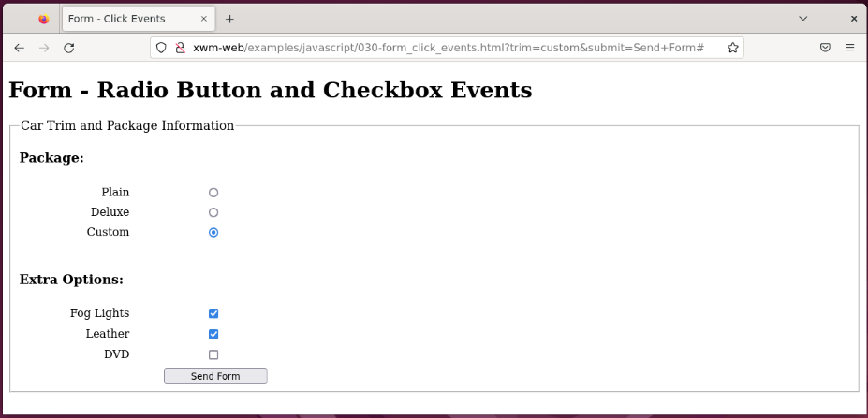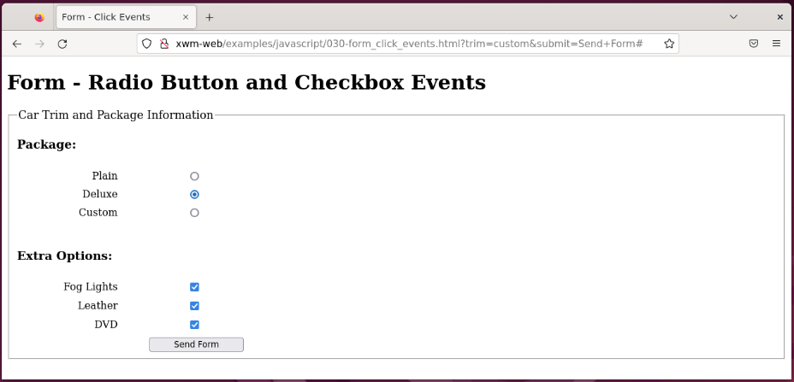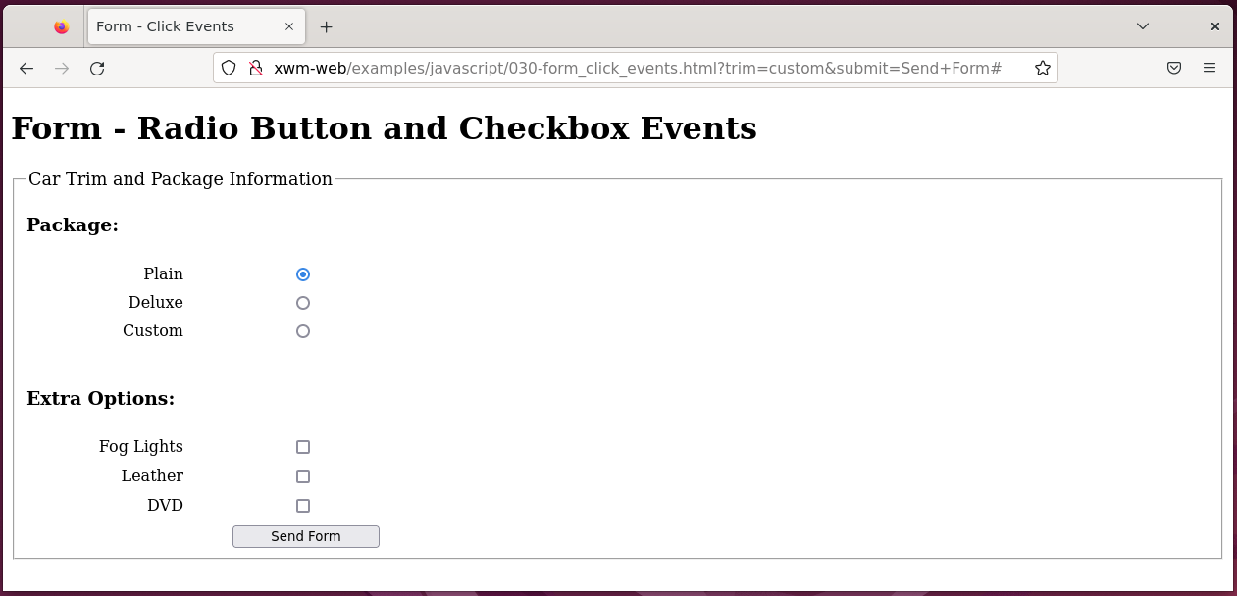

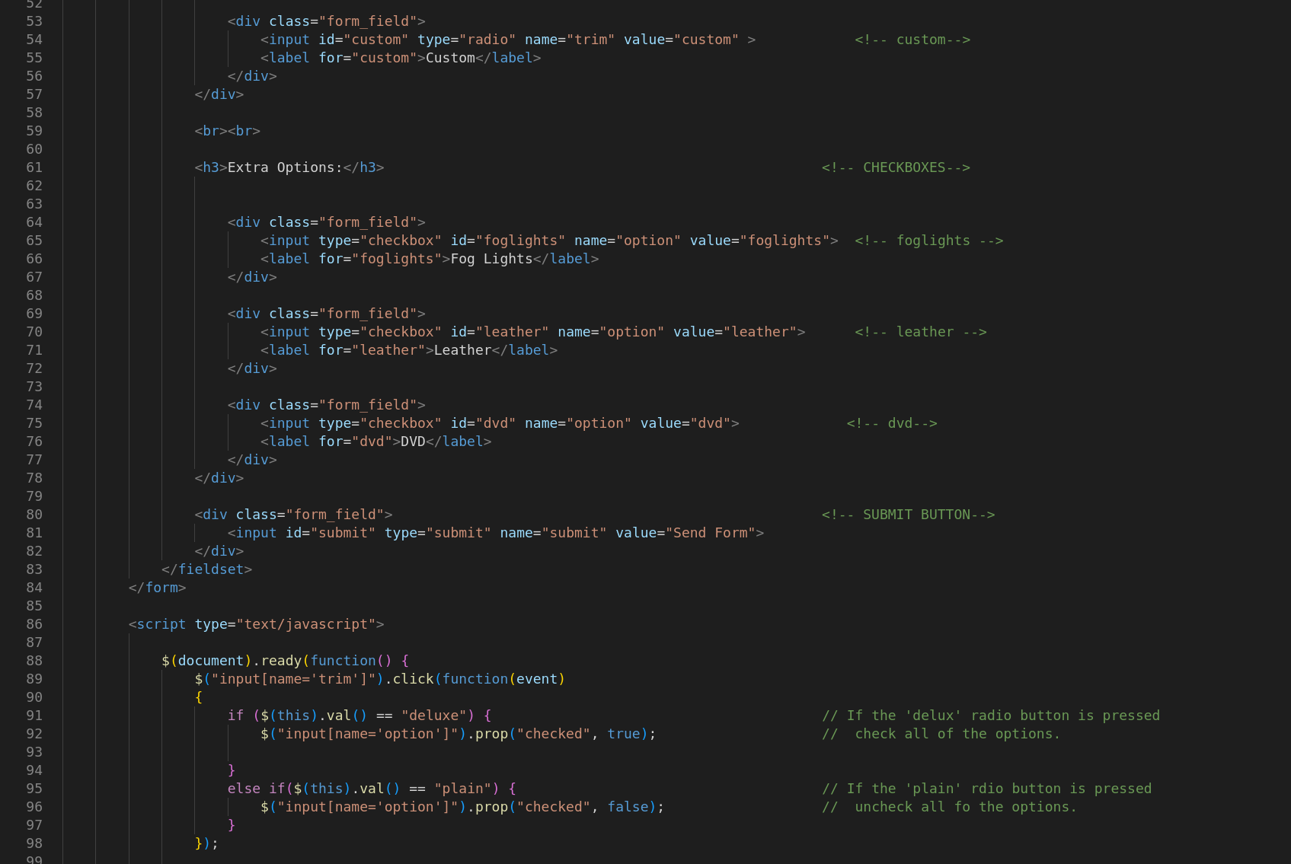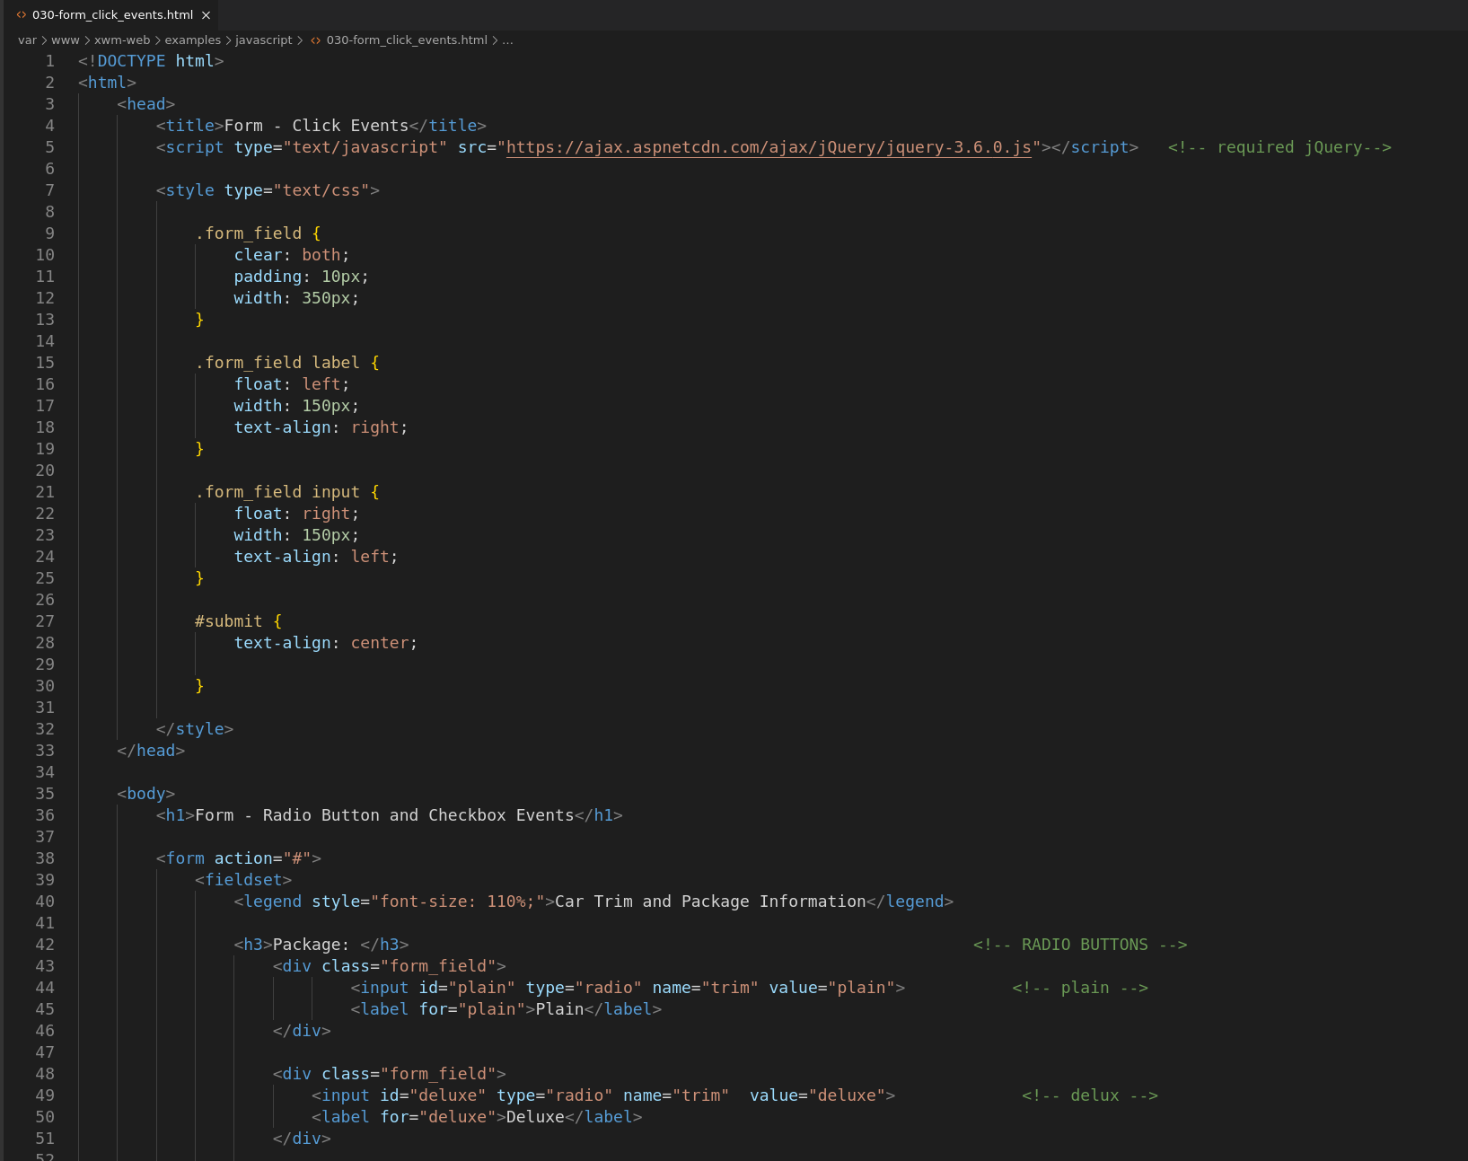

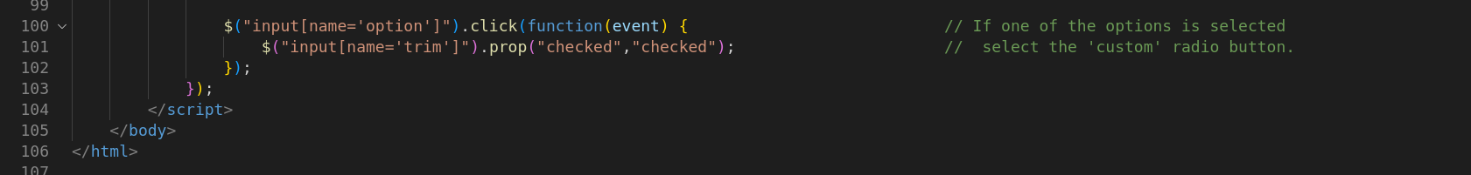

### Mouse movement

You can change an element

when the mouse hovers over it.

You can emulate the hover event handler through CSS.

All items with a class of .box are selected

and the function hover()is chained to them:

$(“.box”).hover(

The function hover() takes two arguments:

what to do when the hover is in effect,

and what to do when a hover finishes.

So, each of those functions is created.

The first one adds a class called “colorBox”

which changes the background color to a shade of grey.

The second function is applied when the mouse moves away from the hover element,

which removes the class “colorBox”

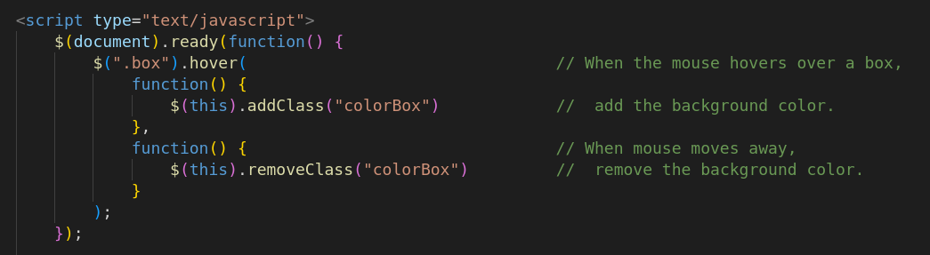

*Next, Mouse hover example …*

#### Example – Mouse hover

Location: /var/www/xwm-web/examples/javascript/031-jq_mouse_hover.html

URL: http://xwm-web/examples/javascript/031-jq_mouse_hover.html

<!DOCTYPE html>

<html>

<head>

<title>Mouse Hover</title>

<script type="text/javascript" src="https://ajax.aspnetcdn.com/ajax/jQuery/jquery-3.6.0.js"></script>

<style type="text/css">

.box{ /* Box layout*/

margin: 50px;

padding: 30px;

width: 50px;

border: 3px solid black;

}

.colorBox { /* Hover background color */

background-color: lightgray;

}

</style>

</head>

<body>

<h1 style="padding: 0 0 35px 0;">jQuery - Mouse Hover</h1>

<span class="box">Box 1</span> <!-- Create boxes-->

<span class="box">Box 2</span>

<span class="box">Box 3</span>

<script type="text/javascript">

$(document).ready(function() {

$(".box").hover( // When the mouse hovers over a box,

function() {

$(this).addClass("colorBox") // add the background color.

},

function() { // When mouse moves away,

$(this).removeClass("colorBox") // remove the background color.

}

);

});

</script>

</body>

</html>

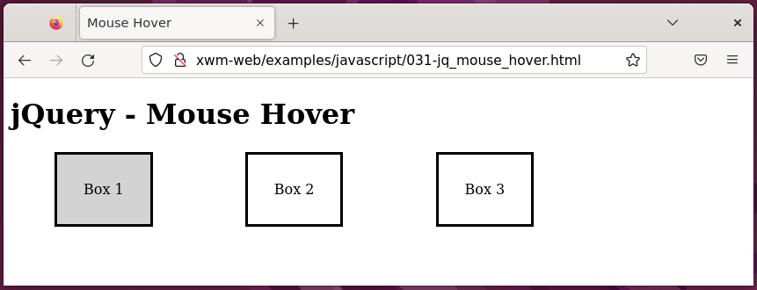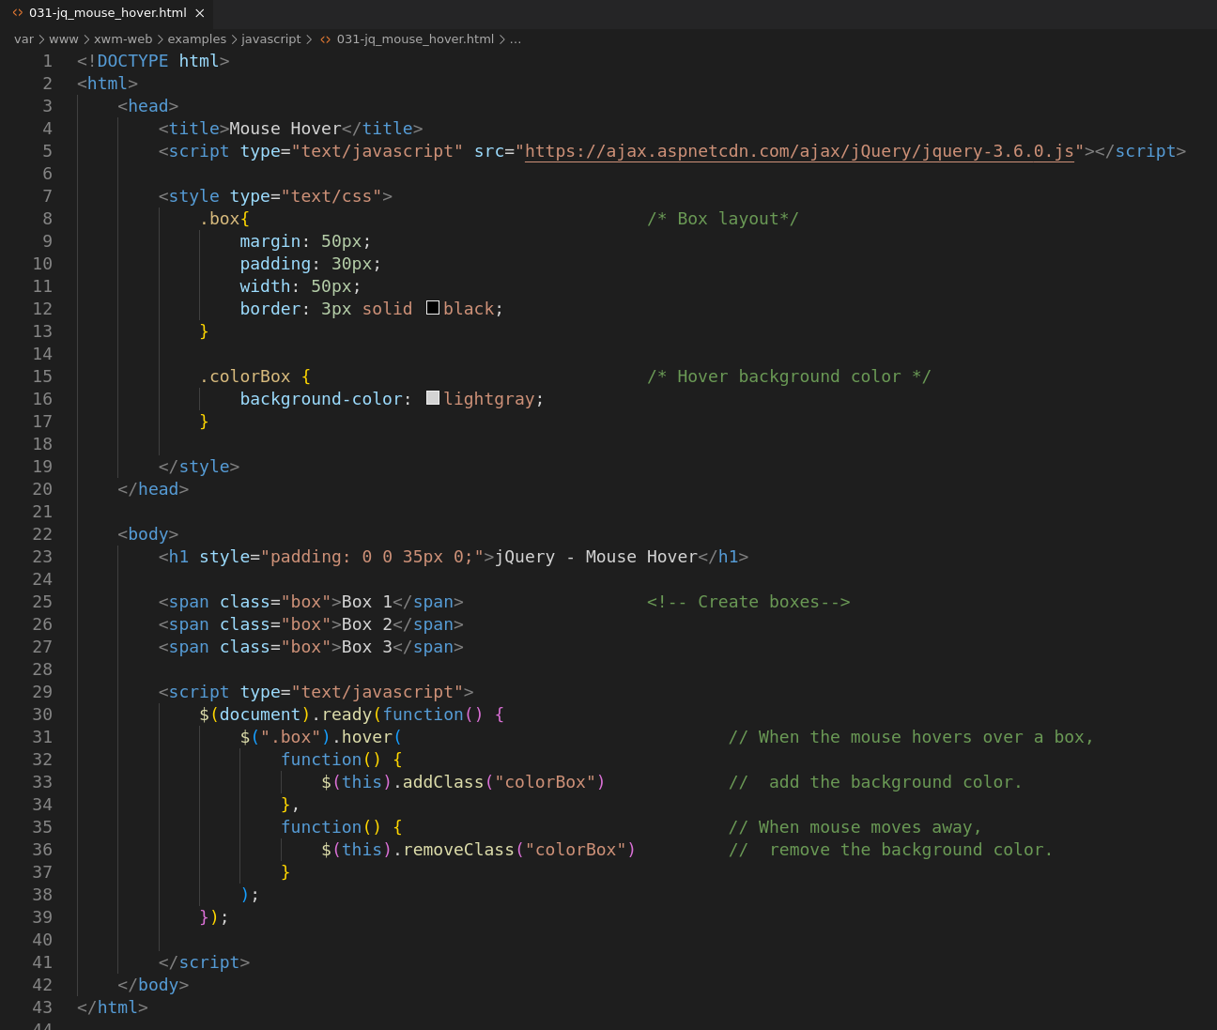

### Keyboard button events

Things like watching when a certain key is pressed

or counting the number of times the keys are pressed

can all be done with JavaScript.

The following example counts the number of button presses.

#### Example – Keyboard button press event

Location:

URL:

<!DOCTYPE html>

<html>

<head>

<title>Keyboard Button Press</title>

<script type="text/javascript" src="https://ajax.aspnetcdn.com/ajax/jQuery/jquery-3.6.0.js"></script>

</head>

<body>

<h1>jQuery - Keyboard Button Press</h1>

<p>The number of remaining characters reduced by one <br>

each time a keyboard button is pressed.</p>

<form action="#">

<textarea id="message" name="message" cols="40" rows="5"></textarea> <!-- Text goes here-->

<p>Characters remaining: <span id="remaining">50</span></p> <!-- Indicates the number of remaing characters-->

</form>

<script type="text/javascript">

$(document).ready(function() {

var maxChar = 50;

$("#message").on("keyup", function() { // When a keyboard button is pressed:

var currentVal = $("#message").val().length; // - get the number of characters in the textarea

var remaining = maxChar - currentVal; // - calculate the number of remaing characters

$("#remaining").text(remaining); // - display the result

});

});

</script>

</body>

</html>

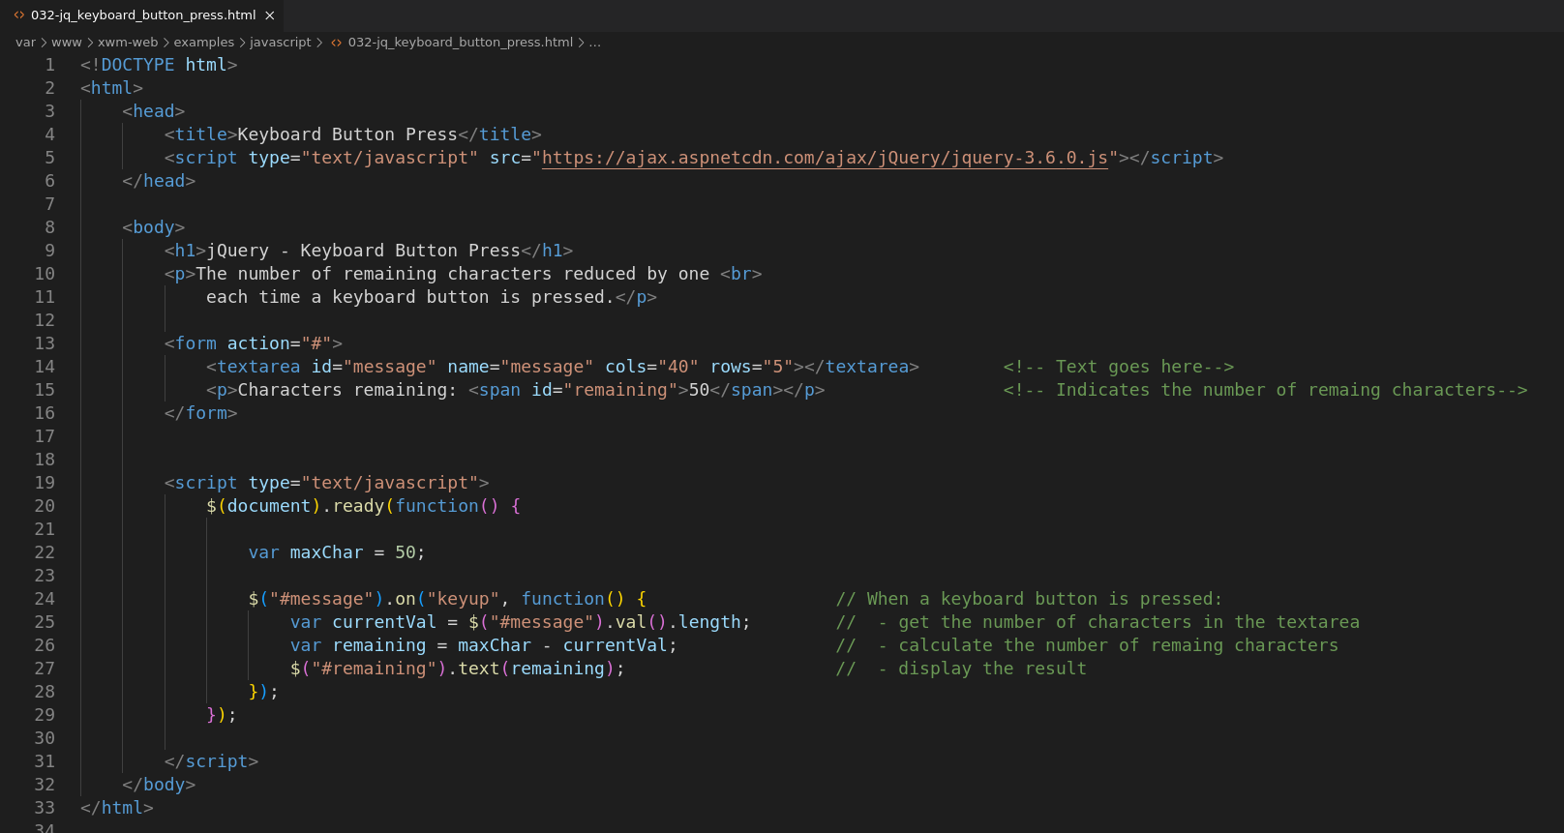

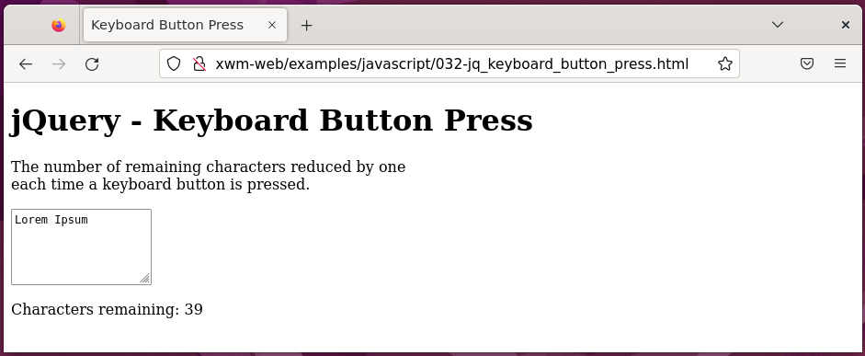

### Preventing character input

You can use JavaScript to disable a form field.

Many sites use a shipping and billing address combination

where a user can click a check box to indicate that

the billing and shipping addresses are the same.

*Next, Prevent character input example …*

#### Example – Prevent character input

Location: /var/www/xwm-web/examples/javascript/033-disable_character_input.html

URL: http://xwm-web/examples/javascript/033-disable_character_input.html

<!doctype html>

<html>

<head>

<title>Disable Character Input</title>

<script type="text/javascript" src="https://ajax.aspnetcdn.com/ajax/jQuery/jquery-3.6.0.js"></script>

</head>

<body>

<h1>jQuery - Disable Character Input</h1>

<form action="#">

Billing the same as shipping address. <!-- Checkbox-->

<input type="checkbox" name="billingAddress" id="billingAddress">

<div style="margin: 10px;"> <!-- Street -->

Street Address:

<input type="text" id="street" class="bAddr" name="street" >

</div>

<div style="margin: 10px;"> <!-- City -->

City

<input type="text" id="city" class="bAddr" name="city">

</div>

</form>

<div style="margin: 25px;">

<p>This page responds to each checkbox click. </p>

<p>When the checkbox is ticked, <br>

the input text boxes are disabled and cleared. </p>

<p>When the checkbox is not ticked, <br>

the input text boxes are enabled. </p>

</div>

<script type="text/javascript">

$(document).ready(function() {

$("#billingAddress").click(function() { // When the checkbox is clicked:

if( document.getElementById('billingAddress').checked ) { // If the checkbox is ticked:

alert("checked"); // - display 'checked'

$(".bAddr").val(""); // - clear the text

$(".bAddr").attr("disabled", "disabled"); // - disable the text input elements

}

else { // Else:

alert("unchecked"); // - display 'unchecked

$(".bAddr").removeAttr("disabled"); // - enable the text inputs

}

})

})

</script>

</body>

</html>

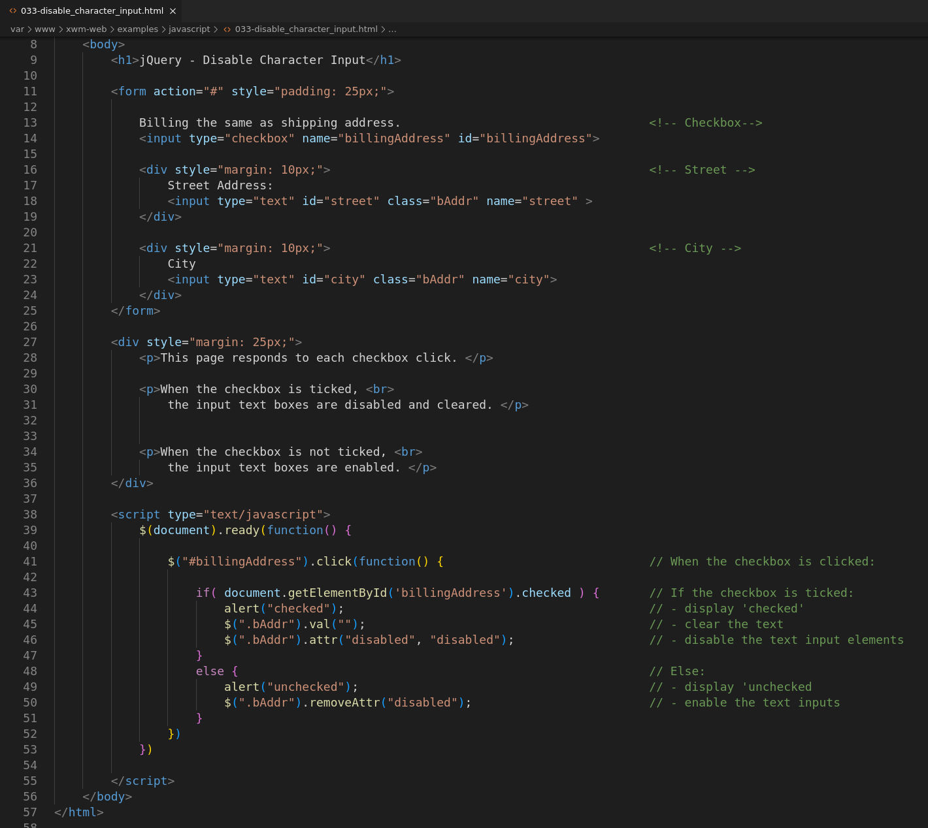

When the checkbox is checked

it implies the billing and shipping address are the same

so, no address needs to be entered.

The input text boxes are disabled and cleared.

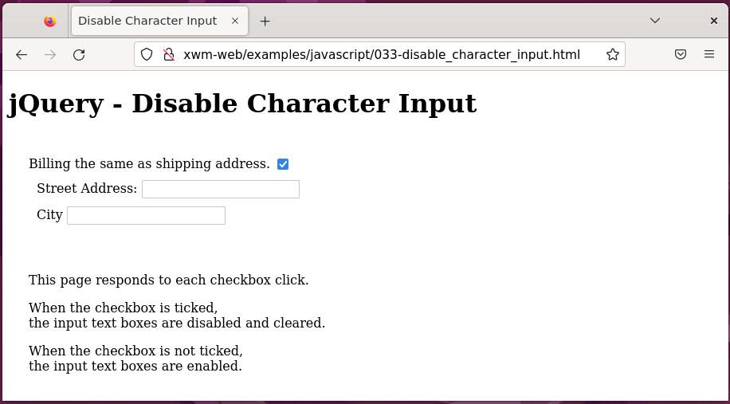

When the checkbox is unchecked

it implies the billing and shipping addresses are different

therefore, an address is required.

The input text boxes are enabled.

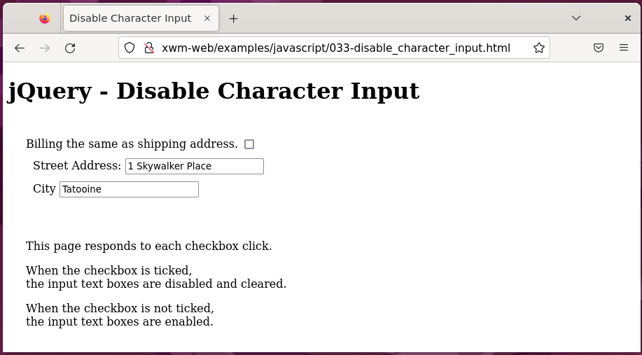

## Troubleshooting JavaScript

Look at the problem from different angles

and reduce it into small parts.

Consider whether the problem is with the database

with the PHP, with the server, with the JavaScript

or none of those *(or more than one)*

### Comments

You can comment sections of code out entirely

then gradually add them back in.

In JavaScript, comments come in two forms.

**//** single line comment.

**/\*** slash-asterisk format for comments that span multiple lines.

### alert()

Use alert() functions to see if code is being reached

and to display relevant information.

### Developer tools

Press F12 browsers to display browser developer tools.

#### Edge Chrome ` Firefox

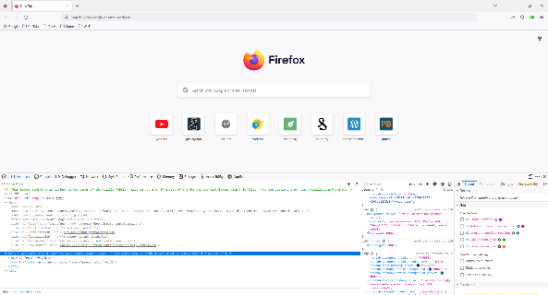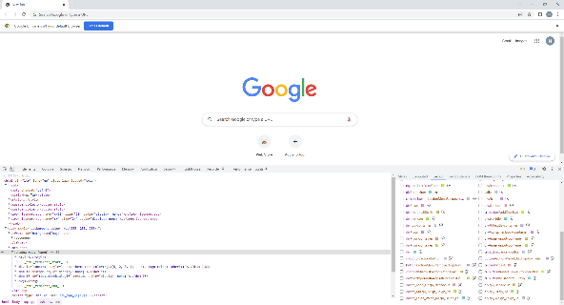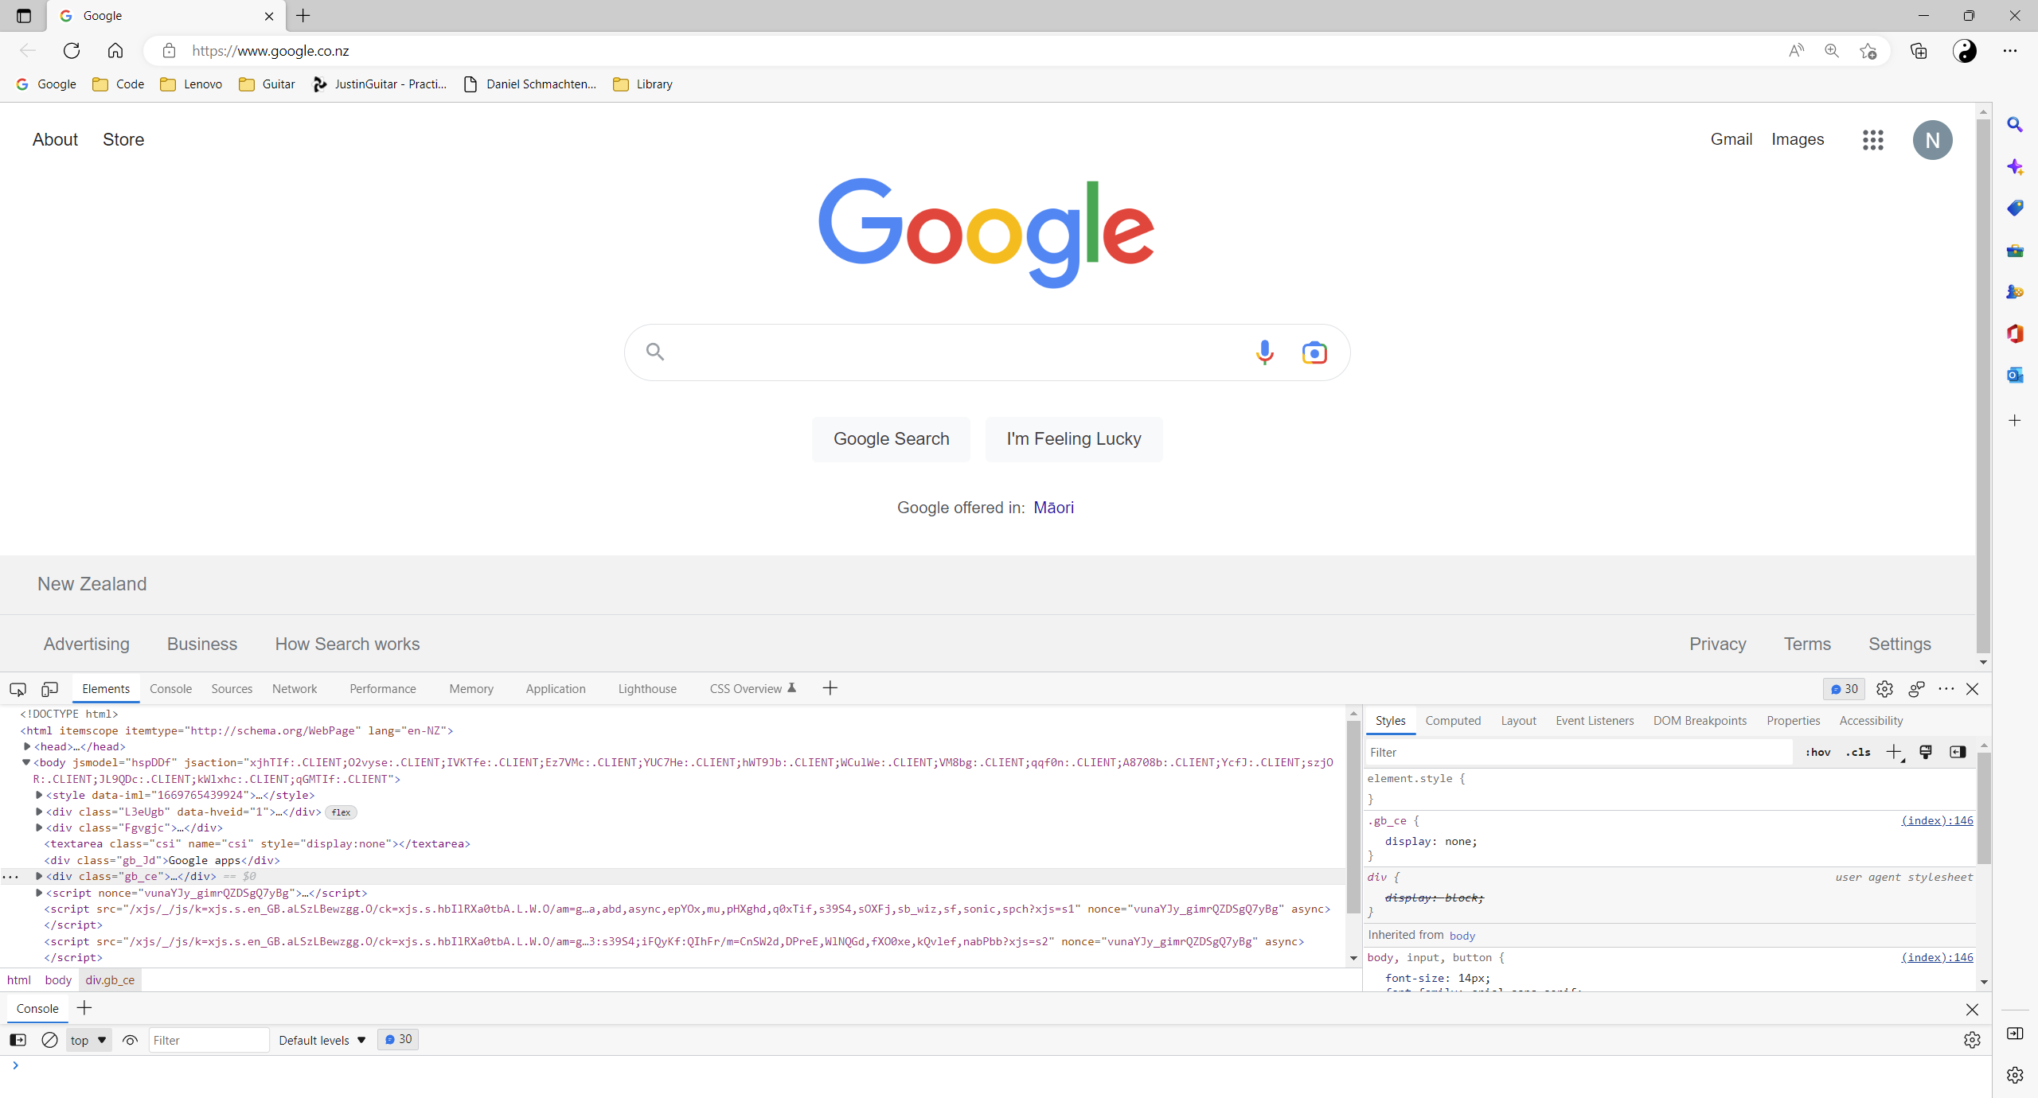

# PHP

PHP description

**PHP**is an embedded scripting language

designed specifically for use on the web.

It includes features to develop dynamic web applications.

The PHP software works with the **web server**

It processes user requests then sends HTML

from the server, back to the user’s browser.

When PHP is installed, the server expects some file extensions

to contain PHP language statements, for example: .php or .phtml

### PHP Tags

In a PHP statement:

**<?php** *is the PHP opening tag*

**?>** *is the closing tag*

#### Example – PHP ‘hello world’

<?php echo “<p>Hello World</p>”; ?>

### PHP Process

The PHP file is processed as follows:

1. The web server starts scanning the file in HTML mode.

It assumes the statements are HTML

and sends them to the browser without any processing.

1. The web server continues in HTML mode

until it encounters a PHP opening tag **<?php**

1. When it encounters a PHP opening tag

the web server hands the processing over to the PHP module.

This is sometimes called *’escaping from HTML’.*

The webserver then assumes that all statements are PHP statements

and uses the PHP module to execute the PHP statements.

If there is output from PHP

the server sends the output to the browser.

1. The web server continues in PHP mode

until it encounters a PHP closing tag **?>**

1. When the web server encounters a PHP closing tag,

it returns to HTML mode.

The browser doesn’t see the PHP section

it only receives its html output.

*Next, Install PHP …*

## Install PHP

To install PHP, run the command:

sudo apt update

then

sudo apt install php

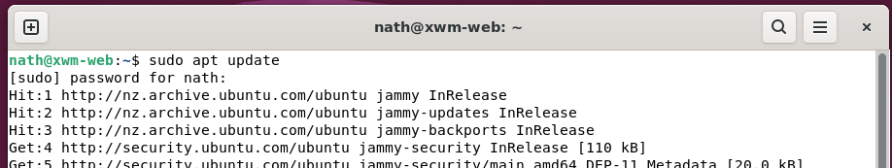

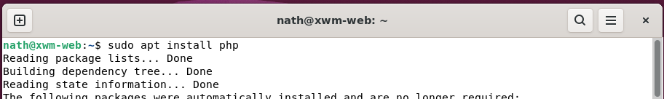

To check the version of php, run the command

php -v

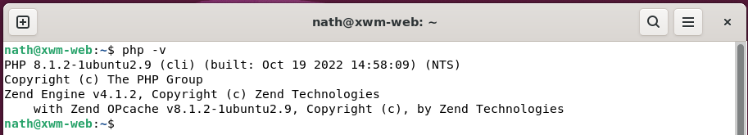

*Next, PHP ‘hello world’ example …*

#### Example – php ‘Hello World’

Location: /var/www/xwm-web/examples/php/002-hello_world.php

URL: http://xwm-web/examples/php/002-hello_world.php

<!doctype html>

<html>

<head>

<title>PHP - Basic Script</title>

</head>

<body>

<h1>PHP - Basic Script</h1>

<?php // PHP tag

echo "<p>Hello World!</p>"; // Write a HTML message in PHP

?> <!-- Closing tag -->

</body>

</html>

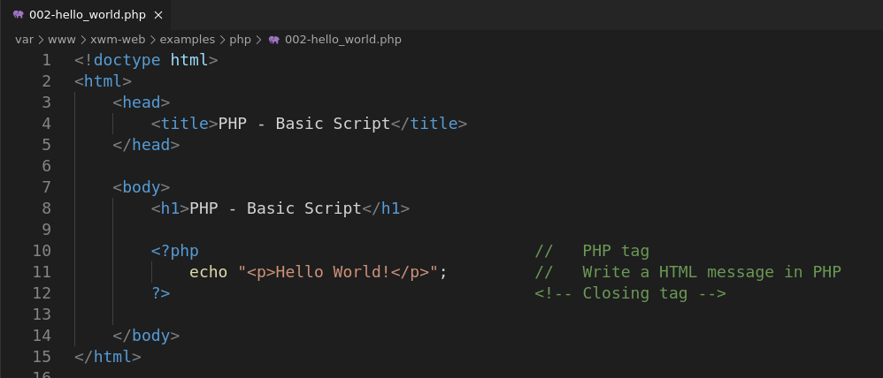

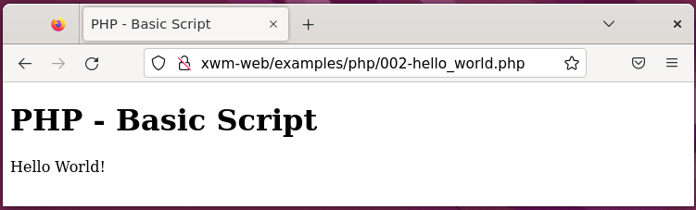

*Next, phpinfo() example …*

#### Example – phpinfo()

The method phpinfo() displays information

regarding the php server configuration.

Location: /var/www/xwm-web/examples/php/001-php_info.php

URL: http://xwm-web/examples/php/001-php_info.php

<!doctype html>

<html>

<head>

<title>PHP - phpinfo()</title>

</head>

<body>

<h1>phpinfo()</h1>

<p>Display information regarding PHP's server configuration.</p>

<?php

phpinfo(); // Display information regarding PHP's server configuration.

?>

</body>

</html>

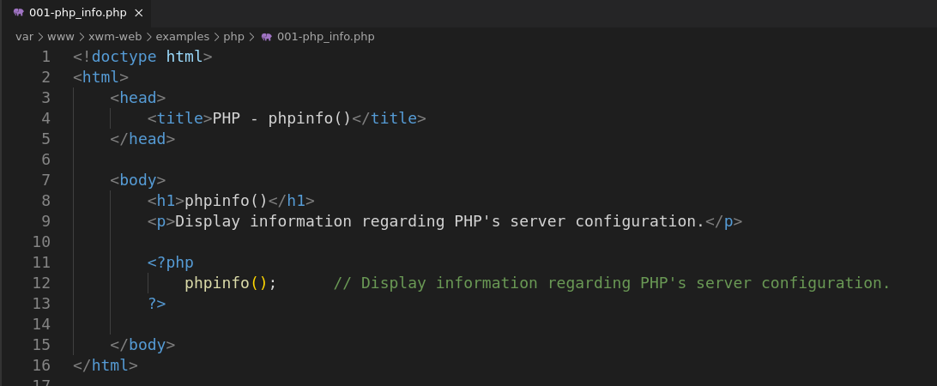

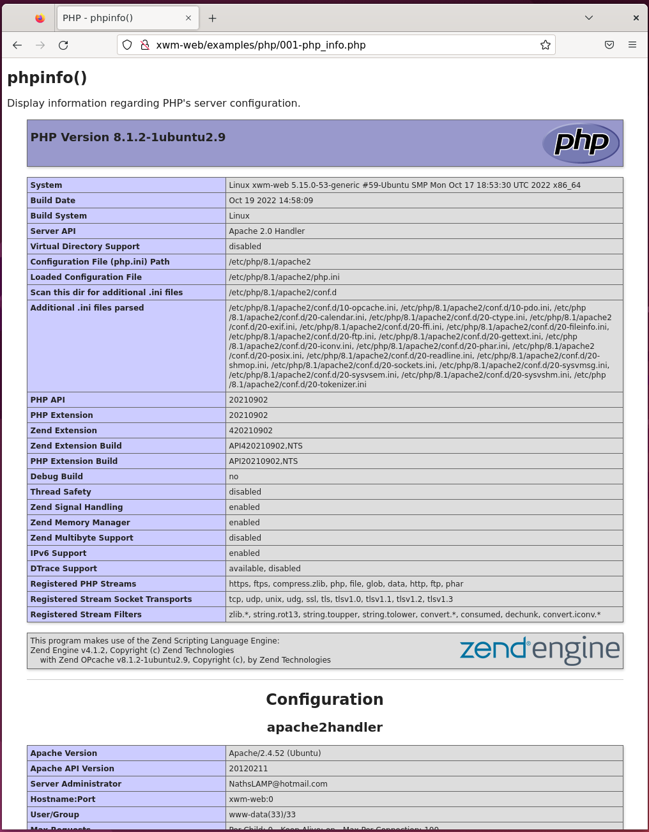

## PHP Variables

A variable has a name and stores information.

For instance, you might name a variable $age

and store the number 12

### Naming a variable

When naming a variable, keep the following rules in mind:

**Identifier:**

All variable names have a dollar sign **$** in front of them.

**Acceptable characters:**

Variable names can include letters, numbers, and underscores.

**Beginning of name:**

Variable names must begin with a letter or underscore.

**Case sensitivity:**

Uppercase and lowercase letters are not the same.

$firstname and $Firstname are not the same variable.

### Creating and assigning values to variables

Variables can hold numbers or strings of characters.

You store information in variables using a single equal sign **=**

#### Example – Assigning variable values

$name = “Bob Builder”; *(strings are enclosed in quotes)*

$price = 2.55;

$number = -2;

$age = 12;

$age = “”; *(*$age *contains no value )*

unset($age); ($age no longer exists )

### Using variables in ‘echo’ statements

You can display the value in a variable on a web page

with an echo or print statement.

<p>Your age is <?php echo $age ?>.</p>

*Next, Displaying variables with ‘var_dump’ statements …*

### Displaying variables with var_dump()

The function **var_dump()**

is a good troubleshooting tool.

It displays a variable’s:

* datatype
* value
* number of characters

#### Example – var_dump()

Location: /var/www/xwm-web/examples/php/003-var_dump().php

URL: http://xwm-web/examples/php/003-var_dump().php

<!doctype html>

<html>

<head>

<title>PHP - vardump()</title>

</head>

<body>

<h1>PHP - vardump()</h1>

<p>Use <b>vardump()</b> to display a variable's datatype and it's value.</p>

<?php

$weekday = "Monday"; // Create the variable

echo"For example, a var_dump() of the variable weekday displays: <br> \n";

var_dump($weekday); // Display the variable using var_dump()

?>

</body>

</html>

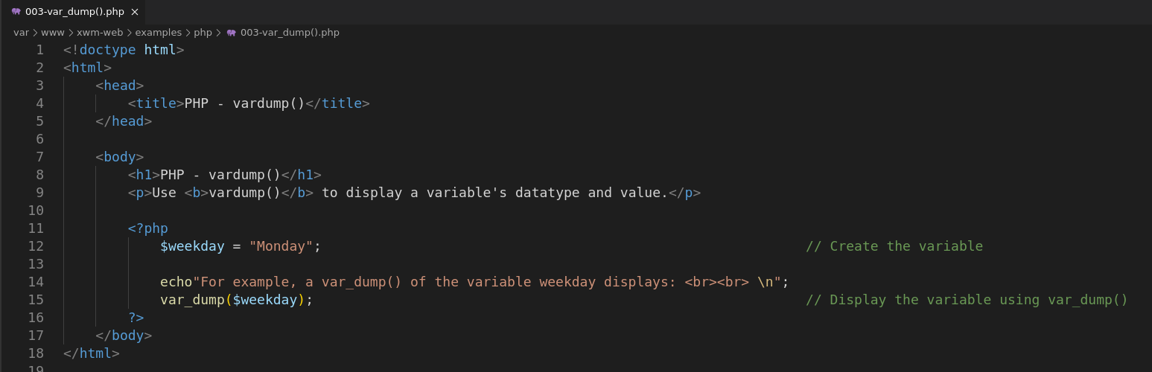

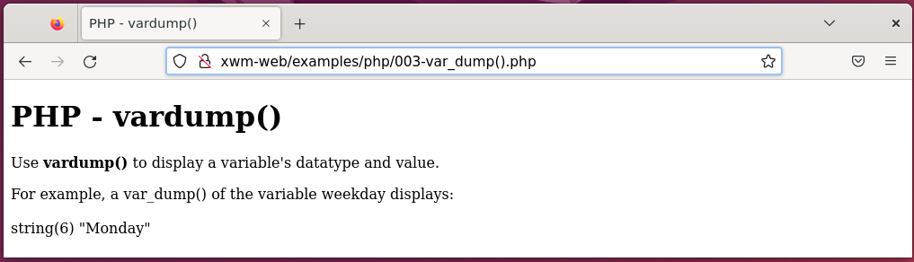

## PHP Constants

Constants are useful when a value is needed in several places

and normally would not change

for example, a company name or website URL.

define(“COMPANY”, ”Awesome Company Name”);

#### Example – Defining constants

Location: /var/www/xwm-web/examples/php/004-define_a_constant.php

URL: /var/www/xwm-web/examples/php/004-define_a_constant.php

<!doctype html>

<html>

<head>

<title>Define a constant</title>

</head>

<body>

<h1>PHP - Define a constant</h1>

<p>Constants are useful when a value will not change <br>

for example, a company's name </p>

<?php

define("COMPANY", "Naths Lamp"); // Define the constant

echo"Company Name: ";

echo COMPANY; // Display the constant (NOTE: no speech marks)

?>

</body>

</html>

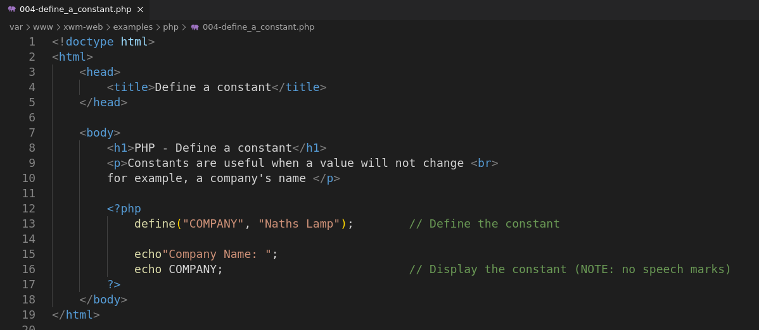

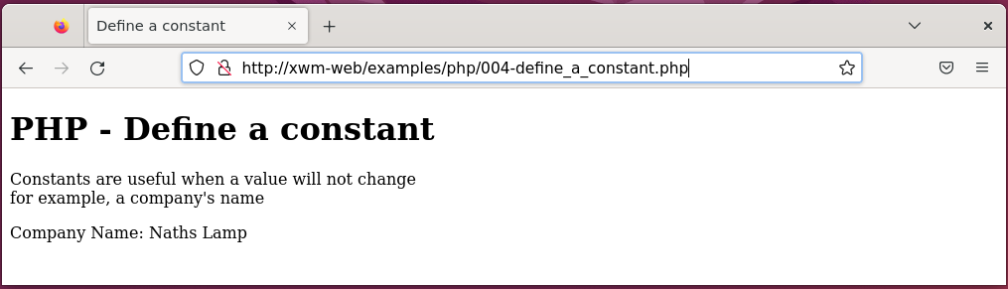

You can use any name for a constant that you can use for a variable

using these conventions:

**No identifier:**

Constant names are not preceded by a dollar sign $

**Case:**

Constants names are all uppercase,

so, they are easy to see *(it’s not required it’s just clearer)*

**Characters:**

You can store either a string or a number, eg

define (“AGE”, 29);

PHP determines the data type automatically.

When writing PHP scripts

you don’t need to specify which datatype you’re storing.

### Variable datatypes

The following two statements store different data types:

$var1 = 123;

$var2 = “123”;

$var1 is stored as an integer.

$var2 is stored as a string, because it’s enclosed in quotes.

### Determining a data type

Occasionally, you might want to store a value as a data type

different than the data type PHP automatically stores.

You can set the data type for a variable with a **cast**

$var3 = “222”;

$var4 = (int)$var3;

### Formatting dollar amounts

To put numbers into the proper format for dollars,

you can use **sprintf**

#### Example – Converting values with sprint()

Location: /var/www/xwm-web/examples/php/005a-convert_to_currency_using_sprintf().php

URL: htttp:// xwm-web/examples/php/005a-convert_to_currency_using_sprintf().php

<!doctype html>

<html>

<head>

<title>Convert to Currency</title>

</head>

<body>

<h1>PHP - sprintf() convert an integar to currency</h1>

<p>Convert a variable to currency, using <b>sprintf()</b> </p>

<?php

$orig_price = 10000; // Original integer.

$conv_price = number_format($orig_price, 2); // Use number_formatf() to convert a value to the correct format.

// Display the:

echo"Original price: $orig_price <br>"; // - original value

echo"Converted price: $conv_price"; // - converted value

?>

</body>

</html>

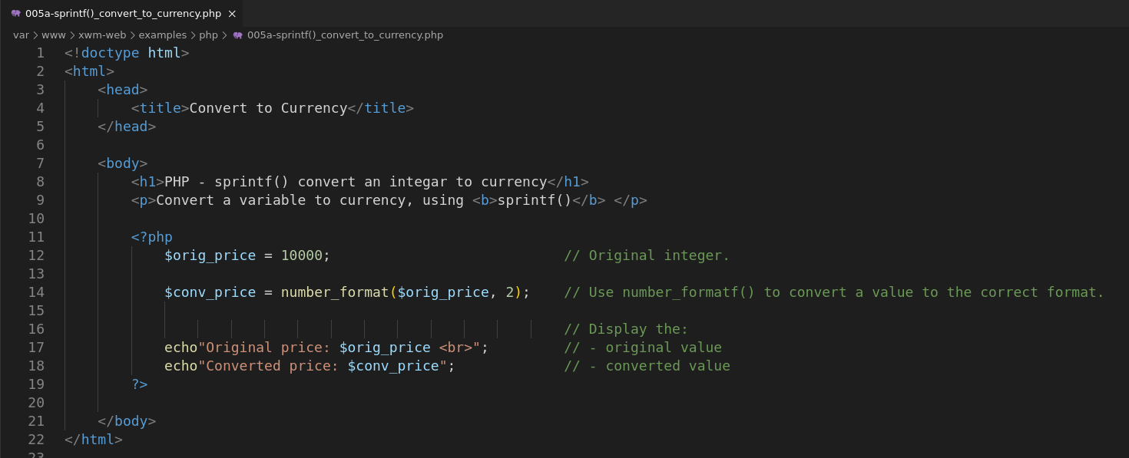

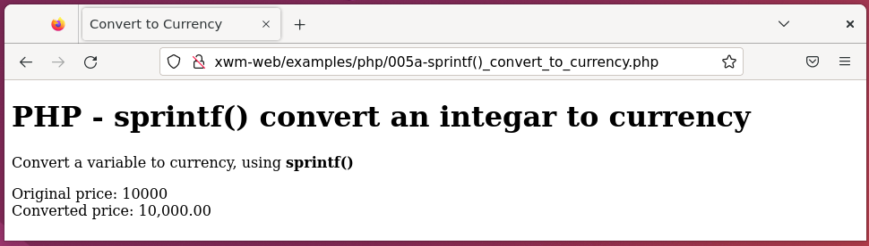

#### Example – Converting values with number_format()

Location: /var/www/xwm-web/examples/php/005b-number_format()_convert_to_currency.php

URL: htttp://xwm-web/examples/php/005b-number_format()_convert_to_currency.php

<!doctype html>

<html>

<head>

<title>PHP - number_format()</title>

</head>

<body>

<h1>PHP - number_format() convert an integer to currency</h1>

<p>Convert a variable to currency, using <b>number_format()</b></p>

<?php

$orig_price = 10000; // Original integer.

$conv_price = number_format($orig_price, 2); // Use number_format() to convert a value to the correct format.

// Display the:

echo"Original price: $orig_price <br>"; // - original value

echo"Converted price: $conv_price"; // - converted value

?>

</body>

</html>

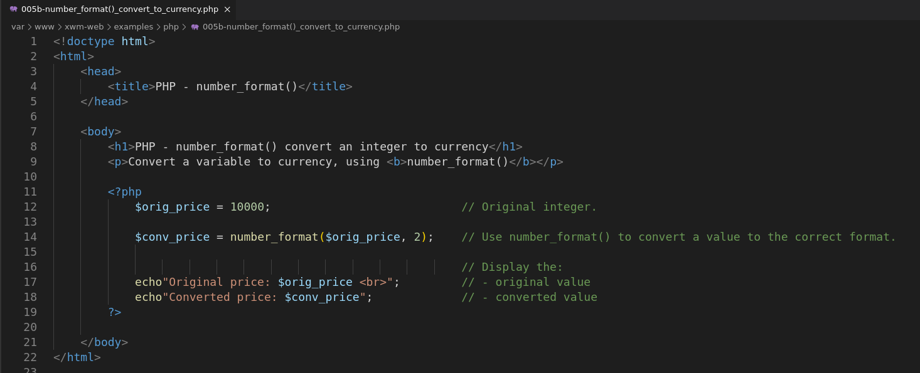

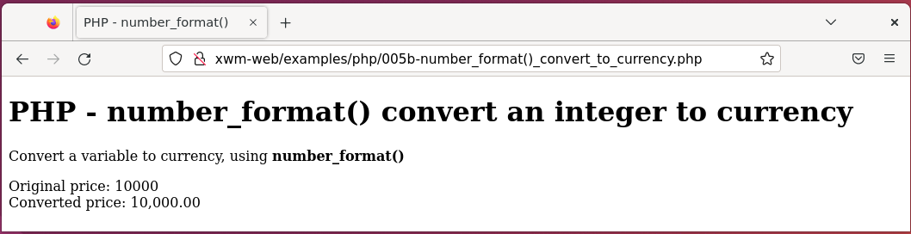

### Escape characters

The backslash **\** means the following character *(eg single or double quote)*

will be treated as part of the string

instead of the end of the sequence.

#### Example – Escape character

Location:

URL:

<!doctype html>

<html>

<head>

<title>PHP - Escape Character</title>

</head>

<body>

<h1>PHP - Escape Character</h1>

<p>When an escape character is used <br>

the following character will be treated as part of the string <br>

instead of the end of the sequence. <br><br>

For example, the semicolon (') in the following sentence.

</p>

<?php

$string = 'This is Sally\'s house'; // The backslash (\) is the escape character for the single quote (')

echo $string;

?>

</body>

</html>

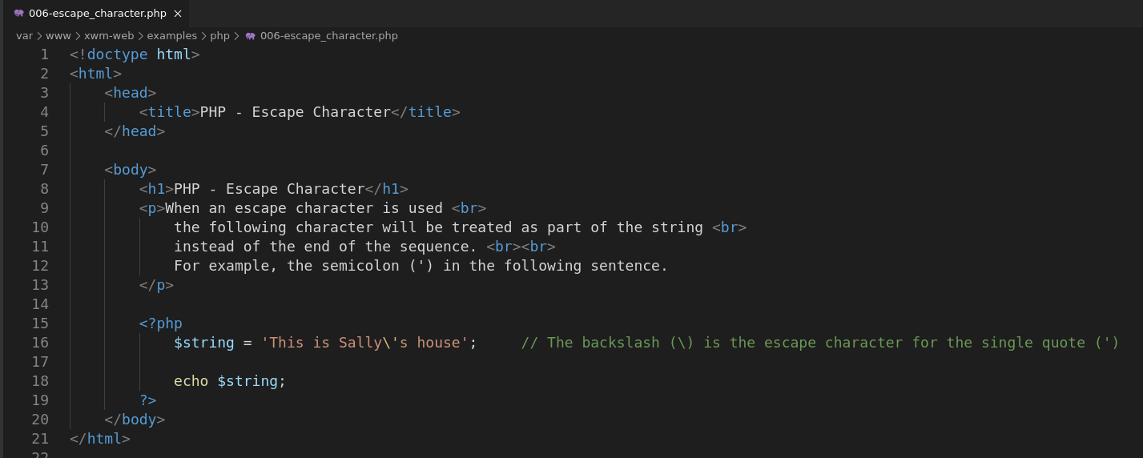

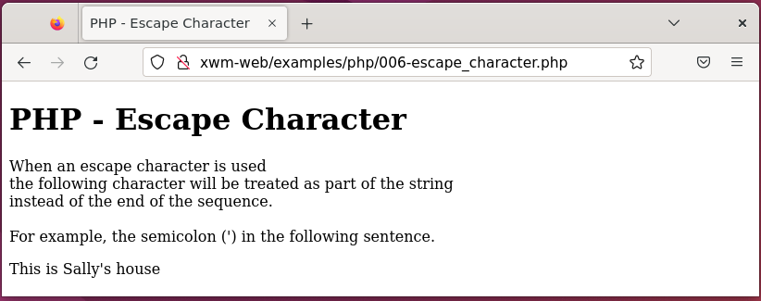

### Using single and double quotes with strings

Single-quoted and double-quoted strings are handled differently.

**Single-quoted strings**

Are stored literally

**Double-quoted strings**

Variables and some special characters are evaluated

before the string is stored.

For example, if you use the following statements:

$month = 12;

$result1 = “$month”; *// evaluated*

$result2 = ‘$month’; *// literal*

echo $result1;

echo “<br />”;

echo $result2;

the output is:

12

$month

*Next, Heredoc …*

### Storing really long strings

PHP provides a feature called a **heredoc**

that is useful for assigning values that consist of really long strings.

A heredoc enables you to state where a string starts and ends.

A heredoc statement has the following format:

$varname = <<<ENDSTRING

text

ENDSTRING;

#### Example – Heredoc

Location: /var/www/xwm-web/examples/php/007-heredoc.php

URL: http://xwm-web/examples/php/007-heredoc.php

<doctype html>

<html>

<head>

<title>PHP - Heredoc</title>

</head>

<body>

<h1>PHP - Heredoc</h1>

<p>Heredocs are used to create large volumes of text. <br></p>

<?php

$dist = 350;

// Start of heredoc

$var = <<<HEREDOC_TEXT

The distance between

Christchurch and Picton is

$dist kilometers.

HEREDOC_TEXT;

// End of heredoc

echo $var; // Display the string

?>

</body>

</html>

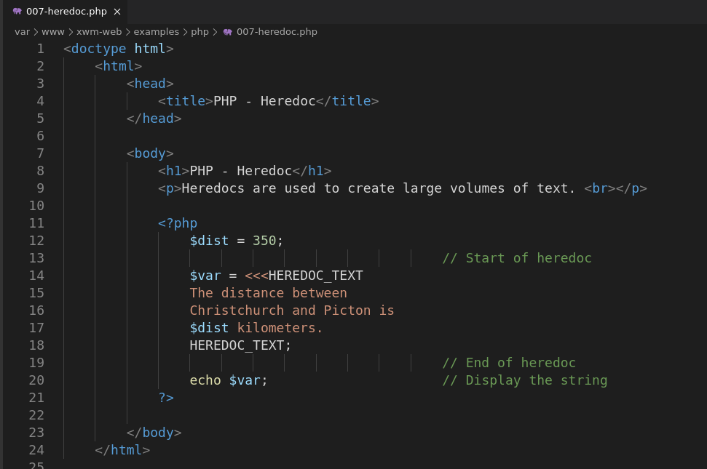

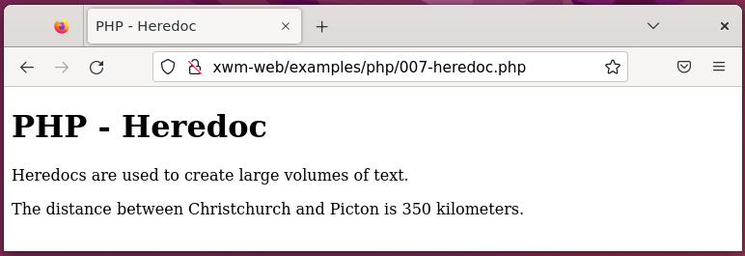

### Arrays

#### Example – Array, add multiple elements

Location: /var/www/xwm-web/examples/php/008a-array_add_multiple_elements.php

URL: http://xwm-web/examples/php/008a-array_add_multiple_elements.php

<!doctype html>

<html>

<head>

<title>Arrays - Multiple Elements</title>

</head>

<body>

<h1>PHP Array - Add multiple elements</h1>

<p>Add multiple elements to an array, <br>

then display all items.</p>

<?php

$sports = array("tennis", "soccer", "rugby"); // Add multiple elements to an array.

foreach($sports as $sport) // Display all elements in the array.

{

echo $sport . "<br>";

}

echo"<br><br>";

?>

</body>

</html>

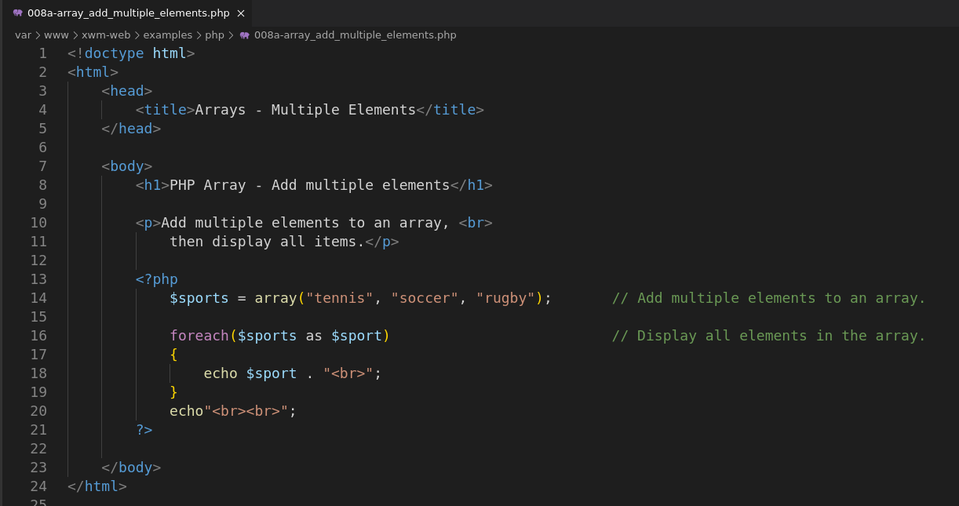

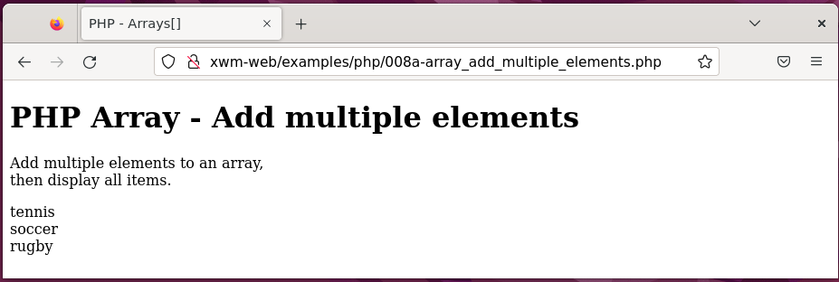

#### Example – Array, add single elements

Location: /var/www/xwm-web/examples/php/008b-array_add_single_elements.php

URL: http://xwm-web/examples/php/008b-array_add_single_elements.php

<!doctype html>

<html>

<head>

<title>Array - Add Single Element</title>

</head>

<body>

<h1>PHP Array - Add single elements</h1>

<p>Add individual elements to an array,<br>

then display one element. </p>

<?php

$cities[] = "Auckland"; // Add individual elements.

$cities[] = "Wellington";

$cities[] = "Christchurch";

echo "cities[1] is: {$cities[1]}"; // Display element one.

?>

</body>

</html>

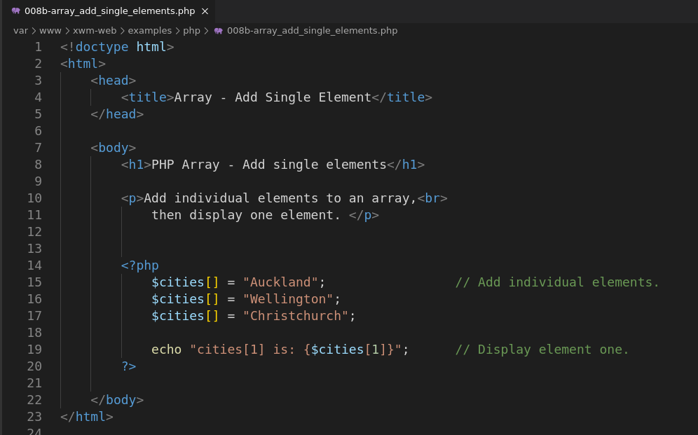

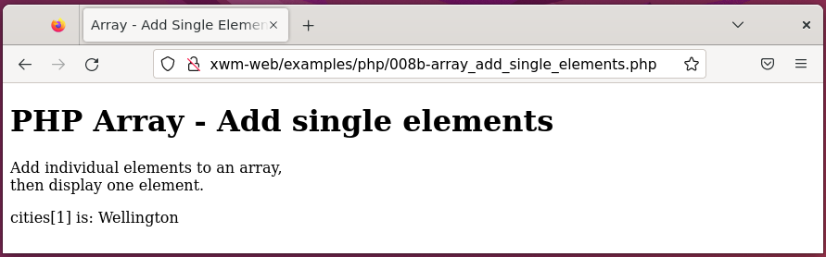

#### Example – Array, named elements

Location: /var/www/xwm-web/examples/php/008c-array_named_elements.php

URL: http:// xwm-web/examples/php/008c-array_named_elements.php

<!doctype html>

<html>

<head>

<title>Arrays - Named Elements</title>

</head>

<body>

<h1>PHP Array - Named Elements</h1>

<p>Create an array that has named elements, <br>

then display one of the items. <br> </p>

<?php

$flower = array("type"=>"Rose", "color"=>"Red", "cost"=>"12"); // Name the array's elements.

echo"flower[color] is: $flower[color]"; // Display one of the named elements.

?>

</body>

</html>

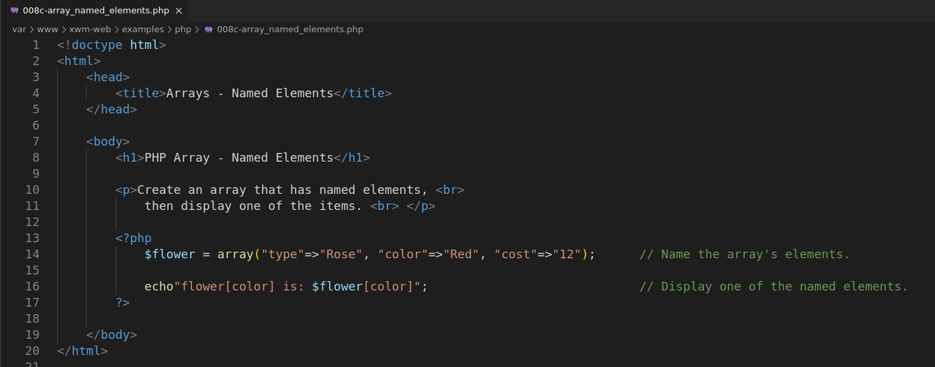

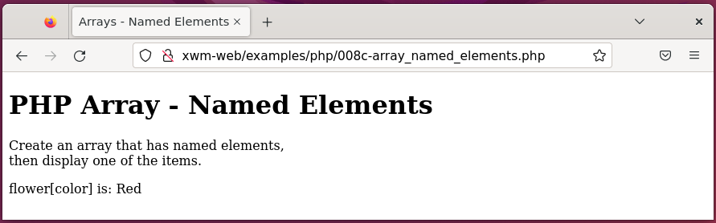



## Create ‘home’

Create the home page

#### Example – Create the ‘home’ page

Location 1: /var/www/xwm-web/home/home.html

Location 2: /var/www/xwm-web/home/home.css

URL: http:// xwm-web/home/home.html

/var/www/xwm-web/home/home.html

<!DOCTYPE html>

<html>

<head>

<title>Home</title>

<link rel="stylesheet" type="text/css" href="home.css">

</head>

<body>

<div id="container">

<div id="header">

<h1>xwm-web</h1>

</div>

<div id="nav">

<ul>

<li><a href="#">Sign-in</a></li>

<li><a href="#">Contact</a></li>

<li><a href="#">About</a></li>

<li><a href="#">Home</a></li>

</ul>

</div> <!-- end 'nav' -->

<div id="mainContainer">

<div id="menu">

<ul>

<li><a href="#xamarin">Xamarin </a></li>

<li><a href="#web">Web </a></li>

<li><a href="#mysql">MySQL </a></li>

<li><a href="https://github.com/NathsXamarin/XWM">GitHub </a></li>

</ul>

</div> <!-- end 'menu' -->

<div id="content">

<h1>Home</h1>

<h3><a name="xamarin">Xamarin </a></h3>

<p>Xamarin allows applications to be written in C# and run on various platforms<br>

such as Windows, iOS, and Linux. <br>

Devices can include mobiles phones, such as Android and iPhones.

</p>

<br>

<h3><a name="web"> Web - Apache </a></h3>

<p>Apache is a free and open-source web-server application.<br>

Although most Apache servers run on Linux (like this web site)<br>

there are also versions available for Windows.

</p>

<br>

<h3><a name="mysql">MySQL</a> </h3>

<p>MySQL is an open-source relational database management system (RDBMS). <br>

It works with the operating system to:

</p>

<ul>

<li>implement a relational database on the computer's harddrive</li>

<li>manages users</li>

<li>provide network access </li>

<li>create backups</li>

</ul

</div> <!-- end 'content'-->

<div id="footer">

<p> This website is part of the GitHub project <a href="https://github.com/NathsXamarin/XWM">'XWM'</a> <br>

which includes Xamarin, Apache and MySQL technologies.</p>

</div> <!-- end 'footer' -->

</div> <!-- end 'mainContainer' -->

</div> <!-- end 'container'-->

</body>

</html>

*Next,* ***home.html*** *continued …*

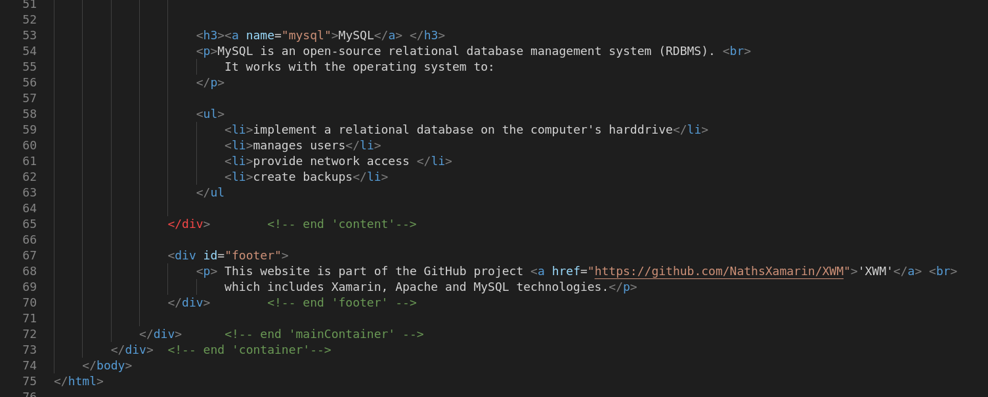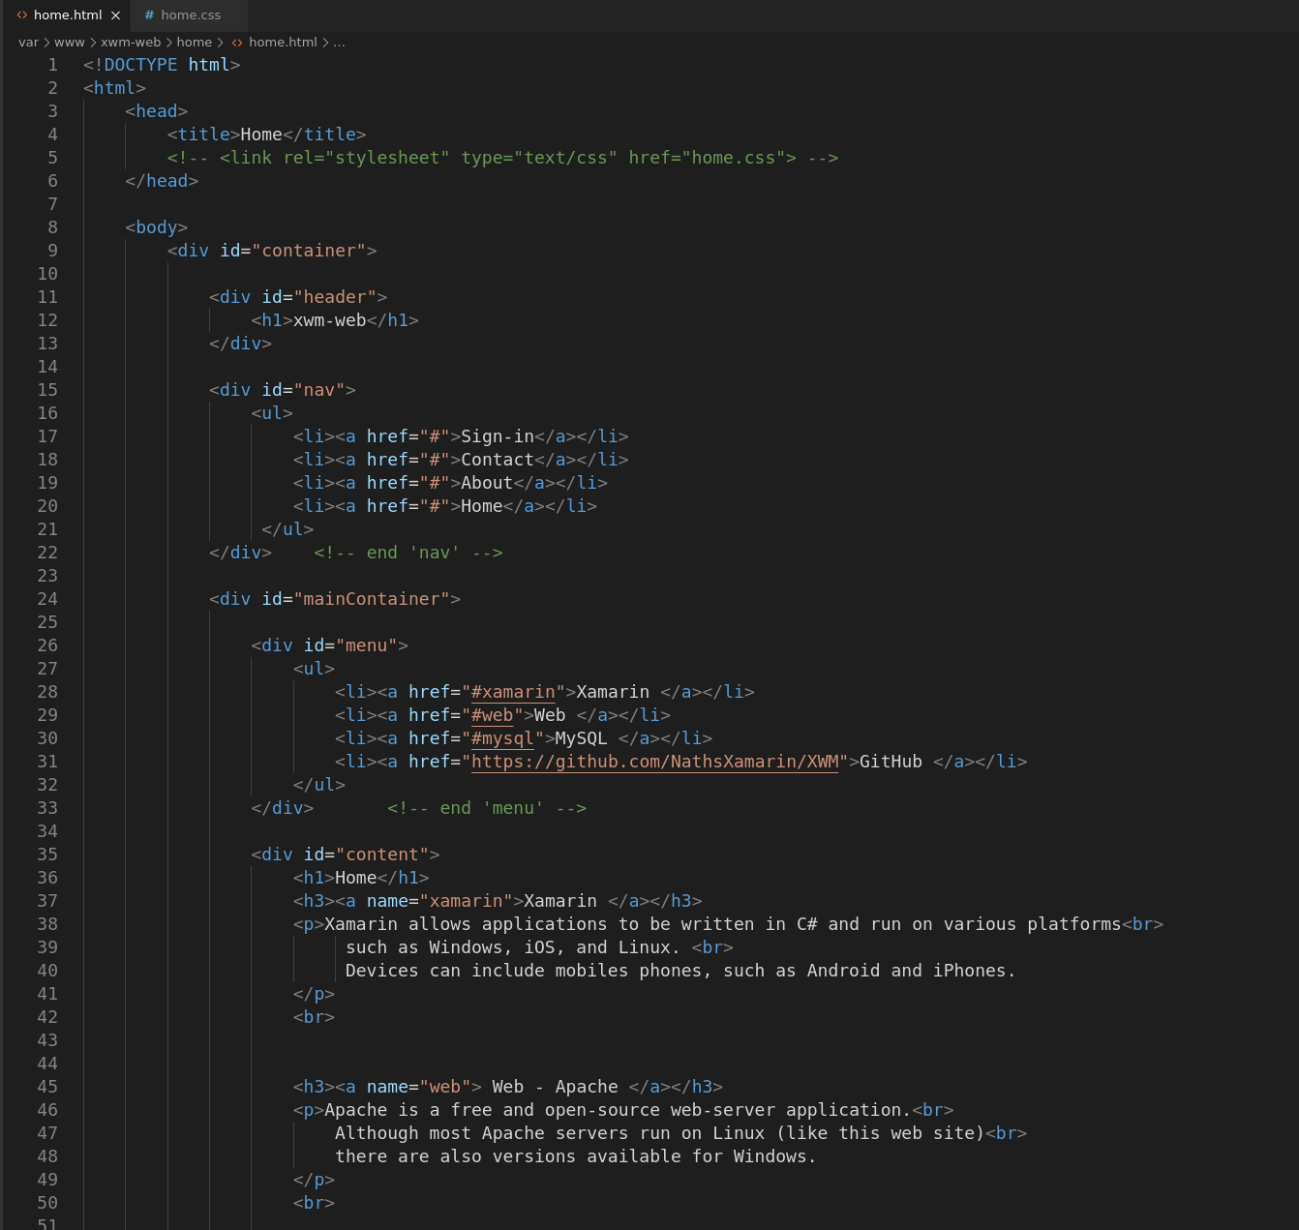

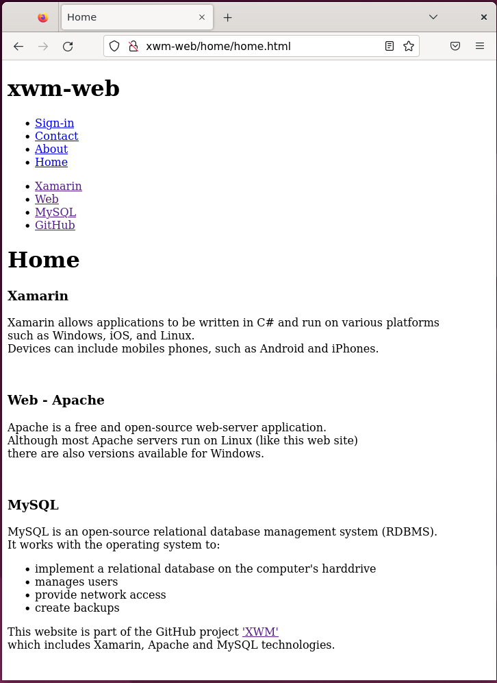

*Next,* ***home.css*** *…*

/var/www/xwm-web/home/home.css

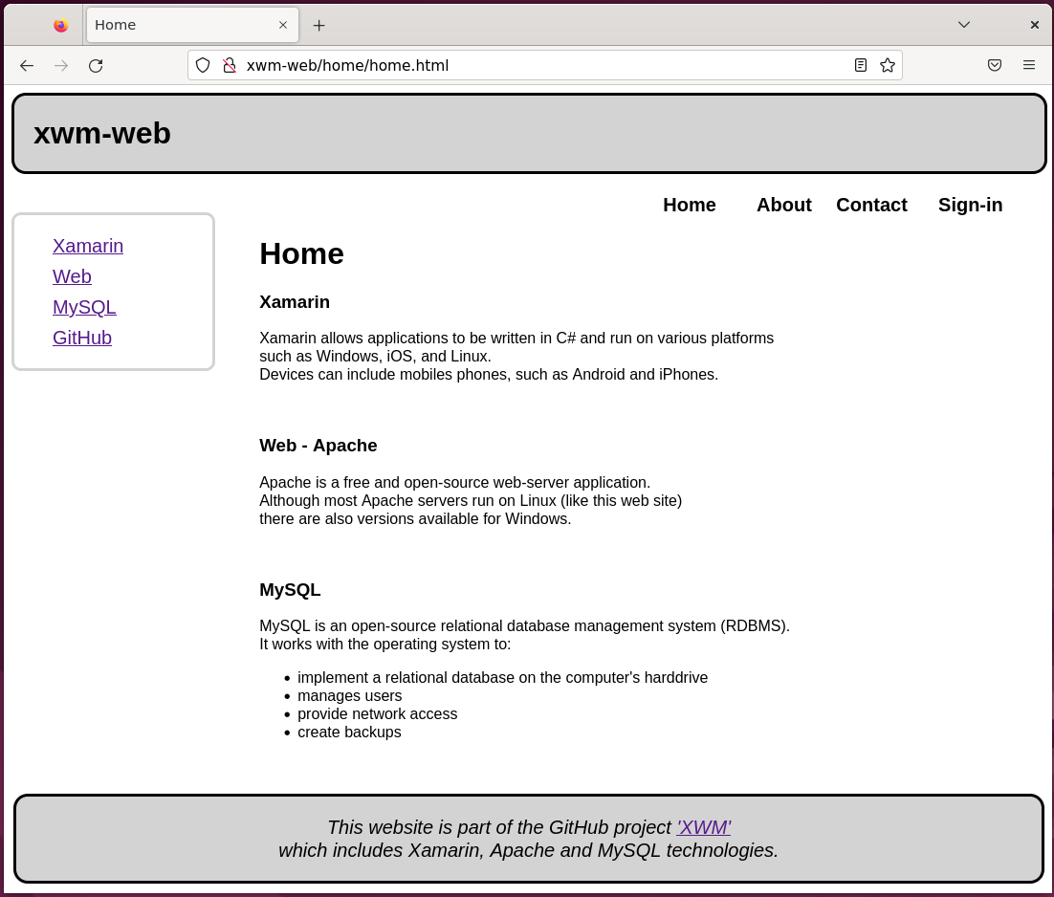body {

font-family: Arial, Helvetica, sans-serif;

}

#container {

width: 96%;

}

#header{

display: inline-block;

vertical-align: middle;

background-color: lightgray;

border-color: black;

border-style: solid;

border-radius: 15px;

width: 100%;

padding: 0 20px;

}

#nav {

font-weight: bold;

font-size: 125%;

width: 100%;

padding: 0px;

}

#nav ul li{

float: right;

text-align: left;

list-style-type: none;

width: 100px;

margin: 0;

}

#nav li a{

display: block;

float: right;

text-decoration: none;

color: black;

padding: 0px;

}

#nav li a:hover {

background-color: lightgray;

}

#mainContainer {

padding: 0px;

}

#menu {

display: inline;

float: left;

border-style: solid;

border-color: lightgray;

border-radius: 10px;

line-height: 200%;

width: 20%;

margin: 20px 0;

}

#menu li {

list-style-type: none;

font-size: 125%;

}

#content {

float: right;

width: 75%;

height: auto;

flex: auto;

}

#footer {

position: fixed;

text-align: center;

text-decoration: none;

font-size: 125%;

font-style: italic;

display: inline-block;

vertical-align: middle;

background-color: lightgray;

border-color: black;

border-style: solid;

border-radius: 15px;

width: 97.8%;

padding: 0;

margin: 10px;

left: 0;

bottom: 0;

}

*Next,* ***home.css*** *continued …*

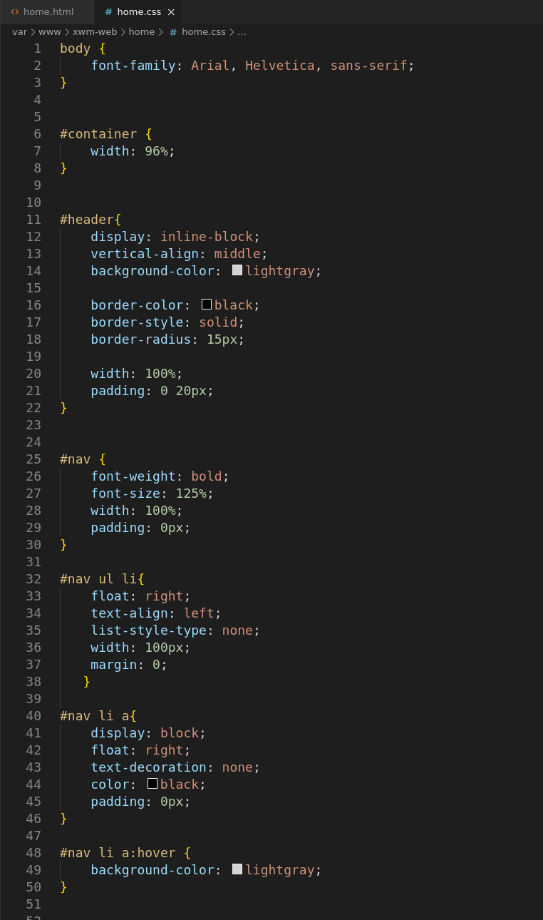

*Next, Add jQuery …*

